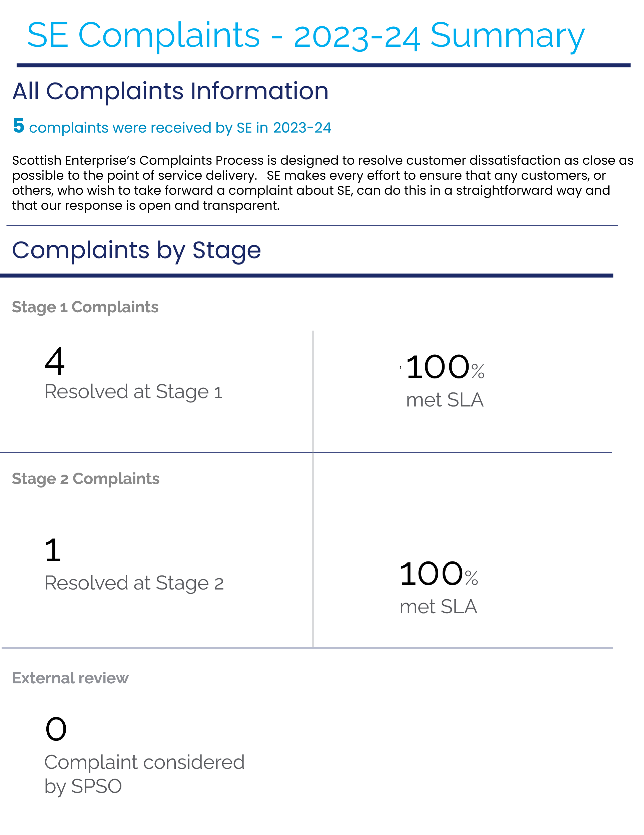

**COMPLAINTS APRIL 2023 – MARCH 2024**

|  |  |  |
| --- | --- | --- |
| **Complaint** | **Action Taken** | **Outcome** |
| Complaint received regarding an IP dispute between a company and a university and SE’s grant funding allocation. | Response provided advising that SE’s funding for the project had been suspended until conclusion of the dispute. | Complaint resolved at Stage 1 |
| A complaint was received from an individual regarding funding provided by SE to Laggan Outdoors Ltd, following three previous FOI requests. | The CEO asked the Internal Audit Team to undertake an independent review.  No issues were identified from the review and a response was provided. | Complaint resolved at Stage 2 |
| A complaint was received from an individual regarding feedback he had received on his application for funding for the Can-Do Innovation Challenge Fund. | A response was provided advising that the process used to review the application was consistent with the published guidance and in line with how all applications were assessed.  Feeback had been provided which had included advice on how the individual could improve their application. | Complaint resolved at Stage 1 |
| A complaint was received from an individual in relation to the £3.3m grant to Guala Closures in 2022, safeguarding 425 jobs, and the recent announcement that the company was moving manufacturing to other parts of Europe, with the loss of 100 jobs. | A response was provided, explaining the basis of SE’s support to assist the company to move into a new, state of the art, production facility at Gartcosh, to assist with increased capacity, improve efficiency and to provide space for future growth, securing long-term investment to sustain its future operations within Scotland. | Complaint resolved at Stage 1 |
| Complaint regarding SE support to a company which had gone into liquidation, and had left the individual’s company with a substantial unpaid debt | A response was provided confirming the grant awarded to the company and outlining the appraisal procedures and processes followed in advance of grant support, as well as the element of risk which SE is prepared to accept as part of its role as an economic development agency.     The individual was directed to the Interim Liquidator. | Complaint resolved at Stage 1 |