The Ophthalmology Market

November 2015

Contents
Executive Summary 1
The Ophthalmology Market 3
Market Growth Projections 7
Technology Barriers and Related Research 11
Case Study 1: Transcend Medical, Inc. 12
Case Study 2: Ocular Therapeutix, Inc. 13
Case Study 3: Lamellar Biomedical Ltd. 14
Case Study 4: Aerie Pharmaceuticals (a university spin-out) 15
Survey of Companies Defined by Technologies 16
Alliances Between Academia and Companies 17
Leading US Centres for Ophthalmology 17
Alliances and Financing in Ophthalmology 18
Conclusions 24
APPENDIX 25
Companies Sorted by Country, then Technology. 25
Survey of Alliances and Financing in 2015 33
Abbreviations 45
References 45

Executive Summary

- This report investigates the market broadly defined as “Ophthalmic”. It should be stressed that this classification covers wide ranging industries and technologies, including: contact lenses, optical instrumentation and devices, gene therapy, biological and small chemical therapeutics, stem cells, drug delivery systems, diagnostics, surgical tools and consumables, “bionic” retinal implants, computer software for eye tests and rehabilitation, research services e.g. cell banking and CROs.
- The data identified suggests that all of the market sectors in Ophthalmic will have strong growth of market value driven by aging populations in developed countries and sales of new products, in particular, anti-VEGF therapeutics. In the longer term, gene therapeutics are expected to be a force for increasing market value.
- A survey of late stage products (Phase 3) suggests that biologics and drug delivery are the most common by technology type. A survey of companies suggests that Scotland has a particular strength in drug delivery technology.
- Technology that is fashionable:
  - Anti-VEGF therapeutics, such as Lucentis (ranibizumab), EYLEA® (aflibercept) and Avastin (bevacizumab),
  - Gene therapy, in particular AAV-based systems, and
  - MIGS (minimally invasive glaucoma surgery) are technology areas that currently receive favourable media coverage and attract funding.
  - Cell Therapy could be an exciting field for new research and development. Scotland is well positioned with Roslin Cells, main contract manufacturer of the retinal epithelial pigment cells for Pfizer’s ongoing clinical trials.
- Ophthalmics is receiving significant investment. In January 2015 the US gene therapy company Spark Therapeutics raised US$ 161 m from an initial public offering (IPO). Most of the funds raised are for SPK-RPE65, an FDA-designated "breakthrough" therapy now in Phase III development to treat inherited retinal dystrophies. At the time of writing this was the seventh largest biotechnology IPO in 2015. Surveys by The Wall Street Journal in 2013 and 2014 found that healthcare venture capital funding was directed more to ophthalmology that any other healthcare sector²⁷.
- Scotland has expertise in drug delivery, diagnostics and instrumentation, and this could be built on, but technology areas that are weak include gene therapy and small molecule drugs. In the body of this report the company Transcend Medical is given as an example of a model device company, which might serve as a prototype of the types of the companies that could be founded and developed in Scotland. Ocular Therapeutix is profiled as a US drug delivery company that is successful, whilst Lamellar Biomedical is a drug delivery company from Scotland that is using the orphan drug system for product development.
- Visual field testing had an estimated value of US$ 280 million in the US in 2012³⁶, with similar market sizes estimated for Europe and Asia. Scotland has three companies in this sector, namely; i2eye Diagnostics Limited, BID Instruments Limited and IbisVision Limited (although the latter two companies are closely associated). It could it be expected that this is a growing market for epidemiological reasons, but also there is an economic argument for testing to allow effective treatment in the early stages of disease.

The Ophthalmology Market

Historically in the pharmaceuticals industry the ophthalmology sector has been seen as a speciality business area with a relatively small number of companies active. Over the last 20 years the market has become more prominent both financially and technologically. The biological characteristics of the eye has attracted gene therapy companies, some of which have attracted “big pharma” partners. Over the last four years major companies have been acquiring the larger, established ophthalmic companies.

The major ophthalmic diseases are :-

- Age related macular degeneration (AMD)
- Cataracts
- Diabetic retinopathy
- Dry eye conditions
- Glaucoma

Glaucoma has the largest market share in the ophthalmic drug market⁵. In 2013, branded and generic glaucoma product sales exceeded US$ 4.5 billion (£ 2.9 billion) in the United States, Europe and Japan combined, according to IMS⁶.

Cataracts, AMD and diabetic retinopathy are age related and are expected to become more common with aging populations in developed countries. This is one of the “drivers” for the increasing value of the ophthalmology market.

Major Eye Diseases in the US

Disease | Prevalence in USA ⁷ | Cause and treatment ⁷
Cataracts | 24 million | The lens of the eye deteriorates, resulting in blurred or cloudy vision.  The only remedy is surgery, a common outpatient procedure.  Cataracts are the primary cause of preventable blindness in the world.
Diabetic retinopathy | 8 million | Affects the blood vessels in the back of the eye and can cause blurring, distortion or loss of vision due to bleeding inside the eye.  It can be treated with lasers and surgery.
Glaucoma | 3 million | High intra-ocular pressure affects the optic nerve and impairs a person’s peripheral vision.  Can be diagnosed early with non-invasive tests, and treatments can be customized for individual patients. Diagnosis and treatments (drops, lasers, and surgery) have improved in recent years, so the incidence of blindness from glaucoma has reduced.  Glaucoma is the second-leading cause of preventable blindness in the world⁹.
Macular degeneration | 2 million (AMD)  Dry form = 90% of cases | New blood vessels grow behind the retina and begin to leak, altering central vision.  The “wet” form is treatable with injections; the “dry” form lacks therapies at this time.  AMD is the most common cause of significant irreversible vision loss among the elderly in developed countries ⁸.

Major Eye Diseases Worldwide

Disease | Prevalence Worldwide
Cataracts | ~ 20 million people in 2010 blind from cataracts ²²
Diabetic retinopathy | 126.6 million in 2010 ²³
Glaucoma | 60 million people ¹³
Macular degeneration,  age related | 196 million projected for 2020 ²⁴

The total world market for ophthalmology products is approximately valued at US$ 50 billion², which is about £ 33 billion. The USA represents about 40% of this total market³. The two largest product segments are Pharmaceuticals and “Eye care” which includes products such as contact lenses⁴.

Breakdown of Global Ophthalmics Market into Broad Sectors

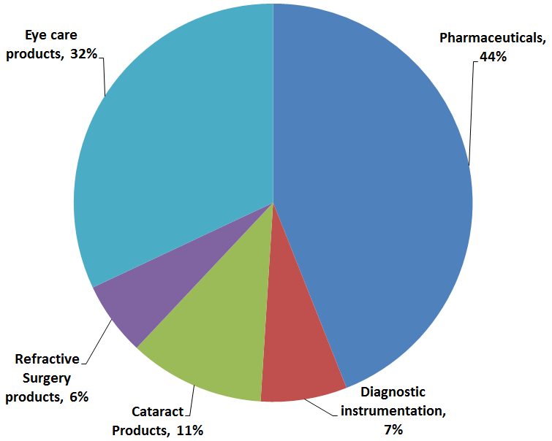

The ophthalmics drugs segment is expected to grow in value from about US$ 16 billion in 2012 to US$ 21.6 billion in 2018 ¹⁰. From 2009 to 2014 the US ophthalmic market has approximately doubled in value.

Value of U.S. ophthalmology market from 2009 to 2014 (in billion U.S. dollars) ³²

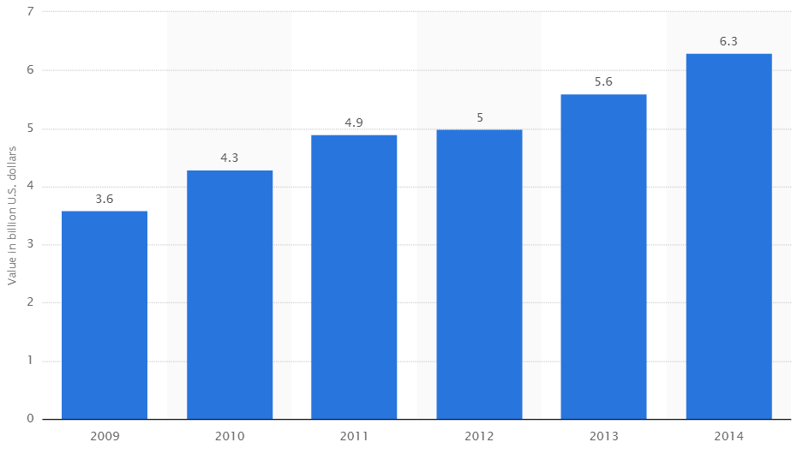

In Europe, by 2019, the top three countries for sales of ophthalmic drugs are expected to be Germany, France and then UK in that order ¹¹.

European Drugs Market for Retinal Diseases, including AMD.
Predicted market shares in 2019 for the top five countries ¹¹.

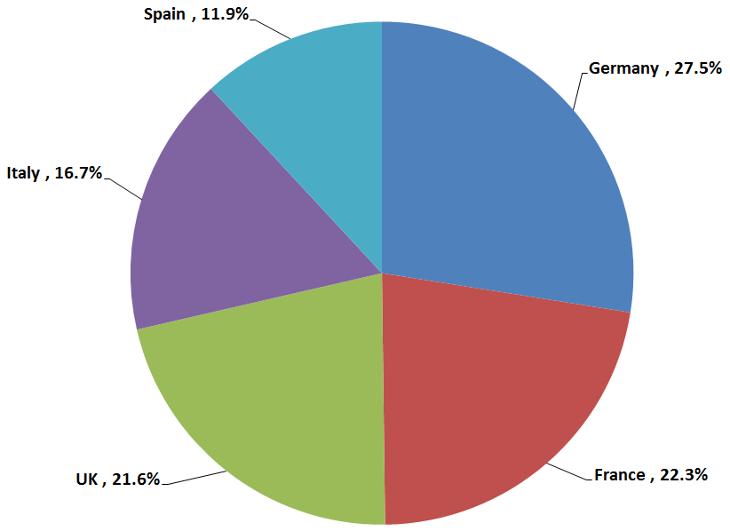

Devices

According to a market research report by Transparency Market Research, the global Ophthalmology Devices market was valued at US$ 26,012.6 million in 2012. The product type segment is further classified into three major sub-segments namely diagnostic devices, surgery devices and vision care products ¹. North America was the largest market in the year 2012 valued at US$ 8,037.9 million for ophthalmology devices followed by the European market at US $ 7,647.70 million ¹. The major device companies with 2013 sales and projected sales in 2020 are provided in the graphic below :-

Worldwide top 10 companies based on ophthalmic medical technology revenues
in 2013 and 2020 ³¹
(million U.S. dollars)

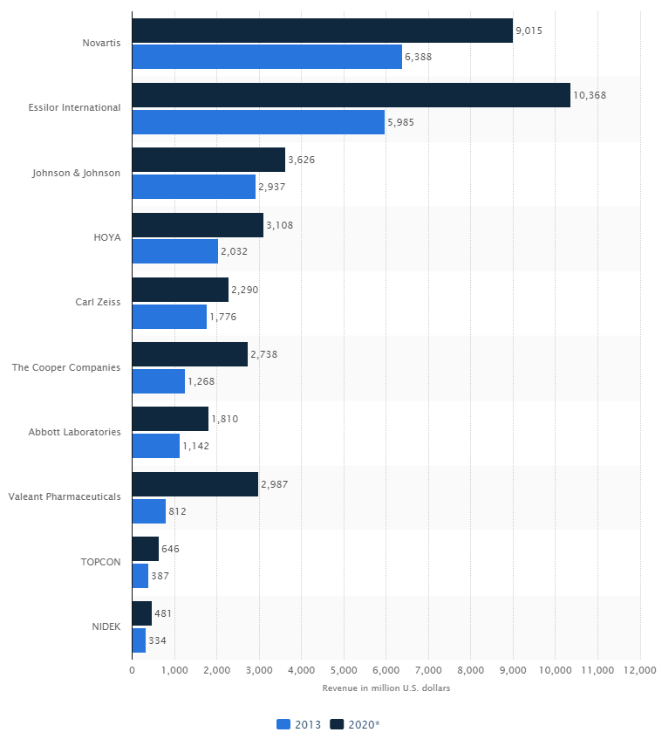

Market Growth Projections

A survey of market research reports shows that all sectors of the ophthalmology market are expected to show strong growth for at least the next five years. In general the reports cite aging populations in developed countries as being a force for increasing market value. In these countries there is scope for high value pharmaceutical products such as antibody fragments, gene therapy and cell-based therapy. New products are also increasing market values. The following products are all in Phase 3, late clinical, development.

- Abicipar in Phase 3 for wet AMD. This biologic is under development by Molecular Partners AG under collaboration with Allergan. The agent uses DARPins (Designed Ankyrin Repeat Proteins) with an anti-VEGF action.
- DEXTENZA™ (dexamethasone) in Phase 3 for post-operative inflammation and pain of the eye. Under development by Ocular Therapeutix.
- E81-005 topical interleukin-1 (IL-1) receptor antagonist in Phase 3 for dry eye disease. Under development by Eleven Biotherapeutics.
- EGP-437 in Phase 3 for non-infectious anterior uveitis. Under development by EyeGate Pharma using iontophoresis.
- Fovista® in Phase 3 for wet AMD. Under development by Ophthotech Corp. in collaboration with Novartis. This small molecule has an anti-PDGF (platelet derived growth factor) action.
- GS010 in Phase 3 for Leber hereditary optic neuropathy. Under development by Gensight Biologics. GS010 is an AAV2 (adeno-associated virus 2) containing the human wild-type ND4 gene.
- Hydrus™ Microstent in Phase 3 for glaucoma. Developed by Ivantis, the product is for MIGS (minimally invasive glaucoma surgery), to reduce intra-ocular pressure.
- IBI-10090 in Phase 3 for inflammation associated with cataract surgery. Under development by Icon Bioscience. Uses Verisome drug delivery technology.
- Optina (danazol) in Phase 3 for diabetic macular oedema. Under development by Ampio Pharmaceuticals. Synthetic hormone derivative.
- Rhopressa in Phase 3 for glaucoma. New molecular entity under development by Aerie Pharmaceuticals.
- SPK-RPE65 AAV-based gene therapy in Phase 3 for inherited retinal dystrophies. Under development by Spark Therapeutics, Inc. in collaboration with Genable Technologies Limited.
- Squalamine in Phase 3 for wet AMD with Ohr Pharmaceutical.

From the above listing it can be seen that biologics and drug delivery are the most common technology types, and this is summarised in the following pie chart.

Numbers of Phase 3 Products by Technology Type
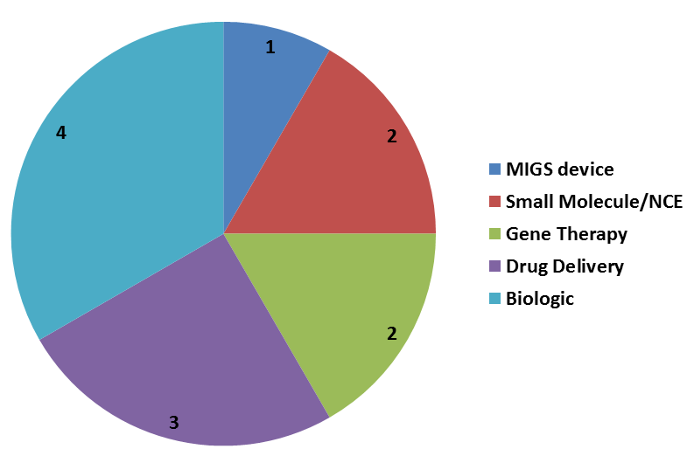

The tables that follow show market growth data represented as CAGR and in terms of US $ value (where available). CAGR means “compound annual growth rate” and is a calculation that gives a standardised annual percentage growth figure across a complete time period.

Projected Market Growth in Percentage CAGR

Disease | Territory | Period | CAGR | Reference
Age-related Macular Degeneration treatment | Seven major countries  US, UK, Germany, France, Spain, Italy and Japan | 2013-2023 | 7.1% | GlobalData ¹⁹
Cataract surgery devices | North America | 2014-2019 | 7.8% | MicroMarket Monitor ²⁰
Contact lenses | Worldwide | 2013- 2019 | 10.3% | Transparency Market Research ²⁵
Diabetic retinopathy market | Worldwide | 2014-2019 | 6.89% | Marketresearchreports.biz ²¹
Dry eye syndrome | Worldwide | 2014-2019 | 4.75% | ResearchMoz ¹²
Glaucoma | Seven major markets  US, France, Germany, Italy, Spain, UK, and Japan | 2013-2023 | 2.4% | GlobalData ¹⁴
Glaucoma devices | Worldwide | 2013-2018 | 20.72% | ReportsNReports ¹⁷
Glaucoma surgery devices | Worldwide | 2014- 2019 | 8.4% | MicroMarket Monitor ¹⁵
Glaucoma therapeutics | Worldwide | 2014-2018 | 2.53% | ReportsNReports ¹⁶
Macular degeneration | Asia-Pacific region. Australia, China, India and Japan. | 2012-2019 | 6% | GBI Research ¹⁸

Projected Market Values in US $

Disease | Territory | Period | US $ Value | Reference
Age-related Macular Degeneration treatment | Seven major countries  US, UK, Germany, France, Spain, Italy and Japan | 2013-2023 | $5.1 billion to $10.1 billion | GlobalData ¹⁹
Cataract surgery devices | North America | 2014-2019 | $2,699.1 million to $3,929.3 million | MicroMarket Monitor ²⁰
Contact lenses | Worldwide | 2013- 2019 | $ 7.47 billion to  $ 13.47 billion | Transparency Market Research ²⁵
Glaucoma | Seven major markets  US, France, Germany, Italy, Spain, UK, and Japan | 2013-2023 | $ 2.4 billion to approximately $ 3 billion | GlobalData ¹⁴
Glaucoma surgery devices | Worldwide | 2014- 2019 | $210.3 million to $314.3 million | MicroMarket Monitor ¹⁵
Macular degeneration | Asia-Pacific region. Australia, China, India and Japan. | 2012-2019 | $675.7 million to $1,016 million | GBI Research ¹⁸

The markets expected to show particularly strong growth are AMD treatment, contact lenses and glaucoma surgical devices. The glaucoma devices are starting from a low baseline, but are expected to become important in treatment, and so the percentage growth figures should be high.

The above historic and projected market values are shown graphically on the following bar chart.
Historic and Projected Market Values (US$ M)

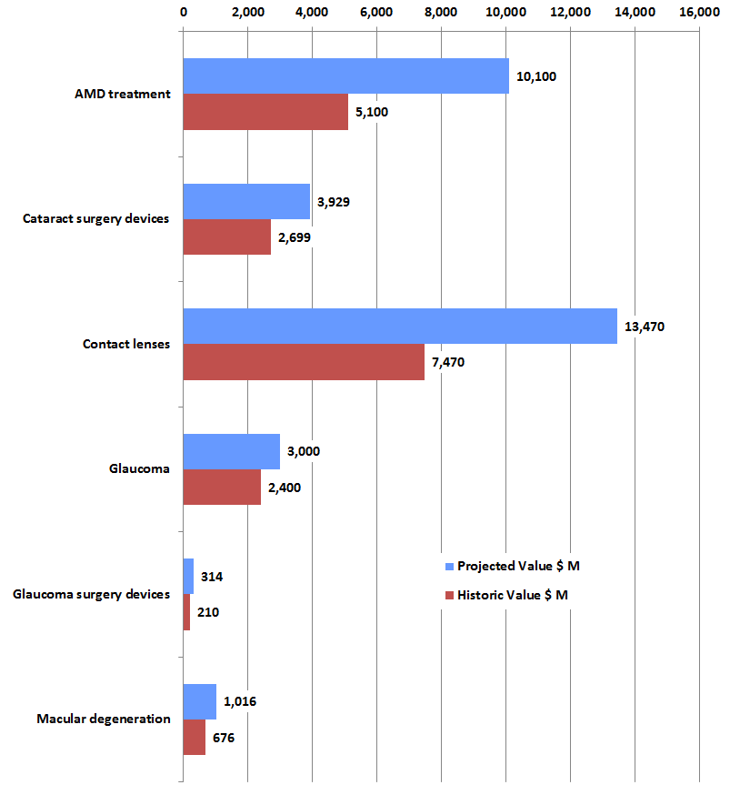

Technology Barriers and Related Research

Drug Delivery – improving drug efficacy and compliance
A significant proportion of ophthalmic medicines are administred as solutions directly to the eye. The problem with this is that there can be insufficient contact time between the eye and the threaputic product. To address this universities and companies have been looking at ways of increasing viscosity of the product. Related approaches to this include using liposomes, “nano carriers”, and other conjugate-type approaches.
Punctal plugs: One way of dealing with the drug delivery problem is to provide drug as an implant that is inserted into the tear duct. Ocular Therapeutix and Mati Therapeutics are actively working in this field. An advantage of this approach is that it increases the possible drug load to the eye.

“Contact lens” delivery: Drug could be loaded into a polymer, like a contact lens, that would sit under the eyelid and release the medication over several months (Amorphex Therapeutics).

Special microneedles: Microneedles are being developed to inject medication into a specific spot to enhance effectivensss (ClearSide Biomedical).

Micro- and Nanoparticles: Implantable extended-release devices using engineered highly-precise microparticles and nanoparticles (Envisia Therapeutics). Kala Pharmaceuticals is developing mucus-penetrating particle (MPP) technology to develop topical ophthalmic formulations with enhanced delivery into ocular tissue by facilitating penetration through the tear film mucus.
Hyrogel particles: A hydrogel template approach to prepare microparticles or other particles of predeﬁned size and shape with homogeneous size distribution. The drug release characteristics of the particles can be adjusted, providing ﬂexibility in controlling release rates in our drug delivery formulations (Ohr Pharmaceutical). Companies like pSivida are also making bioerodible implants that are loaded with drug.

Contact Lenses – adding functionality
In October 2015 Google was issued a US patent (no. 9158133) for smart contact lenses that are solar powered and can collect biological data from the user, such as sugar levels. The idea derived from the University of Washington in Seattle, where the Google project co-founders, researchers Babak Parviz and Brian Otis, worked on the electrical engineering faculty before joining Google. The sensors could also gather data about the environment around the person wearing the lenses. The device would detect and sense allergens like tree pollen and excess dust. It is envisaged that the photo detectors would receive data and enable the device to communicate with smartphones and computers³⁷.
Cataract Surgey – improving efficiency and outcomes
Moorfields Hospital is running a trial on femtosecond laser surgery for cataracts³⁸. The laser machine makes incisions and breaks up the cataract into small pieces before the surgeon starts the operation. The laser procedure takes approximately five minutes and is done before the patient enters the operating theatre. Thus, the laser system partly automates the surgical process.

Eye Stem Cell Therapy – new cells to restore eyesight

In April 2015 the first publication of results from Korea showed that injected human embryonic stem cell (hESC)-derived retinal support cells could improve vision for subjects with macular degeneration. This trial was conducted with four men, and was supported by Ocata Therapeutics of the US³⁹. Three of the men experienced vision improvements in their treated eyes in the year following the procedure, while the fourth man’s vision remained largely the same. The trial adds to growing evidence that injecting hESC-derived cells is feasible.

Case Study 1: Transcend Medical, Inc.

The history of Transcend Medical shows the evolution of a company as it develops medical devices for patients with glaucoma. Transcend Medical works in the field of "MIGS", where minimally invasive surgery is used to try and combine the safety profile of cataract surgery with the efficacy of pharmaceuticals. MIGS has taken off since the iStent Trabecular Micro-Bypass (Glaukos) received FDA approval in 2012.

In September 2005, Transcend Medical became the first company to spin out of ForSight Labs, an incubator solely focused on ophthalmic innovations. In 2006 the company received US$ 7 million Series A funding. The CyPass Micro-Stent was granted CE Mark in October 2008. (The CyPass Micro-Stent is a biocompatible polyimide stent meant to provide a permanent conduit from the anterior chamber to the suprachoroidal space of the eye). In October 2009, Transcend Medical initiated one of the largest glaucoma surgery studies, the COMPASS Clinical Study, evaluating the CyPass Micro-Stent in combination with cataract surgery for patients with primary open-angle glaucoma. In 2011, Transcend Medical closed US$51 million Series B funding. In 2012 Transcend Medical launched the Transcend Vold Gonio Lens (TVG) for improved visualization during Micro-Invasive Glaucoma Surgery. (The Transcend Vold Goniolens is a metal tool used in MIGS surgery). In 2013 Transcend completed enrolment for the COMPASS Clinical Study. In 2014 the company received US$ 22 million Series C funding. In October 2014, Transcend Medical partnered with Volk Optical to make the Transcend Vold Goniolens (TVG) available worldwide. This company history is shown graphically below.

Transcend Medical Company History Shown Graphically
Funding in $ M, time in years on x-axis

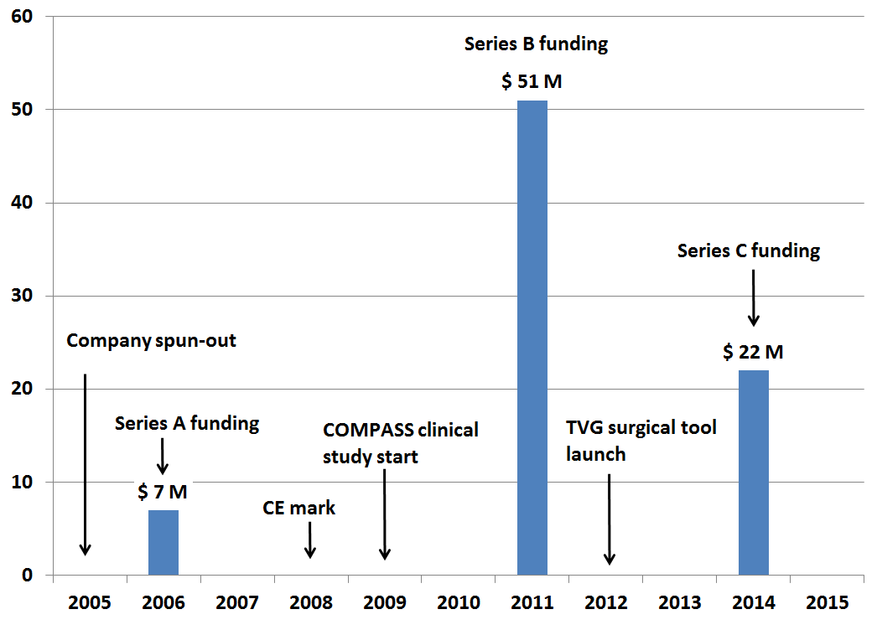

The company is private, so there is no detailed information available about turnover or numbers of employees. The company is classified on “LinkedIn” as having up to 50 employees. However, the company’s timeline appears to be a model example of corporate development over a 10 year period with sustained funding and product development.

The company is based in Menlo Park, California, so is in a high tech environment with access to VC companies and banks that specialise in technology clients. Menlo Park is close to Stanford University, which provides access to a flow of highly educated new recruits. The company is working in a technology area that is generally considered “sexy” in the media covering ophthalmics. Transcend works in the field of “devices” which are generally quicker to develop and have fewer regulatory hurdles than pharmaceuticals. Similar comments could be made for diagnostics and imaging.
Arguably, this is the type of company that the Scottish region should be trying to attract or establish from its own academic resources.

Case Study 2: Ocular Therapeutix, Inc.

Ocular Therapeutix is focused on the development and commercialization of innovative therapies for diseases of the eye using its proprietary hydrogel platform technology. Ocular Therapeutix’s lead product candidates are in Phase 3 clinical development for post-surgical ocular inflammation and pain and allergic conjunctivitis, and Phase 2 clinical development for glaucoma and inflammatory dry eye. The company is also evaluating sustained-release injectable anti-VEGF drug depots for back-of-the-eye diseases. Ocular Therapeutix’s first product, ReSure® Sealant, is FDA-approved to seal corneal incisions following cataract surgery. ReSure® is composed of a synthetic, polyethylene glycol hydrogel, the product is approximately 90% water after polymerization.

This company makes an interesting case study because of Scotland’s history in drug delivery with companies such as Controlled Therapeutics (now part of Ferring). Also of interest is Ocular Therapeutix’s involvement in anti-VEGF therapeutics which are expected to grow the market.

The company was founded in 2006, and its product development pipeline is based on bioresorbable hydrogel technology that uses polyethylene glycol, or PEG, as a key component. In 2011 the company raised $14 million from series D funding. This was followed in 2013 by a $23.8 Million Series D Extension. In July 2014 the company completed an initial public offering, then in April 2015 the company announced the pricing for an intended follow-on offering of shares to the public. So the company history from founding to follow-on IPO has taken 9 years. According to NASDAQ, the company's market capitalisation (as of 25/09/2015) was $ 440 million.

Case Study 3: Lamellar Biomedical Ltd.

Lamellar Biomedical Ltd was established in June 2007 and in 2011 the company secured an Orphan Drug Licence for their lead clinical candidate LMS-611 for the treatment of patients with cystic fibrosis. The company uses Lamellasome™ technology (mimetic lamellar bodies) as a delivery system for therapeutics. The company has been advised that LMS-611 will be regulated as a class 2b medical device for the treatment of dry eye disease (DED). Lamellar Biomedical has been collaborating with the Vision Sciences Unit at Glasgow Caledonian University. The company is hoping to start clicnical trials December 2015 for their Visco-ease product, for the treatment of Radiotherapy Induced Xerostomia in Head and Neck Cancer

In 2013 the company raised £ 3.3 million, and in July 2015 the company closed a £ 2.3 million investment round. Participating investors included funds managed by Invesco Asset Management Limited, the Scottish Investment Bank at Scottish Enterprise, Barwell Plc, members of TRI Cap and a number of other private investors.

The orphan drug status is significant as it helps the company progress its delivery technology, not just for the orphan indication.

An orphan designation by the European Medicines Agency (EMA) provides a range of benefits including:

- Scientific advice and regulatory assistance on clinical development
- Direct access to centralised marketing authorisation
- Certain financial incentives including eligibility for grant support from European agencies
- 10 years of marketing exclusivity subsequent to product approval

Lamellar is a Scottish company that is working in the drug delivery field, an area historically associated with Scotland, and is bridging the gap between university expertise and product commercialisation by using the orphan drug system. An advantage of the “platform” approach is that experience and data gained from one project may be applicable to other projects.

Case Study 4: Aerie Pharmaceuticals (a university spin-out)

Aerie Pharmaceuticals was founded in 2005 by two Profesors from Duke University, North Carolina. The company initially raised US$ 21 M in 2005, followed by US$ 30 M in 2011. In 2013 the company completed an initial public offering raising US$ 60 M. So the company took eight years to go from foundation to IPO. Aerie Pharmaceuticals’ lead product is Rhopressa™ which is a triple action drug currently in Phase 3 trials for glaucoma. The company intends to file an NDA (new drug pplication) mid-2016. If approved by the FDA they expect US commercial launch by the end of 2017. According to Dr David Epstein, a company founder and chair of Duke’s ophthalmology department; “There’s been no new glaucoma drug of any kind for 20 years… This is something really novel. ”

This is an example of a university spin-out company that has found great success.

Aerie Pharmaceuticals History Shown Graphically
Funding in $ M, time in years on x-axis

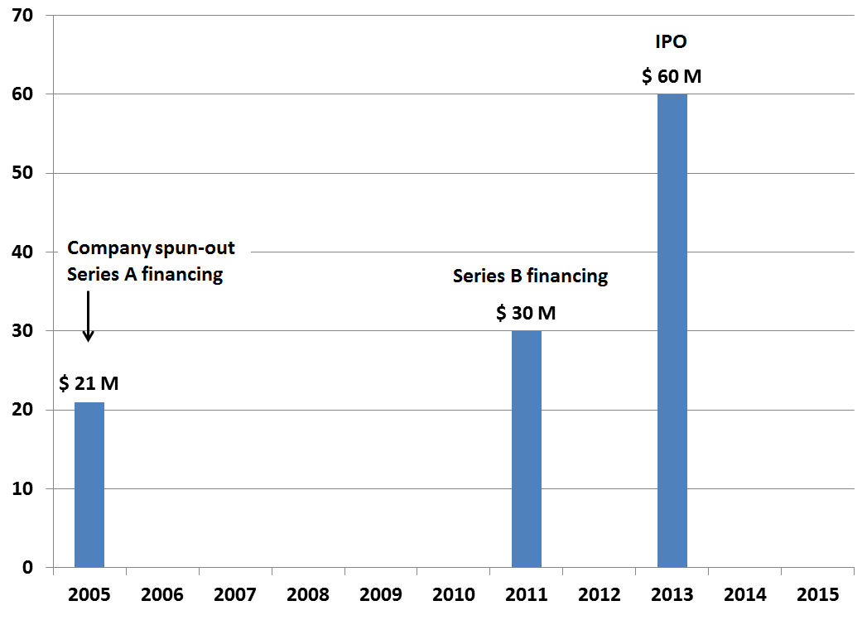

Survey of Companies Defined by Technologies

A survey of companies was made in which ophthalmic companies were defined by technology classifications where possible. The results are summarised below with a list of the companies following. Note that this analysis does not include multinational companies, as they cannot be defined by a single technology and cover many countries worldwide. Note that the classification “Europe” excludes Scotland to avoid double counting.

Number of Companies Classified by Technology and Country or Region

 | Worldwide | Scotland | Europe | North America | Far East
Biologic | 20 | 2 | 4 | 12 | 2
Cell therapy | 6 | 1 | 1 | 4 | 0
Devices | 20 | 4 | 4 | 12 | 0
Diagnostic | 13 | 8 | 1 | 1 | 3
Drug delivery | 11 | 6 | 0 | 5 | 0
Gene therapy | 11 | 0 | 3 | 8 | 0
Small molecule | 17 | 1 | 4 | 11 | 1

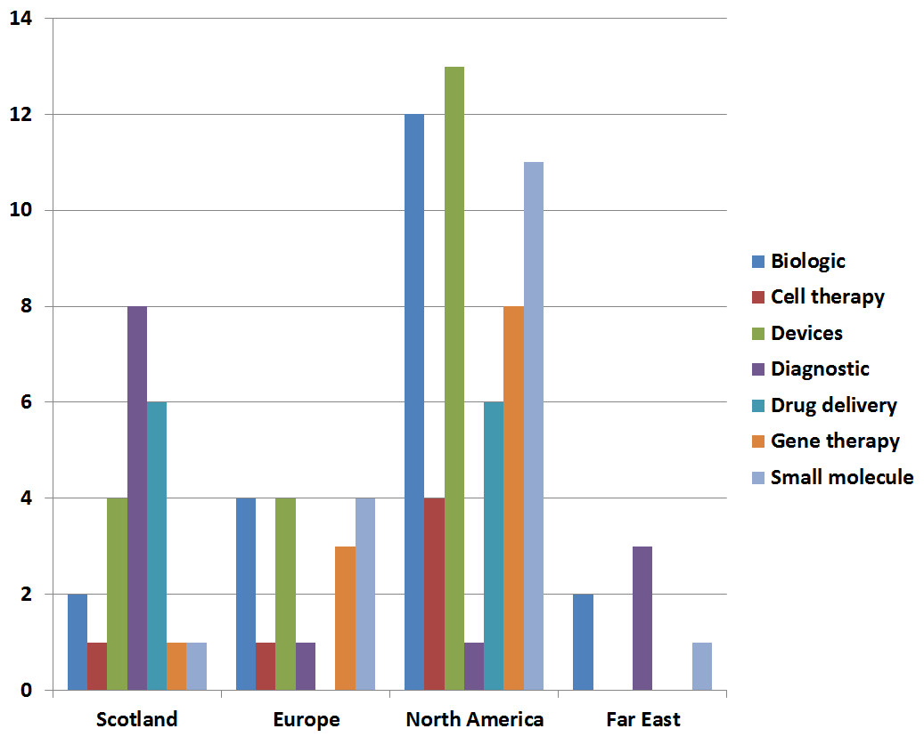

This tentative analysis suggests that Scotland is well represented across of range of technologies, with the exception of gene therapy and novel small molecules where US companies dominate. Certain parts of the human body have “immune privilege”, meaning they are able to tolerate the introduction of antigens without triggering an inflammatory immune response. The eye is one of these special locations, and this is being exploited by gene therapy companies. The single Scottish company identified as “small molecule” is Cyclacel which had a VEGFR2 inhibitor in development. However, it appears that this project has now discontinued. The single Scottish company identified under “cell therapy” is Roslin Cells, and they are the only company to be making retinal cells for implants.

Alliances Between Academia and Companies

Collabration between ophthalmic companies and academia is widespread and varies greatly in scale. From small license agreements between start-ups and Universities, to larger scale investments such as business parks and “incubator” research centres.

The larger companies, such as Bayer and GlaxoSmithKline, have a spectrum of models of interaction from R&D partnerships to open innovation incubators linked to their R&D units.

Examples of Bayer’s collaborations in ophthalmics:
- In 2014 Bayer entered into a broad, multi-indication alliance with Kyoto University in Japan. The collaboration runs for two years and covers cardiology, oncology, hematology, gynecology, and ophthalmology.
- In June 2015 Bayer entered into an agreement with the Wilmer Eye Institute at Johns Hopkins to jointly conduct research activities evaluating new targets and disease mechanisms, drug delivery technologies, and biomarkers for back-of-the-eye diseases with high unmet medical need.

Leading US Centres for Ophthalmology

In medical research it is common for laboratories to be associated with major hospitals. The US News and World Report 2015-2016 ranked the following as the leading ophthalmic hospitals in America³³.

- Bascom Palmer Eye Institute, Miami
- Wills Eye Hospital, Thomas Jefferson University, Philadelphia
- Wilmer Eye Institute, Johns Hopkins Hospital, Baltimore
- Massachusetts Eye and Ear Infirmary, Massachusetts General Hospital, Boston
- Stein and Doheny Eye Institutes, UCLA Medical Center, Los Angeles
- Cleveland Clinic, Cleveland
- University of Iowa Hospital and Clinic, Iowa City
- Duke University Medical Center, Durham
- USC Eye Institute – Keck Medical Center of USC, Los Angeles
- W.K. Kellogg Eye Center, University of Michigan, Ann Arbor
- New York Eye and Ear Infirmary, New York
- Emory University Hospital, Atlanta

Note that for Harvard Medical School, six researchers were winners of the 2014 António Champalimaud Vision Award, for development of anti-angiogenic therapy for retinal disease³⁴.

Although a few years old, The Ophthalmology Times ran a survey of research institutes and ranked them by reputation, as follows³⁵:

Best Research Programs
- Wilmer Eye Institute/Johns Hopkins University, Baltimore MD
- Bascom Palmer Eye Institute/University of Miami, Miami FL
- Massachusetts Eye & Ear Infirmary/Harvard University, Boston MA
- Jules Stein Institute/UCLA, Los Angeles CA
- Duke University Eye Center, Raleigh-Durham NC
- University of Iowa, Iowa City, IA
- Wills Eye Institute/Thomas Jefferson University, Philadelphia PA
- Doheny Eye Institute/USC, Los Angeles, CA
- Washington University, St. Louis MO
- Scheie Eye Institute/University of Pennsylvania, Philadelphia, PA

Alliances and Financing in Ophthalmology

The ophthalmology industry is very active in terms of strategic alliances. This year saw the acquisition of Allergan by Actavis, and various smaller, although significant deals such as Shire’s acquisition of Foresight Biotherapeutics Inc. for $300 million. The competition for acquiring smaller companies is demonstrated by companies such as InSite Vision, Inc. being at the centre of a bidding war between rival companies QLT Inc and an undisclosed “global pharmaceutical company”. Selected recent deals are summarised below.

17th March 2015 - Actavis Completes Allergan Acquisition

Actavis plc completed the acquisition of Allergan, Inc. in a cash and equity transaction valued at approximately US$ 70.5 billion. Actavis had to compete against rival Valeant Pharmaceuticals for the acquisition. The combination created one of the world's top 10 pharmaceutical companies by sales revenue, with combined annual pro forma revenues of more than $23 billion anticipated in 2015. Actavis subsequently changed its name to Allergan. This is an example of a deal which is entirely business-based, i.e. by combining companies in the ophthalmolgy market Allergan can achieve relative dominance in selected markets. Complimentary product portfolios can be merged, and any duplication of infrastture or staffing can be removed to make cost savings.

2nd July 2015 – Biogen deal with AGTC

Biogen was granted a license to the XLRS and XLRP programs and the option to license discovery programs for three additional indications at the time of clinical candidate selection. In return, Biogen agreed to make an upfront payment of US$ 124 million to AGTC, which included a US$ 30 million equity investment in AGTC . Under the collaboration, AGTC was eligible to receive upfront and milestone payments exceeding US$ 1 billion. This included up to US$ 472.5 million collectively for the two lead programs, with royalties in the high single digit to mid-teen percentages of annual net sales. In addition, Biogen will make payments up to US$ 592.5 million across the discovery programs, along with royalties in the mid-single digits to low teen percentages of annual net sales. This is a good example of a deal which is technology-based and could potentially be applied to areas outside of ophthalmology.

3rd August 2015 – Shire acquires Foresight Biotherapeutics

Shire acquired New York-based, privately held Foresight Biotherapeutics Inc. for $300 million. With the acquisition, Shire acquired the global rights to FST-100 (topical ophthalmic drops combining 0.6% povidone iodine (PVP-I) and 0.1% dexamethasone), a therapy in late-stage development for the treatment of infectious conjunctivitis (also known as “pink eye”). This acquisition strengthens Shire’s late-stage pipeline and fits with lifitegrast, which is in late-stage development for treatment of dry eye disease. This deal is typical a medium-sized pahrmacautical company where the driving force is to maintain cash-flow quickly from a product that is already close to market.

The point of highlighting these deals is to show that large deals are being signed regularly amongst companies with interests in ophthalmics.

Venture Capital

A survey by The Wall Street Journal³⁰ on venture capital deal values by disease area from 1999 to the first half of 2015 ranked the eye in 6th position after the immune system (see graphic below). However, this does not reflect recent trends very well.

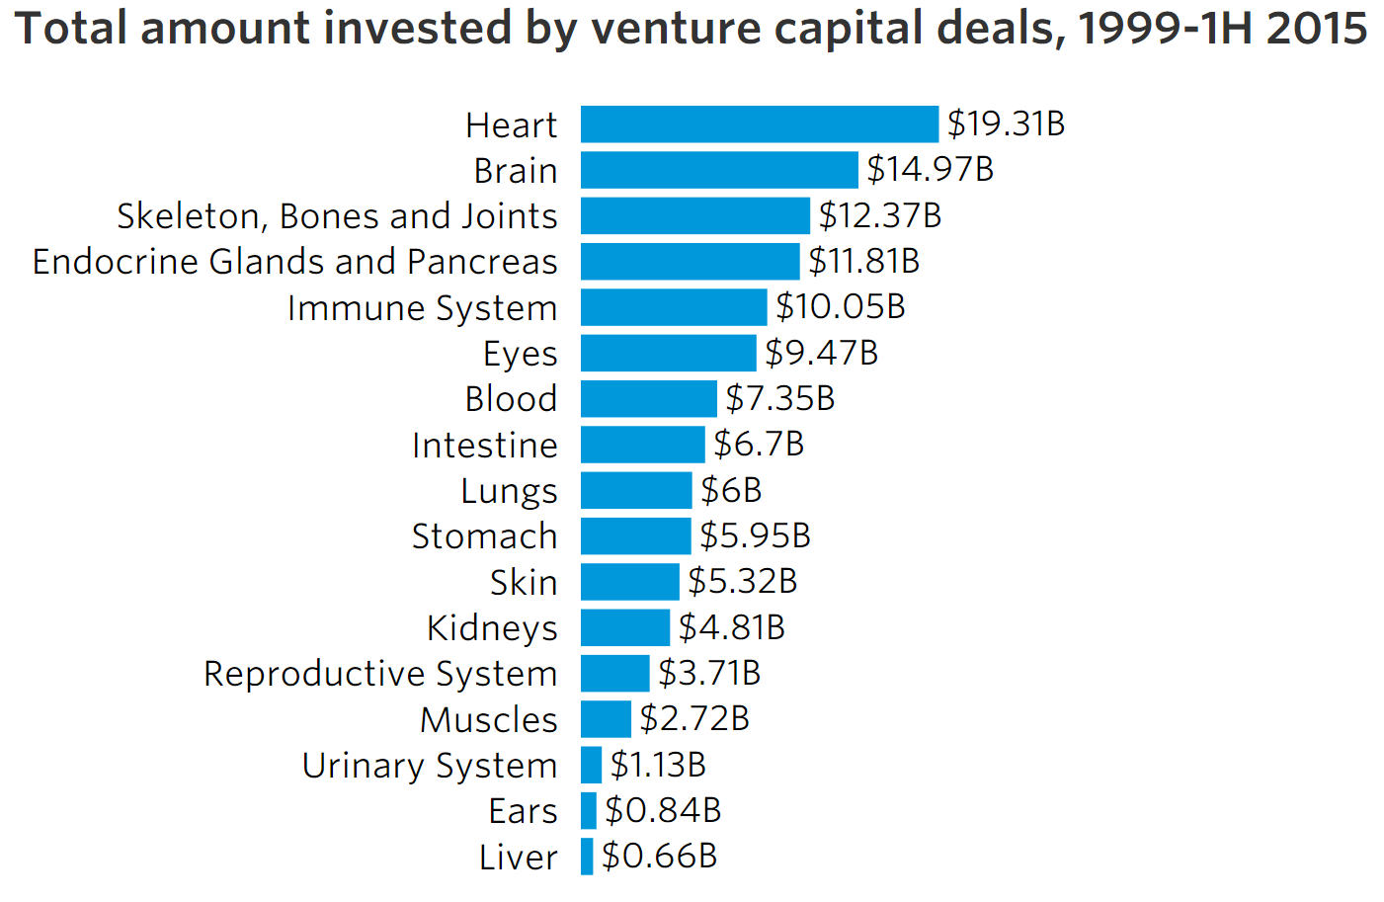

According to a separate analysis by The Wall Street Journal²⁷ (WSJ) new companies addressing eye problems drew US$ 848.9 million in 2013, making eyes the organ that was most attractive to venture capital. Venture funds invested US$ 442.7 million into vision disorders for the first half of 2014, continuing the trend. In a later analysis WSJ found that 2014 had been one of the strongest years ever for investment into ophthalmics, with $ 1.32 billion invested (see graphic below).

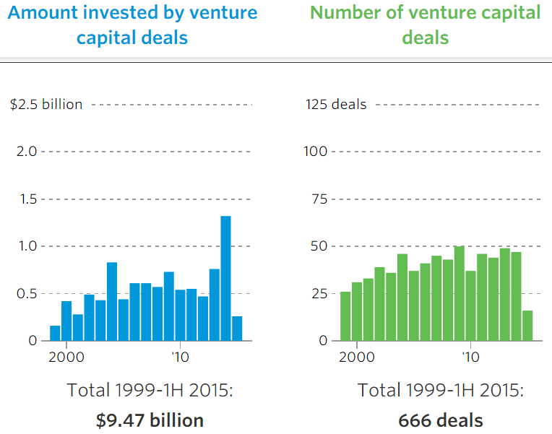

William J. Link, PhD, a founder and managing director of Versant Ventures (http://www.versantventures.com/) quoted from a 2014 article:

“This is the best environment we’ve ever experienced for ophthalmic innovation. To give you an idea, there have been 47 eyecare-related startups funded by venture capital since 1999. There were maybe two or three in the prior decade.” ²⁸

Ora Vision Ventures (http://oravisionventures.com/) is a healthcare venture capital firm focused in ophthalmology. According to Ora Vision :-

“Ophthalmology is one of the most attractive and fastest growing markets in healthcare today. ”

In a February 2015 report from trade association Biotechnology Industry Organization²⁹, venture funding levels were studied for different therapeutic areas. Oncology was the top funded disease area with $9 billion, accounting for 24% of all investment dollars in the last 10 years, followed by Neurology and Infectious Disease. The study period ran from 2004 to 2013, with ophthalmology shown in yellow in the following graphic.

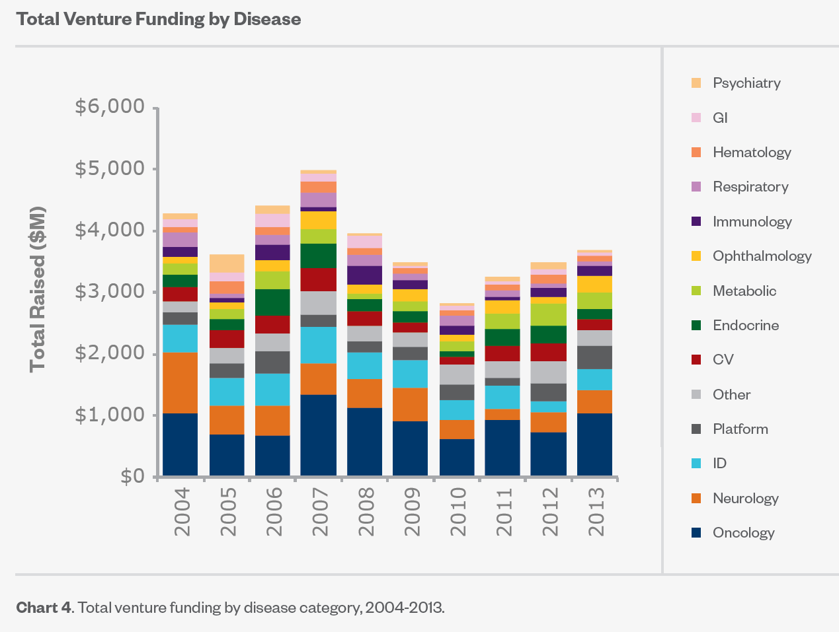

The researchers then analysed changes in funding over two, five year periods, to see which disease areas had increasing or decreasing investment. The results are quite startling and are shown in the graphic below. Ophthalmology is one of only two growth areas for funding.

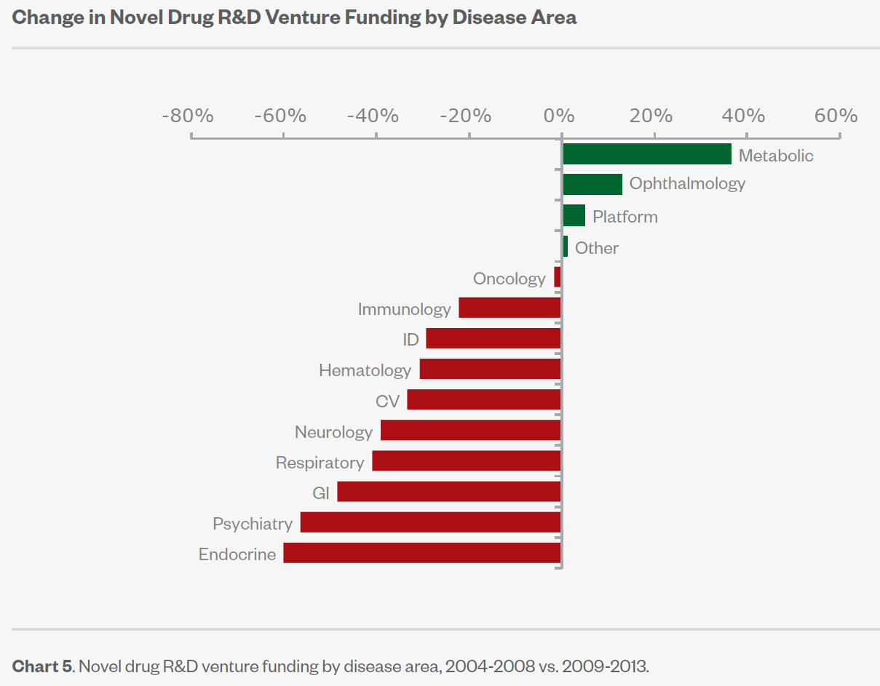
The analysis went further to look at the split of funding between "Novel Drug R&D" versus "Drug Improvement R&D", and also the development phases or different projects. Funding in novel drugs rose from $633 million (2004-2008) to $715 million (2009-2013) which is a gain of 13%. Funding in drug improvement over the same time periods reduced slightly from $175 million to $170 million.

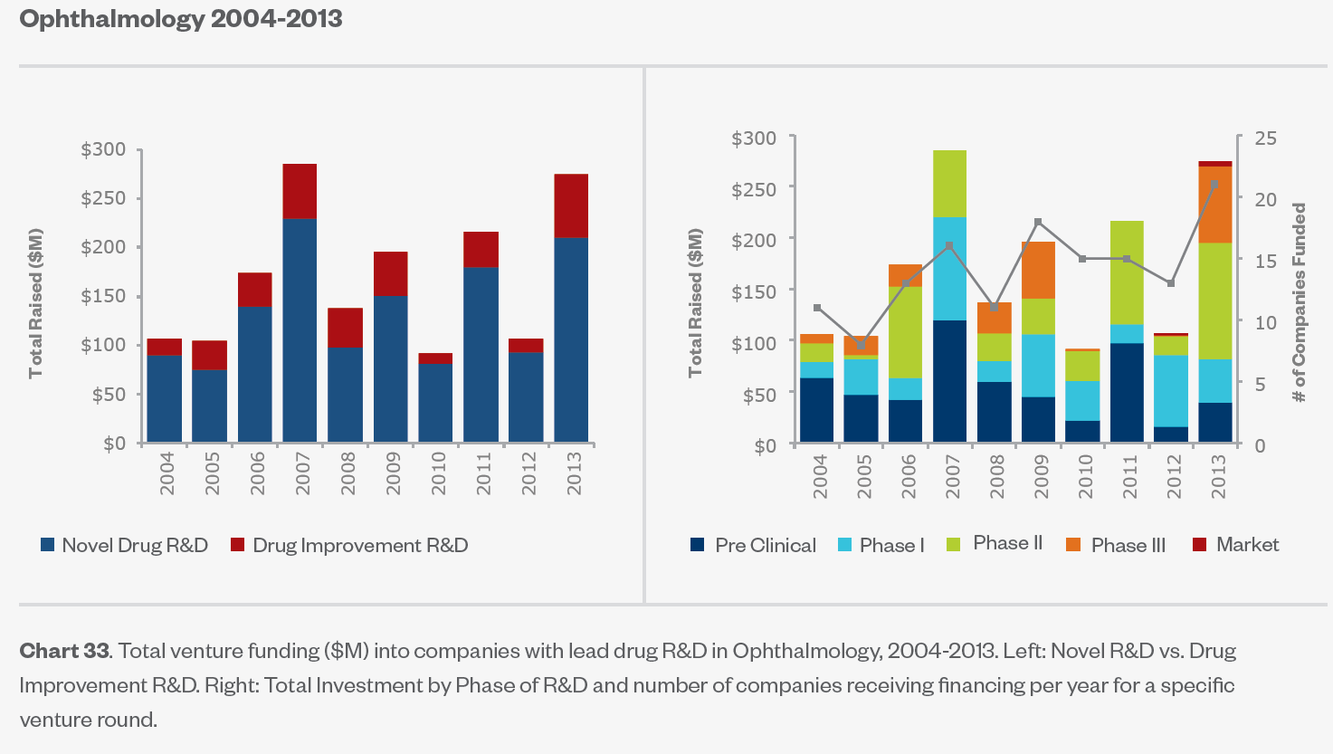

Data from Frost and Sullivan⁴⁰ suggests that the combination of technological capability and viability of funding is high for ophthalmic technologies.

Investment Prospects and Opportunity Evalution of Investors

Segments | Technology Capability | Funding Viability
Implantable ophthalmic devices | High | High
Laser surgey | High | High
Photoacoustic ophthalmoscopy | High | High
Retinal therapeutics | High | High
Intraocular lens | Medium | Medium
Ophthalmic OCT | High | High
Artificial retina implant | High | Medium

In conclusion, venture capital companies consider ophthalmology to be one of the best investments, as evidenced by the level of funding that is being provided to ophthalmic companies.

Conclusions

- The market broadly defined as “Ophthalmic” covers wide ranging industries and technologies, including: contact lenses, optical instrumentation and devices, gene therapy, biological and small chemical therapeutics, stem cells, drug delivery systems, diagnostics, surgical tools and consumables, “bionic” retinal implants, computer software for eye tests and rehabilitation, research services e.g. cell banking and CROs.
- The data identified suggests that all of the market sectors in Ophthalmic will have strong growth of market value driven by aging populations in developed countries and sales of new products, in particular, anti-VEGF therapeutics. In the longer term, gene therapeutics are expected to be a force for increasing market value.
- A survey of late stage products (Phase 3) suggests that biologics and drug delivery are the most common by technology type. A survey of companies suggests that Scotland has a particular strength in drug delivery technology.
- Ophthalmics is receiving significant investment, above that of other indications.

- Scotland has expertise in drug delivery, diagnostics and instrumentation, and this could be built on, but technology areas that are weak include gene therapy and small molecule drugs.

- Cell Therapy could be an exciting field for new research and development. Scotland is well positioned with Roslin Cells, as the only company to be making retinal cells for implants.

APPENDIX

Companies Sorted by Country, then Technology.

The colour coding below relates to technology type.

Biologic |  |  | Diagnostic |  |  | Small Molecule
Cell Therapy |  |  | Drug Delivery
Devices |  |  | Gene Therapy

Company | Country | Website | Technology | Key Ophthalmic Product(s)
ThromboGenics | Belgium | http://www.thrombogenics.com/ | Biologic: protease | JETREA® (ocriplasmin), marketed, symptomatic vitreomacular adhesion
Amakem | Belgium | http://www.amakem.com/ | Small molecule: Rho kinase (ROCK) inhibitor | AMA0076, Phase 1, glaucoma
iCo Therapeutics | Canada | http://www.icotherapeutics.com/ | Biologic: Monoclonal antibody | iCo-008 (bertilimumab), Phase 1, Vernal keratoconjunctivitis
QLT Inc. | Canada | http://www.qltinc.com/ | Biologic: retinal protein | QLT091001, Phase 2a, Impaired dark adaptation
Labtician Ophthalmics, Inc. | Canada | http://www.labtician.com/ | Device: retinal silicone implants | Marketed implants
Valeant Pharmaceuticals International, Inc. | Canada | http://www.valeant.com/ | Multinational, includes Bausch & Lomb | Various: contact lenses and lens care products, pharmaceuticals, intraocular lenses and surgical equipment.
ReNeuron Group plc | England | http://www.reneuron.com/ | Cell Therapy: Stem cells | Human retinal progenitor cells (hRPC), Phase 1, retinitis pigmentosa
SalutarisMD | England | http://salutarismd.co.uk/ | Device: Therapeutic radioisotope implant | SMD Sr90-1 Radionuclide Brachytherapy, 510(k) clearance from US FDA, wet AMD
NightstaRx Ltd | England | http://www.nightstarx.com/ | Gene Therapy: AAV-based | AAV2-REP1, Phase 2, Choroideremia
Kalvista Pharmaceuticals Ltd | England | http://www.kalvista.com/ | Small molecule: Serine protease inhibitors | KVD001, Phase 1, Diabetic macular edema
Altacor Limited | England | http://www.altacor-pharma.com/ | Various low tech. | Eight products marketed in the UK and Ireland
Iris Pharma | France | http://www.iris-pharma.com/ | Contract research organization | Ophthalmology research services
Pixium Vision | France | http://www.pixium-vision.com/en | Device: Retinal implant device | IRIS®, Clinical trials, retinitis
Gensight Biologics | France | http://www.gensight-biologics.com/ | Gene Therapy: AAV-based | GS010, Phase 3, Leber hereditary optic neuropathy
Essilor | France | http://www.essilor.com/ | Multinational | Various in more than 100 countries
Nicox | France | http://www.nicox.com/ | Small molecule: Nitric oxide-donating | Vesneo (latanoprostene bunod), NDA submitted, Glaucoma  AC-170 (cetrizine), NDA submitted, Allerghic conjunctivitis  AzaSite (azythromycin), EMEA approval sought, Bacterial conjunctivitis  Bromsite (bromfenac), EMEA approval sought, Pain/inflammation from cataract surgey
Neuroptis | France | http://www.neuroptis.com/ | Undisclosed | NOP3, Phase 1, dry-eye syndromes
Retina Implant AG | Germany | http://www.retina-implant.de/ | Device: Retinal implant device | Alpha IMS microchip, clinical development, retinitis pigmentosa
Carl Zeiss Meditec AG | Germany | http://www.zeiss.com/meditec/en_de/home.html | Diagnostic | Optical coherence tomography, and others
Bayer | Germany | http://www.bayer.com/ | Multinational | Various
Presbia | Ireland | http://presbia.com/ | Device: Lens implant | Presbia Flexivue Microlens™ marketed
Genable Technologies Limited | Ireland | http://www.genable.net/ | Gene Therapy: AAV-based | SPK-RPE65, Phase 3, Inherited retinal dystrophies
Allergan (formerly Actavis plc) | Ireland | http://www.actavis.com/ | Multinational | Various
Can-Fite BioPharma Ltd | Israel | http://www.canfite.com/ | Small molecule | CF101, Phase 2, Glaucoma
BioLight Israeli (XLVision Sciences Ltd) | Israel | http://www.bio-light.co.il/about-xlvision-sciences-ltd/ | Surgical | IOPtimate™ surgical system, Marketed, Glaucoma
SIFI SpA | Italy | http://www.sifigroup.com/ | Biologic: Polysaccharide | Various hygience and lubricants for eye, Marketed
Seikagaku | Japan | http://www.seikagaku.co.jp/ | Biologic: Polysaccharide | SI-614 Modified Hyaluronate, Phase 2/3, Dry eye
R-Tech Ueno | Japan | http://rtechueno.com/ | Biologic: Prostaglandin | Rescula® Eye Drops, Marketed, Glaucoma
Hoya Group | Japan | http://www.hoya.co.jp/english/ | Diagnostic and Surgical | Various
Nidek Corporation | Japan | http://www.nidek-intl.com/ | Diagnostic and Surgical | Optical coherence tomography, and others
Topcon Corporation | Japan | http://www.topcon.co.jp/en/ | Diagnostic and Surgical | Optical instruments
Santen Pharmaceutical Co., Ltd. | Japan | http://www.santen.com/ | Multinational | Various: Sells products in over 50 countries.
Senju Pharmaceutical | Japan | http://www.senju.co.jp/ | Small molecule: Rho kinase inhibitor | Y-39983, Phase 2, Glaucoma, Diabetic macular edema
Fixed Phage | Scotland | http://www.fixed-phage.com/ | Biologic: Bacteriophage | Anti-microbial e.g contact lenses
Hyaltech Limited | Scotland | http://www.hyaltech.co.uk | Biologic: Polysaccharide | Hyaluronic acid for intraocular surgery
Roslin Cells | Scotland | http://roslincells.com/ | Cell therapy | Retinal cells for implant
Wide Blue | Scotland | http://www.wide-blue.com/ | Consultancy: Device design | Photonics and optical design
Viopti Ltd | Scotland | http://www.viopti.com/ | Consumables: Contact lens solutions | Contactspod pre-filled, single-use contact lens case
Eyesupply UK | Scotland | http://www.eyesupply.co.uk/ | Consumables: Surgical | Consumables for refractive laser eye surgery
Daysoft Ltd | Scotland | http://www.daysoftcontactlenses.com/ | Contact lenses | "Daysoft" lenses
NiTech Solutions | Scotland | http://www.nitechsolutions.co.uk/ | Continuous processors, reactors and crystallisers | Not ophthal. but technology could be used for such
Chiltern | Scotland | http://www.chiltern.com/ | Contract research organization | Ophthalmic research expertise
PPD | Scotland | http://www.ppdi.com/ | Contract research organization | 60 trials in ophthalmic indications
Quanticate Ltd | Scotland | http://www.quanticate.com/ | Contract research organization | Ophthalmic research expertise
Ocutec | Scotland | http://www.ocutec.com/ | Device: Contact lenses | Contact lenses
Emblation Microwave Limited | Scotland | http://www.emblationmicrowave.com | Device: Microwave generators | Medical microwave ablation devices
Sight Science | Scotland | http://www.sightscience.com/ | Device: Rehabilitation | Computer system with visual stimuli
Sixth Sense Assistive Technology | Scotland | http://www.sixthsense-technology.com | Device: Video magnifiers | Computer video products
i2eye Diagnostics Limited | Scotland | http://i2eyediagnostics.com/ | Diagnostic: Eye tracking | Eye tracking and video monitoring for ophthalmic testing
Optos | Scotland | http://www.optos.com/ | Diagnostic: Imaging | Retinal Imaging technology
Keeler Limited | Scotland | http://www.keeler.co.uk/ | Diagnostic: Ophthalmoscopes | Various
Edinburgh Instruments | Scotland | http://www.edinst.com | Diagnostic: Spectrometers | Not ophthal. but technology could be used for such
Gilden Photonics | Scotland | http://www.gildenphotonics.com | Diagnostic: Spectrometers | Not ophthal. but technology could be used for such
Edinburgh Biosciences | Scotland | http://edinburghbiosciences.com/ | Diagnostic: Spectrometers - cataracts | New generation of spectrometers
BID Instruments Limited | Scotland | http://www.bidinstruments.com/ | Diagnostic: Visual field testing | "Ring of Sight" device
IbisVision Limited | Scotland | http://ibisvision.co.uk/ | Diagnostic: Visual field testing | "Ring of Sight" device
FMC Biopolymer UK Limited | Scotland | http://www.fmcbiopolymer.com/ | Drug delivery: Biopolymers | Not ophthal. but technology could be used for such
Antoxis | Scotland | http://www.antoxis.com/ | Drug delivery: Chemistry scaffold for small molecules | Not ophthal. but technology could be used for such
Ferring (Controlled Therapeutics) | Scotland | http://www.ferring.com/ | Drug delivery: Formulation | Not ophthal. but technology could be used for such
Lamellar Biomedical | Scotland | http://www.lamellar.com/ | Drug delivery: Lipid vesicles | LMS-611, Phase 2, Dry eye disease
Cyclogenix | Scotland | http://cyclogenix.net/ | Drug delivery: Plant cyclotide family of micro-proteins | Not ophthal. but technology could be used for such
Xstalbio | Scotland | http://www.xstalbio.com/ | Drug delivery: Protein formulation | Not ophthal. but technology could be used for such
BioReliance | Scotland | http://www.bioreliance.com/gb/ | Gene Therapy: Contract Manufacturing | GMP Manufacturing and testing
Carclo Technical Plastics | Scotland | http://carclo-technical-plastics.production.investis.com/ | Material Supply: Device plastics | Plastics
Rosti Technical Plastics UK Ltd | Scotland | http://www.rosti.com/ | Material Supply: Device plastics | Plastics
Cyclacel | Scotland | http://www.cyclacel.com/ | Small molecule: had VEGFR2 inhibitor (discontinued) | Not ophthal. but technology could be used for such
Unimed Pharma | Slovakia | http://www.unimedpharma.eu/ | Various low tech. | Various marketed
Molecular Partners AG | Switzerland | http://www.molecularpartners.com/ | Biologic: DARPins (Designed Ankyrin Repeat Proteins) anti-VEGF | Abicipar, Phase 3, wet AMD
AC Immune | Switzerland | http://www.acimmune.com/ | Biologic: Monoclonal antibody | ACI-260 (Abeta inhibitor), Preclinical, Glaucoma
Novartis | Switzerland | https://www.novartis.com/ | Multinational | Various includes Alcon Labs
Roche | Switzerland | http://www.roche.com/ | Multinational | Lucentis (ranibizumab), Marketed, AMD  Avastin (bevacizumab), Marketed, off-label anti-VEGF
Eleven Biotherapeutics. | USA | http://www.elevenbio.com/ | Biologic: interleukin-1 (IL-1) receptor antagonist | E81-005 topical, Phase 3, dry eye disease  E81-005 topical, Phase 2, allergic conjunctivitis
Akorn Pharmaceuticals | USA | http://www.akorn.com/ | Biologic: Antibiotic | Azithromycin, Marketed, Ophthalmic anti-bacterial
InSite Vision, Inc. | USA | http://www.insitevision.com/ | Biologic: Antibiotic solutions | Various, two marketed eye solutions
Regeneron Pharmaceuticals, Inc. | USA | http://www.regeneron.com/ | Biologic: Anti-VEGF fusion protein | EYLEA® (aflibercept) marketed for wet age-related macular degeneration, retinal vein occlusion, diabetic macular oedema
Iconic Therapeutics, Inc. | USA | http://iconictherapeutics.com/ | Biologic: Immune-conjugate fusion protein | ICON-1, Phase 2, wet AMD
Alexion Pharmaceuticals | USA | http://alxn.com/ | Biologic: Monoclonal antibody | Eculizumab, Advanced clinical, Relapsing Neuromyelitis Optica
Promedior, Inc. | USA | http://www.promedior.com/ | Biologic: Recombinant protein | PRM-167 (rhPTX-2), Preclinical, Age-Related Macular Degeneration (AMD) and Diabetic Retinopathy (DR)
Ohr Pharmaceutical | USA | http://www.ohrpharmaceutical.com/ | Biologic: squalamine | Squalamine, Phase 3, wet AMD
Ampio Pharmaceuticals | USA | http://ampiopharma.com/ | Biologic: Synthetic hormone derivative | Optina (danazol), Phase 3, Diabetic macular edema
Aura Biosciences | USA | http://www.aurabiosciences.com/ | Biologic: Viral-like nanoparticles | AU-011 Viral-like Nanoparticles (VLP) , Preclinical, ocular melanoma
Neurotech Pharmaceuticals, Inc. | USA | http://www.neurotechusa.com/ | Cell therapy: Genetically engineered ocular implant | NT-503 anti-VEGF, Phase 2, wet AMD  NT-501, Phase 2, macular telangectasia
Ocata Therapeutics, Inc. | USA | https://www.ocata.com/ | Cell therapy: Retinal pigmented epithelial (RPE) cells | RPE Cell Therapy, Phase 2, Stargardt's Disease  RPE Cell Therapy, Phase 2, Dry Age-related Macular Degeneration
BioTime, Inc. | USA | http://www.biotimeinc.com/ | Cell therapy: stem cell-derived retinal pigment epithelial cells | OpRegen®, Phase I/Iia, dry AMD
StemCells | USA | http://www.stemcellsinc.com/ | Cell Therapy: Stem cells | HuCNS-SC® platform, Phase 2, Dry Age-Related Macular Degeneration (AMD)
The Cooper Companies Inc. | USA | http://www.coopercos.com/ | Device: contact lens | Various worldwide
Aquesys, Inc. (Allergan) | USA | http://www.aquesys.com/ | Device: Implant micro-stent | Gelatin stent, EU approved, open angle glaucoma
Glaukos Corporation | USA | http://www.glaukos.com/ | Device: Implant micro-stent | iStent, Marketed, Glaucoma
Ivantis | USA | http://www.ivantisinc.com/index.php | Device: Implant micro-stent | Hydrus™ Microstent, Phase 3, glaucoma
Avedro, Inc | USA | http://avedro.com/ | Device: Laser surgery | KXL II™ System, Marketed, laser surgey of cornea
Volk Optical, Inc. | USA | http://www.volk.com/ | Device: lens manufacture | Various marketed
Katena Products, Inc. | USA | http://www.katena.com/ | Device: Ophthalmic surgical instrumentation | Various
Synergetics USA Inc. | USA | http://www.synergeticsusa.com/ | Device: Ophthalmic surgical instrumentation | Vitrectomy and laser products marketed
Second Sight | USA | http://www.secondsight.com/ | Device: Retinal implant device | Argus® II, Marketed USA and Canada, retinitis pigmentosa
Abbott | USA | http://www.abbott.com/ | Device: surgical | Various worldwide
Transcend Medical, Inc. | USA | http://transcendmedical.com/ | Device: surgical | CyPass Micro-Stent, Investigational Device, glaucoma
IRIDEX Corporation | USA | http://www.iridex.com/ | Devices: Lasers | Marketed laser devices
Optovue | USA | http://www.optovue.com/ | Diagnostic: Imaging | Various
pSivida | USA | http://www.psivida.com/ | Drug delivery: Bioerodible implant | Retisert, marketed, uveitis  Iluvien, marketed, DME
Ocular Therapeutix | USA | http://www.ocutx.com/ | Drug delivery: Hydrogel | DEXTENZA™ dexamethasone, Phase 3, post-operative inflammation and pain of the eye
Jade Therapeutics, Inc. | USA | http://www.jadetherapeutics.com/ | Drug delivery: Hydrogel polymers | Thioloated HA topical gel, Phase 1, Dry eye lubricant
Mati Therapeutics, Inc. | USA | http://www.matitherapeutics.com/ | Drug delivery: implant | Latanoprost Phase 1, glaucoma
EyeGate Pharma | USA | http://www.eyegatepharma.com/ | Drug delivery: Iontophoresis | EGP-437, Phase 3, Non-infectious anterior uveitis
Icon Bioscience | USA | http://iconbioscience.com/ | Drug delivery: Verisome technology | IBI-10090, Phase 3, inflammation associated with cataract surgery
AGTC (Applied Genetic Technologies Corp.) | USA | http://www.agtc.com/ | Gene Therapy: AAV-based | rAAV2tYF-CB-hRS1, Phase 1/2, X-linked juvenile retinoschisis (XLRS)
Biogen | USA | https://www.biogen.com/ | Gene Therapy: AAV-based | rAAV2tYF-CB-hRS1, Phase 1/2, X-linked juvenile retinoschisis (XLRS)
REGENXBIO Inc. | USA | http://www.regenxbio.com/ | Gene Therapy: AAV-based | RGX-314, Preclinical, wet AMD
Spark Therapeutics, Inc. | USA | http://www.sparktx.com/ | Gene Therapy: AAV-based | SPK-RPE65, Phase 3, Inherited retinal dystrophies
Avalanche Biotechnologies Inc. | USA | http://www.avalanchebiotech.com/ | Gene Therapy: Anti-VEGF, sFLT-1 gene in AAV2 vector | AVA-101, Phase 2a, Wet AMD
RetroSense Therapeutics | USA | http://www.retro-sense.com/ | Gene Therapy: Channelrhodopsin-2 | RST-001, Preclinical, Retinitis pigmentosa
Quark Pharmaceuticals, Inc. | USA | http://www.quarkpharma.com/ | Gene Therapy: Synthetic siRNA | PF-655, Phase 2, Diabetic macular edema and wet age-related macular degeneration
Sirnaomics | USA | http://www.sirnaomics.com/ | Gene Therapy: Synthetic siRNA | STP601 (Acurita®) siRNA, Phase 1, AMD and Proliferative Diabetic Retinopathy (PDR)
Johnson & Johnson | USA | http://www.jnj.com/ | Multinational | Various
Merck | USA | http://www.merck.com/ | Multinational | Various
Pfizer | USA | http://www.pfizer.com/ | Multinational | Xalatan® (latanoprost ophthalmic solution), Xalacom® (latanoprost and timolol), and Macugen® (pegaptanib injection)
Aerie Pharmaceuticals | USA | http://www.aeriepharma.com/ | Small molecule | Rhopressa, Phase 3, glaucoma
Alkeus Pharmaceuticals, Inc. | USA | http://www.alkeuspharma.com/ | Small molecule | ALK-001, Preclinical, Stargardt disease and dry AMD
Ophthotech Corp. | USA | http://www.ophthotech.com/ | Small molecule | Fovista® (anti-PDGF), Phase 3, wet AMD
Inotek Pharmaceuticals | USA | http://www.inotekpharma.com/ | Small molecule: Adenosine mimetic | Trabodenoson, Phase 2, Glaucoma
Acorn Biomedical | USA | http://www.acornbio.com/ | Small molecule: Adenosine A3 receptor antagonists | ACN-1052, Preclinical, glaucoma
Alimera Sciences | USA | http://www.alimerasciences.com/ | Small molecule: Corticosteroid | ILUVIEN® (fluocinolone acetonide), Marketed, Diabetic Macular Edema (DME)
Shire | USA | https://www.shire.com/ | Small molecule: Integrin inhibitor | Lifitegrast, Registration, Dry eye disease
Acadia Pharmaceuticals | USA | http://www.acadia-pharm.com/ | Small molecule: Muscarinic | Muscarinic, Phase 1, glaucoma
Bionure | USA | http://www.bionure.es/ | Small molecule: SGK agonists | BN201, Preclinical, optic neuritis and neuromyelitis optica
Aerpio Therapeutics | USA | http://www.aerpio.com/ | Small molecule: Tie-2 activating agent | AKB-9778, Phase 2a, Diabetic macular edema
Acucela | USA | http://acucela.com/ | Small molecule: Visual Cycle Modulation compounds | VCM-Emixustat HCI, Phase 3, Age-Related Macular Degeneration (AMD)

Survey of Alliances and Financing in 2015 (reverse date order, most recent at top)

Deal Date | Deal Type | Headline | Summary | Industry | Company
Sep. 4, 2015 | Stock listing | Dual listing of shares | Common shares currently listed on NYSE MKT will also be listed on the Tel Aviv Stock Exchange (TASE) beginning September 8, 2015 under ticker symbol BTX | Biotechnology/Gene Therapy, Cell Therapy | BioTime, Inc.
 |  |  |  | Pharmaceuticals
Sep. 3, 2015 | Acquisition | Allergan to acquire glaucoma treatment company Aquesys to add minimally invasive implantable shunt to eye care portfolio | Allergan will acquire AqueSys for a $300 million upfront payment and regulatory approval and commercialization milestone payments related to AqueSys’ lead development programs, including XEN45. | Biotechnology/Gene Therapy, Cell Therapy | AqueSys, Inc.
 |  |  |  | Pharmaceuticals | Allergan plc.
Sep. 1, 2015 | Acquisition | Valeant pays $166mm plus earn-outs forSynergetics USA | Valeant Pharmaceuticals International Inc.is buying public device firm Synergetics USA Inc. for $6.50 per share (a 50% premium) in cash, or $166.2mm, plus potential earn-outs. | Medical Devices/Consumables, Central Supplies | Synergetics USA Inc.
 | Full Acquisition |  |  | Medical Devices/Infusion Therapy Equipment and Supplies | Valeant Pharmaceuticals International Inc.
 | Includes Earnout |  |  | Medical Devices/Laser
 | Payment Includes Cash |  |  | Medical Devices/Radiofrequency Devices
 |  |  |  | 1 more...
Aug. 1, 2015 | Financing | Ocata gets $6mm in first tranche of $10mm debt financing from SVB | Ocata Therapeutics Inc. (cell therapeutics for ophthalmic conditions) received a secured term loan of $6mm from Silicon Valley Bank. | Biotechnology/Gene Therapy, Cell Therapy | Ocata Therapeutics Inc.
 | Nonconvertible Debt |  |  | Pharmaceuticals
 | Private Placement
Aug. 1, 2015 | Acquisition | Shire buys conjunctivitis drug developer Foresight for $300mm | Shire PLC paid $300mm in cash to acquire the private ophthalmic drug developer Foresight Biotherapeutics Inc. | Biotechnology | Foresight Biotherapeutics Inc.
 | Acquisition of Private Biotech |  |  | Pharmaceuticals/Drug Delivery/Topical Delivery | Shire PLC
 | Full Acquisition
 | Payment Includes Cash
Aug. 1, 2015 | Financing | Gene therapy firm REGENXBIO tries to go public | Gene therapy company REGENXBIO Inc. filed for its initial public offering. | Biotechnology/Gene Therapy, Cell Therapy | REGENXBIO Inc.
 | IPO |  |  | Biotechnology/Large Molecule
 |  |  |  | Pharmaceuticals/Drug Delivery/Macromolecule
Aug. 1, 2015 | Alliance | Aerie, GrayBug sign one-year ophthalmic research collaboration | Aerie Pharmaceuticals Inc. signed a one-year research collaboration with GrayBug Inc. During the deal term (which may be extended), Aerie will apply GrayBug's microparticle controlled-release drug. | Biotechnology | Aerie Pharmaceuticals Inc.
 | Intra-Biotech Deal |  |  | Pharmaceuticals/Drug Delivery/Controlled Release | GrayBug Inc.
 | R+D and Marketing-Licensing
Aug. 1, 2015 | Financing | FOPO nets $74.4mm for Inotek | Six months after completing its $37.2mm IPO, Inotek Pharmaceuticals Corp. (optic nerve damage and degenerative eye diseases) raised funds again, netting $74.4mm in a follow-on public offering. | Biotechnology | Inotek Pharmaceuticals Corp.
 | FOPO |  |  | Pharmaceuticals
Aug. 1, 2015 | Alliance | SIFI to sell Alimera's Iluvienin Italy and nearby territories | For the next five years, Societa Industria Farmaceutica Italiana SPA (SIFI) has exclusive rights to Alimera Sciences Inc.'s intravitreal implant Iluvien (fluocinolone) in Italy, San Marino. | Biotechnology | Alimera Sciences Inc.
 | Marketing-Licensing |  |  | Medical Devices/Implantable Devices | Societa Industria Farmaceutica Italiana SPA
 |  |  |  | Pharmaceuticals/Drug Delivery/Controlled Release
Aug. 1, 2015 | Acquisition | Bristol gets option to acquire Promedior for up to $1.25bn | Bristol-Myers Squibb Co. received the exclusive right to buy Promedior Inc., a private rare fibrotic disease drug developer. BMS pays $150mm up front. | Biotechnology/Large Molecule | Bristol-Myers Squibb Co.
 | Acquisition of Private Biotech |  |  | Pharmaceuticals | Promedior Inc.
 | Full Acquisition
 | Includes Earnout
 | 1 more...
Jul. 1, 2015 | Alliance | Akorn licenses AzaSite to Knight Therapeutics in Canada | Knight Therapeutics Inc. received exclusive Canadian rights to market Akorn Inc.'s AzaSite (azithromycin ophthalmic solution 1%). | Biotechnology | Akorn Inc.
 | Marketing-Licensing |  |  | Pharmaceuticals/Drug Delivery/Controlled Release | Knight Therapeutics Inc.
 |  |  |  | Pharmaceuticals/Drug Delivery/Topical Delivery
 |  |  |  | Pharmaceuticals/Specialty Pharmaceuticals
Jul. 1, 2015 | Financing | ReNeuron raises £68.4mm in PIPE | Neural and human retinal progenitor stem cell therapy company ReNeuron PLC raised £68.4mm ($109mm) by selling 1.4bn new ordinary shares at £0.05 (market average) to first-time and returning investors. | Biotechnology/Gene Therapy, Cell Therapy | ReNeuron Group PLC
 | Private Investment in Public Biotech |  |  | Biotechnology/Nanotechnology, Chips, etc.
 | Private Placement |  |  | Pharmaceuticals
Jul. 1, 2015 | Financing | GenSight Biologics files for initial public offering | French biotech GenSight Biologics SA (ophthalmic orphan disorders) filed for an initial public offering of its ADSs in the US. | Biotechnology/Gene Therapy, Cell Therapy | GenSight Biologics SA
 | IPO |  |  | Biotechnology/Large Molecule
 |  |  |  | Medical Devices
 |  |  |  | Pharmaceuticals/Drug Delivery/Macromolecule
Jul. 1, 2015 | Financing | Series B round brings KalVista $33mm | Novo AS and SV Life Sciences returned to invest in a $33mm Series B round forKalVista Pharmaceuticals Ltd., which is developing oral and intravitreal plasma kallikrein inhibitors. | Biotechnology | KalVista Pharmaceuticals Ltd.
 | Private Placement |  |  | Pharmaceuticals
Jul. 1, 2015 | Financing | GenSight Biologics raises $36mm in Series B round | According to CFO Thomas Gidoin, GenSight Biologics SA(restoring vision via gene therapeutics and optogenetics) raised $36mm in a Series B round from 15 investors, including first-time buyers Fideli... | Biotechnology/Gene Therapy, Cell Therapy | GenSight Biologics SA
 | Private Placement |  |  | Biotechnology/Large Molecule
 |  |  |  | Medical Devices
 |  |  |  | Pharmaceuticals/Drug Delivery/Macromolecule
Jul. 1, 2015 | Acquisition | Allergan pays $125mm up front for ophthalmic device start-up Oculeve | Allergan PLC paid $125mm in cash up front for privately held ophthalmic device start-up Oculeve Inc., which could also receive commercialization milestones tied to its lead candidate. | Medical Devices/Implantable Devices | Allergan PLC
 | Full Acquisition |  |  |  | Oculeve Inc.
 | Includes Earnout
 | Payment Includes Cash
Jul. 1, 2015 | Alliance | Alimera partners Iluvien with Knight in Canada | Alimera Sciences Inc. licensed Knight Therapeutics Inc. exclusive Canadian rights to the ophthalmic product Iluvien (fluocinolone). | Biotechnology | Alimera Sciences Inc.
 | Intra-Biotech Deal |  |  | Medical Devices/Implantable Devices | Knight Therapeutics Inc.
 | R+D and Marketing-Licensing |  |  | Pharmaceuticals/Drug Delivery/Controlled Release
Jun. 1, 2015 | Financing | Ocata Therapeutics nets $28.4mm in FOPO | Ocata Therapeutics Inc. (terminally differentiated cell therapies for degenerative eye diseases) netted $28.4mm in a follow-on public offering of 5.5mm shares for $5.50. | Biotechnology/Gene Therapy, Cell Therapy | Ocata Therapeutics Inc.
 | FOPO |  |  | Pharmaceuticals
Jun. 1, 2015 | Acquisition | Katena Products bought out by Audax Group | Asset management firm Audax Group acquired Katena Products, a private distributor of ophthalmic instruments, from private equity company Cortec Group. | Biotechnology | Katena Products
 | Acquisition of Private Biotech |  |  | Medical Devices/Biomaterials
 | Buy-out |  |  | Medical Devices/Surgical Equipment & Devices/Minimally or Less Invasive
 | Full Acquisition
Jun. 1, 2015 | Alliance | Bayer, Wilmer Eye Institute sign five-year deal | Through a collaboration with Johns Hopkins University's Wilmer Eye Institute, Bayer HealthCare Pharmaceuticals AG received an option to license exclusive rights to drug candidates they discover. | Pharmaceuticals/Drug Delivery | Bayer AG
 | R+D and Marketing-Licensing |  |  |  | Bayer Corp.
 |  |  |  |  | Bayer HealthCare LLC
 |  |  |  |  | Bayer HealthCare Pharmaceuticals AG
 |  |  |  |  | 2 more...
Jun. 1, 2015 | Financing | QLT raises $25mm in convertible debt financing | QLT Inc. (developing the Phase II synthetic retinoid QLT091001 for impaired dark adaptation, Leber's congenital amaurosis, and retinitis pigmentosa) raised $25mm by issuing 21-month redeemable convertible debt. | Biotechnology | QLT Inc.
 | Convertible Debt |  |  | Pharmaceuticals/Specialty Pharmaceuticals
 | Private Placement
Jun. 1, 2015 | Acquisition | Investment firm XIO takes Lumenis private in $505mm deal | Just about a year-and-a-half after completing a US IPO, publicly traded Israeli company Lumenis Ltd. (surgical, aesthetic, and ophthalmological devices) was acquired by investment firm XIO Group. | Medical Devices/Laser | Lumenis Ltd.
 | Buy-out |  |  | Medical Devices/Radiofrequency Devices
 | Full Acquisition |  |  | Medical Devices/Surgical Equipment & Devices/Minimally or Less Invasive
 | Includes Contract
 | 1 more...
Jun. 1, 2015 | Financing | Glaucoma device company Glaukos nets $116mm in IPO | Glaukos Corp. (glaucoma devices) netted $116mm in its IPO of 6.9mm shares (including the overallotment) at $18, upsized from the initial terms it set of 5.4mm shares at $13-15. | Medical Devices/Implantable Devices | Glaukos Corp.
 | IPO |  |  | Medical Devices/Surgical Equipment & Devices/Minimally or Less Invasive
 |  |  |  | Pharmaceuticals/Drug Delivery/Controlled Release
May 1, 2015 | Acquisition | OphthaliX may buy Improved Vision Systems; finalized at about $5.4mm in stock | OphthaliX Inc. (an 82% owned subsidiary of Can-Fite BioPharma Ltd.) signed a nonbinding term sheet to acquire privately held Improved Vision Systems Ltd.(IVS; eye tracking devices). | Medical Devices/Monitoring Equipment & Devices | Can-Fite BioPharma Ltd.
 | Full Acquisition |  |  |  | Improved Vision Systems Ltd.
 | Includes Contract |  |  |  | OphthaliX Inc.
 | Includes Earnout
 | 1 more...
Apr. 1, 2015 | Alliance | Caltech, IROC license corneal cross-linking patents to Avedro | California Institute of Technology and IROC Innocross AG each licensed Avedro Inc. their corneal cross-linking-focused patents. | Medical Devices/Surgical Equipment & Devices/Minimally or Less Invasive | Avedro Inc.
 | R+D and Marketing-Licensing |  |  |  | California Institute of Technology
Apr. 1, 2015 | Alliance | Clearside acquires ophthalmic delivery patents from iScience | Clearside Biomedical Inc. acquired iScience Interventional Corp.'s portfolio of US and international issued patents and patent applications protecting drug delivery systems. | Biotechnology | Clearside Biomedical Inc.
 | Product Purchase |  |  | Medical Devices/Surgical Equipment & Devices/Minimally or Less Invasive | iScience Interventional Corp.
 |  |  |  | Pharmaceuticals/Drug Delivery/Site Specific
Mar. 1, 2015 | Financing | Ocular drug delivery company GrayBug completes $1.74mm Series A2 round | Returning backer Maryland Venture Fund and new investor Hatteras Venture Partners led a $1.74mm Series A2 round for GrayBug Inc. (controlled-release ophthalmic drug delivery). | Biotechnology/Nanotechnology, Chips, etc. | GrayBug Inc.
 | Private Placement |  |  | Pharmaceuticals/Drug Delivery/Controlled Release
 |  |  |  | Pharmaceuticals/Drug Delivery/Site Specific
Feb. 1, 2015 | Financing | FOPO nets Ohr Pharmaceutical $27mm | Ohr Pharmaceutical Inc., which is developing candidates for ophthalmic diseases (and breast cancer, through a JV with Cold Spring Harbor Laboratory), netted $277mm by publicly selling 4.3mm shares. | Biotechnology | Ohr Pharmaceutical Inc.
 | FOPO |  |  | Pharmaceuticals
Feb. 1, 2015 | Financing | Concurrent with IPO, Inotek publicly offers $18.6mm in notes | Simultaneous with completing its $37.2mm IPO,Inotek Pharmaceuticals Corp. (glaucoma, ocular hypertension, and optic neuropathies) publicly sold five-year 5.0% convertible notes to net $18.6mm. | Biotechnology | Inotek Pharmaceuticals Corp.
 | Convertible Debt |  |  | Pharmaceuticals
 | FOPO
Feb. 1, 2015 | Financing | Inotek Pharmaceuticals nets $37.2mm in IPO | Ophthalmic-focused Inotek Pharmaceuticals Corp. netted $37.2mm in its initial public offering of 6.7mm shares at $6. (Existing stockholders may buy $18mm of the stock.) | Biotechnology | Inotek Pharmaceuticals Corp.
 | IPO |  |  | Pharmaceuticals
Feb. 1, 2015 | Acquisition | Nikon buys digital imaging company Optos for £259.3mm | Nikon Corp. acquired publicly traded Optos PLC(ophthalmic digital imaging) for £259.3mm ($402mm), or £3.40 per share, a 32% premium. | Medical Devices/Diagnostic Imaging Equipment & Supplies/Digital Imaging | Nikon Corp.
 | Full Acquisition |  |  | Medical Devices/Diagnostic Imaging Equipment & Supplies/Ultrasound | Optos PLC
 | Payment Includes Cash |  |  | Medical Devices/Surgical Equipment & Devices
Feb. 1, 2015 | Financing | After postponing and revising, EyeGate Pharmaceuticals nets $3.8mm in OTCQB IPO | EyeGate Pharmaceuticals Inc. (ophthalmic therapeutics and delivery devices) netted $3.8mm in its initial public offering on the OTCQB of 683k shares at $6. The company first filed on Nasdaq in July ... | Biotechnology | EyeGate Pharmaceuticals Inc.
 | IPO |  |  | Medical Devices
 |  |  |  | Pharmaceuticals/Drug Delivery/Site Specific
Feb. 1, 2015 | Alliance | Pfenex partners Lucentis biosimilar with Hospira | On the heels of its $17bn acquisition by Pfizer Inc.,Hospira Inc. licensed exclusive global rights to develop, manufacture, and sell Pfenex Inc.'s Phase Ib/IIa PF582, a biosimilar. | Biotechnology/Large Molecule/Antibodies | Hospira Inc.
 | Includes Royalty or Profit Split Information |  |  | Biotechnology/Synthesis Technologies, Production Processes | Pfenex Inc.
 | R+D and Marketing-Licensing |  |  | Pharmaceuticals/Generic Drugs
Jan. 1, 2015 | Alliance | Hanmi takes $20mm stake in Allegro and rights to Luminate | Allegro Ophthalmics LLC licensed Hanmi Pharmaceutical Co. Ltd. rights to its ophthalmic oligopeptide candidate Luminate (ALG1001) in the Republic of Korea and People's Republic of China. | Biotechnology/Large Molecule | Allegro Ophthalmics LLC
 | Includes Equity |  |  | Pharmaceuticals | Hanmi Pharmaceutical Co. Ltd.
 | Intra-Biotech Deal
 | R+D and Marketing-Licensing
Jan. 1, 2015 | Financing | Spark Therapeuticsnets $172mm in initial public offering | Gene therapy company Spark Therapeutics LLC netted $172mm in its initial public offering of 8.1mm shares (including the overallotment) for $23. Both the number of shares and price were upsized from ... | Biotechnology/Gene Therapy, Cell Therapy | Spark Therapeutics Inc.
 | IPO |  |  | Biotechnology/Large Molecule
 |  |  |  | Pharmaceuticals/Drug Delivery/Macromolecule
 |  |  |  | Pharmaceuticals/Drug Delivery/Site Specific

Abbreviations

AAV Adeno-associated virus
AGTC Applied Genetic Technologies Corp.
AMD Age-related macular degeneration
CAGR Compound annual growth rate
CRO Clinical research organisation
DARPins Designed ankyrin repeat proteins
DED Dry eye disease
EMA European Medicines Agency
FOPO Follow-on public offering
IPO Initial public offering
JV Joint venture
MIGS Micro-invasive glaucoma surgery, also used for minimally invasive glaucoma surgery
OCT Optical coherence tomography
PDGF Platelet derived growth factor
VEGF Vascular endothelial growth factor
wAMD Wet age-related macular degeneration
XLRS X-linked juvenile retinoschisis

References

- Press release from Transparency Market Research on PRNewswire. April 4, 2014.
http://www.prnewswire.com/news-releases/ophthalmology-diagnostics-and-surgical-devices-market-expected-to-reach-usd-4038-billion-globally-in-2019-transparency-market-research-253882951.html

- Healthios. Published on Sep 24, 2013.
http://www.slideshare.net/IBFConferences/ophthalmology-capital-markets
- Ishan Shukla, Portfolio and Project Management at SUN Pharmaceutical Industries Limited. Published on Oct 07, 2012
http://www.slideshare.net/ishanshukla21/opthalmology-market-an-oppertunity-and-overview-1?related=1
- 6th Global Ophthalmologists Annual Meeting. Published 27 August 2015.
http://annualmeeting.conferenceseries.com/ophthalmologists/
- Transparency Market Research. 4 February 2014
http://optometrytimes.modernmedicine.com/optometrytimes/content/tags/eye-and-vision-disorders/ophthalmic-drug-market-expected-reach-216-billi?page=full
- Aerie Pharmaceuticals. Retrieved 28/08/2015.
http://www.aeriepharma.com/aerieabout.html
- Physician Focus: Common eye disorders. Dr. John T. H. Mandeville and Dr. Gerri L. Goodman. 25 Aug. 2015.
http://www.metrowestdailynews.com/article/20150825/NEWS/150829985/11703/LIFESTYLE
- EpiCast Report: Age-Related Macular Degeneration – Epidemiology to increase 18.5% over the forecast period 2023. 27 August 2015.
http://www.medgadget.com/2015/08/epicast-report-age-related-macular-degeneration-epidemiology-to-increase-18-5-over-the-forecast-period-2023.html
- Annual Report 2014 for Valeant Pharmaceuticals International, Inc.
http://ir.valeant.com/investor-relations/annual-reports/default.aspx
- Ophthalmic Drugs Market - Global Industry Analysis, Size, Share, Growth, Trends and Forecast, 2013. Published on Aug 26, 2014. TransparencyMarketResearch.Com
https://www.youtube.com/watch?v=CSihcDFj_Dk&list=FLJIO0vgMUohkR3W0JIioEHQ
- Macular Degeneration AMD and Other Retinal Diseases Market 2015-2025 Report. Visiongain. Published on Apr 14, 2015.
https://www.youtube.com/watch?v=mztohoUgY64&index=5&list=FLJIO0vgMUohkR3W0JIioEHQ
- ResearchMoz published 2nd September 2015
http://www.medgadget.com/2015/09/global-dry-eye-syndrome-market-to-grow-at-a-cagr-of-4-75-over-the-period-2014-2019.html
- InventorSpot.com. 4 September 2015.
http://inventorspot.com/articles/new-micro-implant-restores-hope-and-sight-for-glaucoma-sufferers
- GlobalData 10/06/2015.
http://www.dddmag.com/articles/2015/06/glaucoma-treatment-market-value-will-grow-moderately-3b-2023
- MicroMarket Monitor. May 7, 2015
http://www.prnewswire.com/news-releases/glaucoma-surgery-devices-market-is-expected-to-reach-3143-million-by-2019-at-a-cagr-of-84-from-2014-to-2019-502940741.html
- ReportsNReports (http://www.reportsnreports.com/). 16 Apr 2015.
https://www.prbuzz.com/business-entrepreneur/222225-glaucoma-therapeutics-market-to-grow-at-cagr-of-2-53-to-2018.html
- ReportsnReports. 28 Oct 2014
https://www.whatech.com/market-research/medical/33008-global-glaucoma-devices-market-to-grow-at-a-cagr-of-20-72-by-2018
- GBI Research. July 22nd, 2015.
http://www.medgadget.com/2015/07/macular-degeneration-therapeutics-market-asia-pacific-grow-cagr-6-2019-existing-angiogenics-retain-dominance-though-high-unmet-need-remains-research-report-marketresearchreports.html
- GlobalData. 3 Dec. 2014
http://www.healthcare.globaldata.com/media-center/press-releases/pharmaceuticals/agerelated-macular-degeneration-treatment-market-value-to-exceed-10-billion-by-2023-says-globaldata
- MicroMarket Monitor. June 8, 2015.
http://www.prnewswire.com/news-releases/north-america-ophthalmology-cataract-surgery-devices-market-is-expected-to-reach-39293-million-by-2019-at-a-cagr-of-78-from-2014-to-2019-506490141.html
- Marketresearchreports.biz. June 2nd, 2015
http://www.medgadget.com/2015/06/global-diabetic-retinopathy-market-reach-cagr-6-89-2014-2019.html
- World Health Organisation. Undated.
http://www.who.int/blindness/causes/priority/en/index1.html
- The worldwide epidemic of diabetic retinopathy. Sept-Oct. 2012.
http://www.ncbi.nlm.nih.gov/pmc/articles/PMC3491270/
- Global prevalence of age-related macular degeneration and disease burden projection for 2020 and 2040: a systematic review and meta-analysis. Published Online: 03 January 2014.
http://www.thelancet.com/journals/langlo/article/PIIS2214-109X(13)70145-1/abstract
- Transparency Market Research, Aug. 21, 2015.
http://globenewswire.com/news-release/2015/08/21/762452/10146809/en/Contact-Lens-Market-to-Register-a-Promising-CAGR-of-10-3-from-2013-to-2019-is-Projected-to-be-valued-at-US-13-47-Billion-by-2019-Transparency-Market-Research.html
- Allergan, identified 10/09/2015.
http://www.boldallergan.com/2015/09/allergan-to-acquire-aquesys-building-on-companys-leadership-in-glaucoma/
- The Wall Street Journal, 15 September 2014.
http://www.wsj.com/articles/where-in-the-human-body-venture-capital-is-going-1410724817
- Venture Capital Is Catalyst That Spurs Major Advances. 01/10/2014
http://www.retinalphysician.com/articleviewer.aspx?articleID=111862
- Venture Funding of Therapeutic Innovation. Bio Industry Analysis 9 February 2015.
https://www.bio.org/sites/default/files/BIO-Whitepaper-FINAL.PDF
- The Human Body, According to Venture Capitalists. By: Renee Lightner, Christopher Zinsli and Alberto Cervantes. Last updated August 10, 2015.
http://graphics.wsj.com/venture-capital-and-the-human-body/
- Statista, 2015
http://www.statista.com/statistics/331754/top-global-companies-by-ophthalmic-medtech-revenues/
- Statista, 2015
http://www.statista.com/statistics/445654/us-ophthalmology-market-size/
- Bascom Palmer Eye Institute. Retrieved 25/09/2015.
http://bascompalmer.org/about
- Harvard Medical School
http://eye.hms.harvard.edu/news/champalimaud
- Ophthalmology Times: Best Programs. October 2010.
http://www.glaucoma.org/treatment/ophthalmology-times-best-programs.php
- Edinburgh Bioquarter Announces Launch of i2eye Diagnostics. March 19, 2012.
http://www.prnewswire.com/news-releases/edinburgh-bioquarter-announces-launch-of-i2eye-diagnostics-143317256.html
- Will Google's Solar-Powered Smart Contact Lenses Come to Fruition? 21/10/2015.
http://www.wirelessdesignmag.com/blog/2015/10/will-googles-solar-powered-smart-contact-lenses-come-fruition
- Research trial will use femtosecond laser surgery for NHS cataract patients. 27/10/2015.
http://www.moorfields.nhs.uk/news/research-trial-will-use-femtosecond-laser-surgery-nhs-cataract-patients
- Eye Stem Cell Therapy Moves Ahead. 30/04/2015.
http://www.the-scientist.com/?articles.view/articleNo/42863/title/Eye-Stem-Cell-Therapy-Moves-Ahead/
- Data from email 18/11/2015. Frost and Sullivan 2013.

