Review of scotland’s enterprise areas
A Final Report to Scottish Enterprise
November 2019

Executive summary

Introduction
RSM UK Consulting LLP (RSM) has been commissioned by Scottish Enterprise (SE) to undertake a review of Scotland’s Enterprise Areas (EAs) on behalf of SE, Scottish Government, Highlands and Islands Enterprise (HIE) and Skills Development Scotland (SDS). The review is being undertaken between May and October 2019. This report provides a summary of emerging findings based on desk research and fieldwork carried out between May and August 2019.
The purpose of this commission is to assess the effectiveness and impact of Scotland’s EAs since their designation in April 2012 to date. With the current EA policy coming to an end in 2020, the evaluation is intended to provide an evidence base to support thinking on how (and whether) the policy should be taken forward.

EA Overview
The purpose of EA designation was to create a business environment to support employment, investment and growth. By offering financial incentives (non-domestic rate relief and enhanced capital allowance) and other support for businesses locating at these sites (streamlined planning, fast broadband, international marketing and skills support), the Scottish Government’s ambition was to create jobs, attract investment and promote growth.
In addition to EA incentives, various public agencies have made considerable infrastructure investments in some EAs. However, this has not been done on a systematic basis; it has not always resulted in additional economic activity; and in some instances, this investment started prior to EA designation so cannot be attributed to EA status.
Companies that locate within EAs (together with those located outside EAs) can also be eligible for a variety of additional business support measures from the enterprise and skills agencies which includes account management services and access to a national skills offer. Eligibility for some external support may depend upon company characteristics, but it is important to note that access to wider support is not dependent upon being located in an EA and there is no causal link between accessing these services and being located in an EA. As of October 2019, there were an additional 88 companies and 3,125 jobs on the EAs. This should not be taken to imply causality.

The Rationale for Intervention
There was a strong rationale for intervention in 2012 to negate the effects of the economic recession, but EAs were always intended to be a short-term intervention. Although the Scottish economy has grown over the past seven years, there remains a rationale for intervention with productivity lagging the UK and other EU countries. Furthermore, economic growth in Scotland is expected to fall behind global trends and after several years of falling unemployment, the employment rate fell between 2017 and 2018 in contrast to trends across the United Kingdom. Business confidence is also subdued, driven by economic uncertainty particularly in relation to Brexit. Given the current economic uncertainty, it will be important to ensure there is an effective and appropriate portfolio of support available to businesses and careful consideration would need to be given to any withdrawal or reduction of support at this time.
All strategic stakeholders consulted as part of this review indicated that there remains a need and rationale to support business growth and inward investment across Scotland. However, without robust empirical evidence regarding their costs and benefits, the majority of stakeholders concede that it is difficult to determine whether EAs are the most appropriate mechanism to achieve the desired economic growth objectives and address local market failures. The majority of stakeholders agreed that EA status demonstrates a commitment to agreed priority sites which are recognised nationally and can be strategically promoted nationally and internationally by local partners, Enterprise Agencies and Scottish Development International (SDI), and this is part of the EAs added value. They demonstrate at a strategic level therefore that Scotland is open for business and has a clear offer. It was noted by several stakeholder consultees that EA status is recognised internationally and gives a good indication to potential inward investors that there will be support available, however it is difficult to determine the extent to which this affects decisions to relocate.
The assumption that the EA status and associated incentives can unlock private sector investment is however flawed in many instances, with stakeholders indicating that site specific issues and conditions also need to be considered. A significant proportion of stakeholders have noted that the constraints and market failures which have been holding back development on sites are not addressed by EA status. Lack of physical infrastructure, low land values, geographical peripherality, and the financial viability/high risk associated with bringing sites forward, which restricts speculative development of the quality and type required by local partners, have not necessarily been impacted by EA status.
It was recognised by most stakeholders that where EA status can offer support is as a marketing tool to facilitate conversations with businesses and potentially attract businesses where quality, serviced sites are already available. Stakeholders also perceive the approach has more value for start-ups and small businesses where non-domestic rates can be more burdensome, although this view was not necessarily shared by all businesses. It was noted however that in the majority of instances, EA status is just ‘part of the toolkit’ to facilitate business conversations, but it is rarely, if ever, the deciding factor for an investor.
Therefore, whilst all stakeholders agree there is a rationale for intervention and recognition that the market failures noted above still exist and are hindering economic development on key sites, the majority of stakeholders question the extent to which EAs have sufficient ‘teeth’ to address these market failures, particularly in isolation from other investment (e.g. public sector gap funding of physical infrastructure).
The rationale for a one size fits all policy approach has also been questioned. Whilst the opportunity to demonstrate a strategic commitment to develop sites across Scotland has been noted, the lack of flexibility of EA policy to tailor offers to individual needs and circumstances for many stakeholders is counter to the direction of national policy which is increasingly focused on greater local and regional control over interventions – City and Growth Deals are an example of this. This includes for instance, the ability to change sectoral focus or the nature, scale and targeting of financial and other incentives to better respond to local market needs.
Furthermore, for some stakeholders the policy context for EAs has shifted slightly with a need for more focus on equity and dispersal and the delivery of broader place-based outcomes beyond company growth. For some stakeholders (particularly strategic stakeholders), EAs need to move away from property occupier incentive support measures (which do not address the lack of speculative investment in sites and premises) and provide a more integrated support, particularly more active management of sites to broker other support for EA businesses, integrate EA activities into wider economic development activity and maximise the benefits of agglomeration effects (e.g. through peer to peer networking).
Regional Growth Deals for instance include tangible social outcomes valued as part of wider economic response, and work may be required to redefine the market failure in the context of a new policy environment. Strategic discussions regarding the type of economy Scotland wants suggest a focus on a more nurturing, progressive and sustainable economy which encourages growth where small companies take root and places less emphasis on fewer ‘big bets’ in terms of FDI or large corporate investments.

Business Perspectives: Understanding and Impact of EAs
Consultations with a sample of businesses located in EAs suggest there is limited awareness of EA status/incentives, and, in the majority of cases, EA designation has limited impact on businesses’ location decisions. However, in a small number of cases, businesses did indicate that it was a consideration. Businesses are often unable to disentangle EA incentives from wider business support provision and are therefore unable to provide detailed insight into whether incentives are fit for purpose.
Only two businesses (of the 14 consulted) indicated that EA status was a factor in their location decision. The first business indicated that although there were other reasons for their location in BioQuarter, zero non-domestic rates was an attractive offer (with other incentives being less relevant). The second business indicated that they were fully aware of the EA offer and had not considered any other locations as a result of this. Interestingly however, this business was founded in Ayrshire and decided to locate on the Irvine EA because the owner was aware of the incentives available through word of mouth/other local businesses. Several businesses said they were unable to determine whether the EA had any impact on their business and cited other factors (a good business plan, global market conditions for instance) as being more important determinants of performance.
Overall, businesses were reluctant to attribute improvements in business performance specifically to their location within an EA, although one business indicated that non-domestic rates relief had, “had a major impact” and the business would not have achieved the same level of growth due to the challenge of managing cashflow in early stage business growth.
“We see the value of rates that we would have paid (£0.5m approximately) as freed up cashflow which we then used to employ additional staff. This equates to the equivalent of 10 full time staff. It is simply a conversion from zero rates to increased employment in our view”

The Relevance of EAs
EAs were a short-term response to the economic conditions prevailing at the time of the policy development. Although they remain broadly aligned with policy and there is a continued rationale to support local economic growth, they do not address the primary market failure which constrains investment in key employment sites (i.e. low land values and the financial viability of securing private sector investment in premises and infrastructure) and are not perceived to be a crucial factor in businesses’ location decisions. With the growing commitment to broader place-based and inclusive approaches to development, the rationale to invest in a spatially targeted initiative specifically to attract inward investment is less clear.
Stakeholder consultations note that the primary market failure which prevents employment sites from coming forward for development is lack of private sector investment in sites and premises due to the costs of development and low financial returns (driven by low land values). Enterprise Areas alone do not address this market failure but may have some value as a marketing tool and brand where they sit alongside wider place-making interventions and investments.
This view is supported by analysis of comparator areas which indicates that there is a degree of consensus that on their own EAs are not an effective tool for economic regeneration, and successful EAs will depend on a wider, coherent industrial strategy in which investment in training, research and innovation underpins sites and infrastructure development.
A shift in policy emphasis towards productivity and innovation-led growth and creating the conditions which underpin growth (investment in infrastructure, human capital, and R&D) suggests tightly defined and rigid area-based interventions may have less relevance in the future. This is particularly as it is recognised that maximising the potential of local sectoral specialisms and building a resilient economy may require increased cross-region/border co-operation and an appreciation of the wider assets and supply chains which cut across sectors but are important to support business growth. EAs would also need to be more closely aligned with wider place-based and inclusive growth agendas if continued (i.e. a reduced focus on short-term business benefits and an increased focus on nurturing long-term sustainable growth).

Impact
It is important to note that the evaluation has not been able to assess impact based on performance data. The findings are drawn from qualitative discussions with businesses and stakeholders and is therefore based on their perceptions and views. The actual effectiveness of the EAs has yet to be demonstrated for most stakeholders. The majority of stakeholders do not attribute any success in EAs solely to EA status, with many suggesting that the same results would probably have been achieved anyway. This is aligned with the experience from other EAs in England, Wales and overseas where direct economic benefits have been challenging to quantify. For the majority of stakeholders however, EAs are recognised as part of the intervention package working alongside other incentives and were never intended to be a solution in isolation of other incentives that address market failure and growth potential.
The findings suggest that sites securing investment tend to have been more actively managed (by local partners), have a clear focus/rationale, build on local strengths and assets, and have benefited from wider investment which complements and supports the EA offer. However, there is limited evidence that EA status has been the critical component or catalyst for this activity. For most stakeholders, the value of EAs is primarily as a marketing tool once other market failures (e.g. public sector investment in infrastructure to address low land values) have been addressed. Furthermore, consultations with businesses do not suggest that EA incentives are currently a major factor in their location decisions and highlight other considerations (e.g. quality/suitability of premises, proximity to markets/supply chains/support infrastructure, and the broad portfolio of business/skills support) as being important. It has to be questioned therefore that if EAs are primarily a marketing tool, are there not already measures in place (e.g. though SDI and local inward investment teams) to perform this function?
The findings suggest that the value of EA incentives has been eroded over time as other supports have become available, and the extent to which EA incentives remain additional has been questioned by stakeholders. Although a small number of businesses have indicated that non-domestic rate relief has supported their growth, there is limited evidence that it has impacted on location decisions. The logic of the EA policy (i.e. that the package of incentives will stimulate private sector investment in localities) appears therefore to be flawed and is highly dependent upon a range of other factors and variables also being in place.
Should EAs be retained, there needs to be a review of the policy logic and theory of change agreement at a detailed level on what benefits are important, how EAs will effect this change and how they need to be structured and delivered. Consideration would also need to be given to baselining and a monitoring and evaluation framework required to enable a robust assessment of impact which can be disentangled from other support.

Flexibility
Despite the limited evidence of impacts, most stakeholders support continuation of EAs in some form, ideally with a sharper set of incentives to attract business and greater flexibility to tailor the offer to local contexts. The economic and market changes are seeing a shift towards more small-scale enquiries and expansions rather than a high volume of major enquiries, and some of the major opportunities forecast in sectors such as renewables have yet to emerge. Such changes will require an adjustment in the type of space and property terms that are more suited to short term occupier requirements and the principle of flexibility in terms of occupancy to allow for future growth and expansion. The distinct difference between locations and local economies has created interest in how the EA concept could be flexed and continued as part of the tools to address the challenges of business and economic growth.
The flexibility to devise forward looking incentives with EAs as a distinct part of the wider offer to address the challenges of economic growth is seen by most stakeholders as worth pursuing. Where an EA has been created and promoted as part of a response to crisis (such as factory closures in West Lothian for example), or without a clear growth proposition, there is no evidence of success.

The Future
The market failure that underpinned the creation of EAs (i.e. the need to stimulate private sector investment in business growth) remains. However, it is evident that EAs alone lack the ability to address this market failure on a significant scale. The logic behind the policy (i.e. that EA status and incentives result in increased private sector investment) has not consistently occurred in practice, and EA policy has been applied differently across localities. Where successes have been documented, there are other critical success factors which have supported this. Despite this, the review has found very limited support for abandonment of EAs (particularly given the economic uncertainty surrounding Brext), although stakeholders have conceded that the economic rationale for retention is weak.
The majority of consultees favoured retention, but with modification and more consideration of the subtleties of the public sector response going forward. Consideration of more attractive financial incentives working with the private sector would be appropriate to boost the distinct benefits from having EA status. This could shift the emphasis to a forward-looking longer-term agenda rather than continuing with an inflexible short-term responsive measure. The closer alignment of powers and interventions between agencies could also improve the promotion of the EA offer, facilitating the routes to direct funding for beneficiaries based on an improved understanding of the investor requirements and public sector intervention tools. More effective and better co-ordination of marketing also needs to be ensured.
The dynamics of the market and the economy require flexibility to re-designate and change/modify sites and drop the EA status in some areas where it has shown little effect or relevance to location and investment decisions. This approach should also consider other locations where a revised form of EA could be designated with integrated and focused incentives promoted in a targeted and coordinated way. Consideration should be given to competitive bidding for EA status to encourage partners to work collaboratively to put forward robust propositions outlining clear mechanisms and proposals as to how EA status will be used to directly lever investment. The evidence suggests that complementary public sector investment in infrastructure for instance will be required to facilitate access and attract economic activity with additional sustainable impacts.
An increasing policy emphasis on the concepts of place and inclusive growth in Scotland will also influence how the future of EAs can be aligned to this as well as business growth and sector development. These considerations should work in favour of a more flexible approach to EAs and integration with other policies and intervention tools.
Overall, stakeholders have struggled to collectively provide a clear vision for EAs moving forwards but would prefer ‘something’ to support local growth rather than ‘nothing’. Before considering how incentives should be modified, there is possibly a need to take a step back and consider what a revised approach would seek to achieve given the new policy environment, inclusive growth objectives and the funding landscape (e.g. Regional Growth Deals) and how a revised approach would fit alongside other initiatives, such as Regional Economic Partnerships. It appears unlikely that a modified approach (if progressed) would simply require a revision of EA incentives. Based on the review of experience elsewhere, consideration would also need to be given to the delivery model, resourcing/funding, marketing, governance/ownership and the monitoring and evaluation framework. A robust business case would also need to be prepared which provided the evidence and assurance that the private sector would respond to the new opportunity and that it would deliver value for money (see section 6 for further detail on issues and potential options for consideration in relation to a modified approach).

Contents
Executive summary i
1. introduction 1
2. Scotland’s Enterprise areas 3
3. review of Ea implementation outside scotland 21
4. stakeholder feedback on EA Performance and Impact 28
5. business feedback 35
6. conclusions 39
appendix 1: Site summaries 48
appendix 2: city region and growth deals 79
Appendix 3: other support provision 82
Appendix 4: EA Case Studies 87

The matters raised in this report are only those which came to our attention during the course of our review and are not necessarily a comprehensive statement of all the weaknesses that exist or all improvements that might be made.
Recommendations for improvements should be assessed by you for their full impact before they are implemented. This report, or our work, should not be taken as a substitute for management’s responsibilities for the application of sound commercial practices. We emphasise that the responsibility for a sound system of internal controls rests with management and our work should not be relied upon to identify all strengths and weaknesses that may exist. Neither should our work be relied upon to identify all circumstances of fraud and irregularity should there be any. This report is supplied on the understanding that it is solely for the use of the persons to whom it is addressed and for the purposes set out herein. Our work has been undertaken solely to prepare this report and state those matters that we have agreed to state to them. This report should not therefore be regarded as suitable to be used or relied on by any other party wishing to acquire any rights from RSM UK Consulting LLP for any purpose or in any context. Any party other than the Board which obtains access to this report or a copy and chooses to rely on this report (or any part of it) will do so at its own risk. To the fullest extent permitted by law, RSM UK Consulting LLP will accept no responsibility or liability in respect of this report to any other party and shall not be liable for any loss, damage or expense of whatsoever nature which is caused by any person’s reliance on representations in this report. This report is released to our Client on the basis that it shall not be copied, referred to or disclosed, in whole or in part (save as otherwise permitted by agreed written terms), without our prior written consent.
We have no responsibility to update this report for events and circumstances occurring after the date of this report. RSM UK Consulting LLP is a limited liability partnership registered in England and Wales no.OC397475 at 6th floor, 25 Farringdon Street, London EC4A 4AB
- introduction

RSM UK Consulting LLP (RSM) has been commissioned by Scottish Enterprise (SE) to undertake a review of Scotland’s Enterprise Areas (EAs). The review is being undertaken between May and October 2019. This report provides a summary of the findings based on desk research and fieldwork carried out between May and August 2019.
  - Study Objectives and Approach
The purpose of this commission is to assess the effectiveness and impact of Scotland’s EAs since their designation in April 2012 to date. With the current EA policy due to run until 2020, the evaluation is intended to provide an evidence base to support politicians in deciding how (and whether) the policy should be taken forward.
The study:
- provides an update to the September/October 2018 review of economic activity on the EAs;
- reviews the support that the companies that have located on EAs since their designation in 2012 have received;
- identifies similar initiatives elsewhere in the United Kingdom (UK) and more widely, focussing on the incentives on offer, the available evidence as to impacts and identifies any transferable lessons that could influence policy in Scotland;
- explores the following key lines of enquiry through a series of interviews with stakeholders, including Highlands and Islands Enterprise (HIE), Skills Development Scotland (SDS), SE (including staff within Scottish Development International) and Scottish Government (SG) staff:
- how the EAs have been marketed and how effective this is felt to have been;
- the impact of the streamlined planning approach, highlighting examples of this;
- the type of skills and training support that is available, how this has been marketed to companies, again highlighting examples of its impact;
- why some EAs have, after almost 7 years, had no additional economic activity attracted to them. Ways of reversing this should also be explored;
- views on the attractiveness of the designated EAs as foci for economic development activity and as place making initiatives;
- views on the management of individual EAs and of the programme as a whole;
- views on the impact that the EA programme has had. This should cover several dimensions including, its impact upon economic development, its use as a marketing tool and the attractiveness of the incentives offered for achieving the objectives set for the EA programme; and
- opinions on the future policy for the EAs covering such things as continuation, abandonment, changes to the incentives or more wider changes in such things as marketing, planning or complementary support.

- explores the following key lines of enquiry through a series of interviews with companies based on the EAs:

- the reason why the company is now based on the EA;
- knowledge of the EA and its financial incentives;
- the extent to which the company has awareness of, and has benefited from, such things as the simplified planning regime and skills and training support;
- the other public-sector support that the company has received and views on its effectiveness and impact;
- wider views and opinions upon how the public sector should go about stimulating economic activity in areas of economic weakness. This should explore the role of EAs given BREXIT and their role in building resilience and attracting investment at a time of uncertainty; and
- views on the future of the EAs and their role in economic development.

The evaluation has included the following tasks:
Stage/ (Timing) | Task
Inception (April 2019) | - Project inception meeting
Desk based research (April – June 2019) | - Best practice and review of comparable initiatives  - Policy and economic review  - EA Data Compilation and Analysis  - Research tool design
Primary research (May to August 2019) | - 31 stakeholder consultations: Telephone / face to face meetings with Steering Group members, SE, Scottish Government, local government, sector representative bodies and those involved in comparable initiatives elsewhere  - 14 business consultations: In-depth, qualitative telephone interviews with a sample of businesses located on EAs (see chapter 5 for details of businesses consulted)
Reporting (July – October 2019) | - Draft and final reporting  - Stakeholder discussion of draft and final findings, conclusions, recommendations and next steps.

- Scotland’s Enterprise areas
  - EA Overview
The purpose of EA designation was to create a business environment to support employment, investment and growth. By offering incentives and other support for businesses locating at these sites, the Scottish Government’s ambition is to create jobs, attract investment and promote growth. The financial incentives available to eligible EA tenants (non-domestic rate relief and enhanced capital allowance), are limited to de minimis levels related to EU State Aid regulations. The estimated cost of rate relief assistance is outlined below (see Table 2.1): a total of £2.5 million over 7 years. However, this does not reflect the actual cost of EA policy, which has not been monitored.
Table 2.1: The Cost of Non-Domestic Rate Relief to Businesses in EAs
 | 2012/13 actual | 2013/14 actual | 2014/15 actual | 2015/16 actual | 2016/17 actual | 2017/18 Actual | 2018/19 Outturn*
Cost of non-domestic rates relief to EAs | £5,312 | £61,424 | £217,341 | £334,825 | £488,483 | £686,967 | £706,044
Source: SG (* 2012/13 - 2017/18 are audited amounts. 2018/19 is provisional outturn data.)
An overview of all EA incentives is provided in Figure 2.2 overleaf. In addition to EA incentives, it is important to note that in some of the EAs various public agencies have made considerable infrastructure investments. However, this has not been done on a systematic basis (e.g. some areas such as West Lothian have received no investment), it has not always resulted in additional economic activity, and in some instances this investment started prior to EA designation so cannot be attributed to EA status.
Companies that locate within EAs can also be eligible for a variety of additional business support measures from the enterprise agencies which includes account management services and access to a national skills offer. Eligibility for some external support may depend upon company characteristics, but it is important to note that access to wider support is not dependent upon being located in an EA and there is no causal link between accessing these services and being located in an EA. A summary of services accessed by account managed businesses located in EAs and a summary of SDS support accessed by businesses located in EAs, is provided in Appendix 3.
A total of 16 sites have been designated with EA status (14 in 2012, one (West Lothian) in 2013 and another (BioCity) in 2016). The sites are clustered into the following groups:
- Life Sciences: BioCampus in Midlothian, BioQuarter in Edinburgh, Forres Enterprise Park in Moray, Inverness Campus in Highland Council, BioCity in North Lanarkshire and Irvine in North Ayrshire;
- Low Carbon/Renewables:
  - North: Arnish in Comhairle nan Eilean Siar, Hatston in Orkney, Lyness in Orkney, Nigg Cromarty Firth in Highland Council, and Scrabster Caithness in Highland Council;
  - East: Ports of Dundee and Leith Edinburgh; and
- General Manufacturing/Growth Sectors: Creative Clyde in Glasgow, Prestwick International Aerospace Park in South Ayrshire, and West Lothian, including plots in Broxburn and Livingston.

Figure 2.2: The EA Incentives
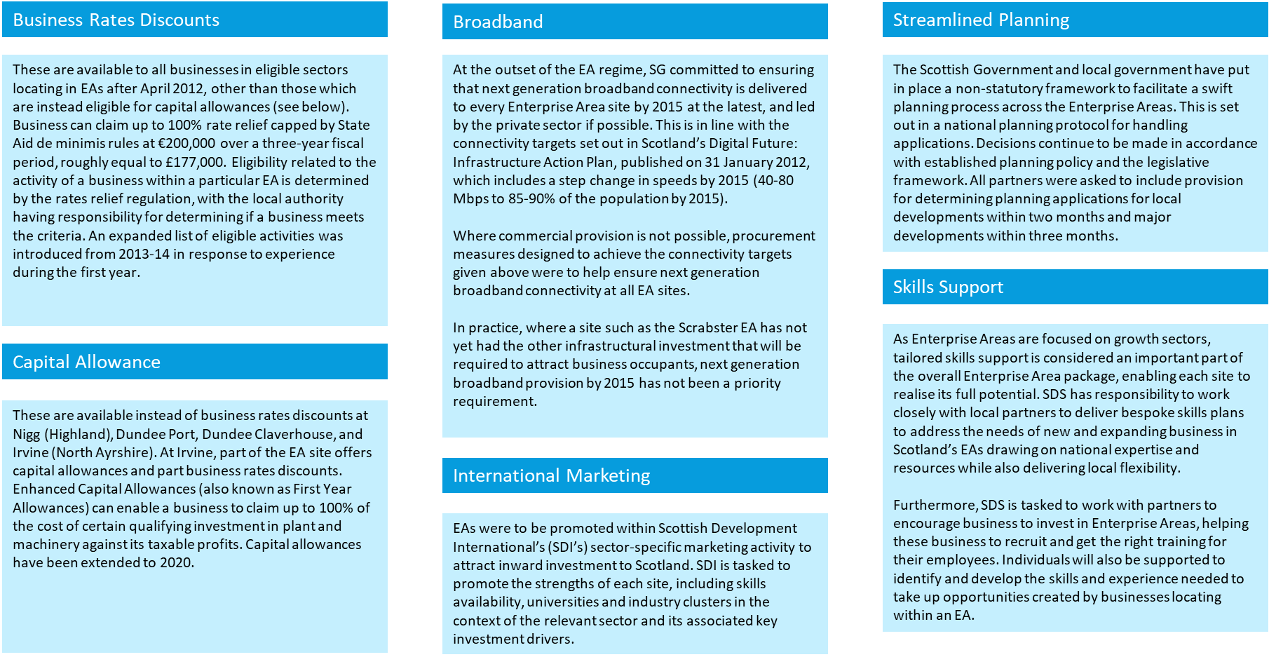
Source: Adapted from Review of Enterprise Areas in Scotland, October 2015

    - Quantitative Impact
Table 2.3 overleaf presents the quantitative data available to assess the performance of EAs and is based on data collated by SE since designation and last updated in October 2019. The following constraints and limitations should however be noted:
- The performance of EAs (e.g. number of companies attracted, and additional jobs created as well as firm-level data), has not been routinely monitored and recorded at a local or strategic level. Robust and consistent data to determine the baseline position and subsequent performance is not therefore available.
- As some businesses located on EAs are account managed by SE and HIE, data is available regarding the number/type of products and support services they have accessed. However, these are not additional services and could still have been accessed by the business if they had been located elsewhere in the country.
- As businesses within EAs have availed of several other support services and products, it is difficult to attribute growth (in terms of jobs created) specifically to EA incentives.
As EA performance has not been consistently monitored, accurate performance data to understand the quantitative impacts in terms of additional business investment and jobs created is not available.
Across the 16 EAs, there are an additional 88 companies and 3,125 jobs compared to the situation prior to EA designation. However, it needs to be stressed that these increases should not be taken to imply causality. Excluding Leith (for which figures are unknown), four EAs have not attracted any new companies or jobs to sites. The data illustrates the variation in performance across EAs, the reasons for which are explored in chapter 4.

Table 2.3: EA Performance (October 2019)
Enterprise Area | No. of companies on site prior to designation | No. of companies on site: Dec 2015 | No. of companies on site:  Oct 2019 | Change in companies on site: Designation to  Oct 2019 | Employment prior to designation | Employment: Dec 2015 | Employment:  Oct 2019 | Change in Employment on site: Designation to  Oct 2019
BioCampus | 0 | 0 | 1 | 1 | 0 | 0 | 250 | 250
BioCity | 16 | 16 | 26 | 10 | 65 | 65 | 336 | 271
BioQuarter | 0 | 24 | 19 | 19 | 0 | 300* | 564 | 564
Forres | 0 | 3 | 18 | 18 | 0 | 112 | 470 | 470
Inverness | 0 | 0 | 10 | 10 | 0 | 0 | 66 | 66
Irvine | 13 | 24 | 26 | 13 | 443 | 717** | 800** | 357
Arnish | 0 | 0 | 3 | 3 | 0 | 0 | 165 | 165
Hatston | 0 | 3 | 2 | 2 | 0 | 32 | 32 | 32
Lyness | 0 | 0 | 0 | 0 | 0 | 0 | 0 | 0
Nigg | 0 | 1 | 1 | 1 | 0 | 5 | 500 | 500
Scrabster | 0 | 0 | 0 | 0 | 0 | 0 | 0 | 0
Dundee | 0 | 0 | 0 | 0 | 0 | 0 | 0 | 0
Leith | 2*** | 2*** | 2*** | 0 | Unknown | Unknown | Unknown | Unknown
Creative Clyde | 0 | 2 | 3 | 3 | 0 | 89 | 160 | 160*
Prestwick | 3 | 6 | 11 | 8 | 30* | 119 | 320 | 290
West Lothian | 0 | 0 | 0 | 0 | 0 | 0 | 0 | 0
TOTAL | 34 | 81 | 122 | 88 | 538 | 1,439 | 3,663 | 3,125

Source: SE (* Estimate; ** Excludes 420 contractors working for GSK; *** Two major companies plus some smaller operations – number unclear)

The following provides an overview of the sites.
- Arnish: Located in the Comhairle non Eilean Siar (Western Isles), the Arnish EA covers 6.47 hectares and is located within a 43.9 hectare greenfield and brownfield site and quay. The land is owned by the Stornoway Trust and leased to HIE. The site has targeted investment in renewables/low carbon sector.
HIE had previously invested in a quay extension, road infrastructure and utilities services to create a multi-user/cross sector facility from the previous single user oil/gas sector set-up and viewed the site as a prime location for the growth of renewables. At the time of designation, the site had only attracted one major investor (tier one supplier, BiFab) and therefore additional incentives were required to increase the scale of operations. As of October 2019, three additional businesses generating 165 jobs were reported as having located on the site.
- BioCampus: Located in Midlothian, the BioCampus was designated as part of a life sciences EA. The SE-owned site comprises of serviced development land totalling around 12 ha upon which a 2,500 sqm building suitable for current Good Manufacturing Practices (cGMP) bio-manufacturing has been constructed. The Campus is also in close proximity to Edinburgh BioQuarter, which also provides biomedical and R&D facilities. As of October 2019, one additional business generating 250 jobs was reported as having located on the site.
- BioCity: Located in Newhouse, North Lanarkshire, BioCity comprises a 120,000sq ft. former Merck Sharp and Dohme facility at Newhouse which closed in 2010. BioCity Scotland (a subsidiary of the private company, BioCity Group) has been established to operate the building as specialist multi occupancy life sciences incubation space providing smaller scale units for a range of occupiers including start-ups, spin outs and Small and Medium sized Enterprises (SMEs). As of October 2019, ten additional businesses resulting in a positive employment change of 271 was reported since its designation in 2016.
- BioQuarter: BioQuarter is situated in Edinburgh and is a major health and science campus leading in regenerative medicine, healthcare data informatics and translational medicine, part of which holds EA status. The EA comprises a 28.94 hectares site which is owned by SE. The wider BioQuarter has seen significant public investment in land acquisition, infrastructure, servicing and construction by SE and others since 2002. Nine, the first commercial facility, was built in 2012 and provides 7,900 metres squared of laboratory and office space for life science companies. EA status has been used to support the on-going development of the area. As of October 2019, 19 additional companies generating 564 jobs were reported.
- Creative Clyde: Creative Clyde is located in Glasgow and was launched to be a vibrant community for creative industries. The EA covers manufacturing and growth sector opportunities. The 14.5-hectare site has development land available on the South side of the Clyde at Pacific Quay with BBC Scotland and STV both relocating there. As of October 2019, three additional companies had been attracted to the site creating an estimated 160 jobs.
- Dundee: The 67-hectare EA site is divided between sites at Port of Dundee (owner Forth Ports) and Claverhouse (owner Dundee City Council). Only Enhanced Capital Allowances are available at the site. EA status was intended to enable faster business and job creation on the port site, with the potential to realise three separate manufacturing operations, with a total of 700 jobs within a five-year period. Support sites inland in the ownership of Dundee City Council were earmarked to house component suppliers to main manufacturers with the availability of EA incentives intended to play a part in bringing this forward. As of October 2019, there had been no additional investment on site.
- Forres Enterprise Park: Forres Enterprise Park was designated as part of a life sciences EA, targeting growth sectors, particularly renewable energy and life sciences. The 9.3-hectare site is HIE owned and includes 7,000 sq. ft. light manufacturing space. As of October 2019, 18 additional companies, generating 470 jobs have been attracted to the site.
- Hatston: With the aim of supporting the marine renewable energy sector, the 11-hectare site is owned by Orkney Islands Council. The £8m publicly-funded extension to the Hatston Pier, which is adjacent to the EA, was completed in May 2013 as a support and logistics base for marine energy developers. As of October 2019, two additional companies generating 32 jobs were reported at the site.
- Inverness Campus: Owned and developed by HIE, the Campus occupies 87 hectares of development land at Beechwood, Inverness. A number of businesses are already located at Inverness Campus, with key organisations such as the University of the Highlands. HIE has marketed a number of fully serviced plots, with the EA and wider Campus site considered an important driver of the Highlands and Islands economy. As of October 2019, ten additional companies generating 66 jobs had been reported.
- Irvine Innovation Campus: Irvine Innovation Campus and expansion land at GSK’s Irvine plant have all been designated as part of Scotland’s Life Sciences EA cluster and is Scotland’s largest designated EA with 132 ha of allocated land. Both non-domestic rate relief and Enhanced Capital Allowance are available at the site. The site comprised a number of serviced development plots and buildings, and a detailed masterplan was prepared for the EA to guide its development through the implementation of infrastructure. The Irvine Bay Regeneration Company led this between 2006 and 2017, before responsibility was handed over to North Ayrshire Council’s Economic Growth Service following the company’s winding up. As of October 2019, 13 additional businesses generating 357 new jobs had been reported.
- Leith Port: Leith Port is a 60-hectare site owned by Forth Ports. The port infrastructure supported working cargo with some cruise ship traffic and onsite manufacturing operations. EA status was awarded to create local manufacturing opportunities in the low carbon and renewable sectors. As of October 2019, no additional investment had been reported.
- Lyness: Lyness is a 14-hectare site owned by Orkney Island Council. With a focus on low carbon and renewables, the site has sought to capitalise on growth in Scotland’s renewables sector and recent investment in shoreside facilities. As of October 2019, no additional investment had been reported.
- Nigg: Nigg is a 66-hectare site which is part of a wider 96-hectare development located in the Highlands and owned by Global Energy Nigg Ltd. The facility is well suited and equipped for all types of heavy construction, including new build, inspection and repair, and decommissioning. The Highland Council awarded a £630,000 grant towards the costs of regenerating the Nigg Energy Park, and as a National Renewables Infrastructure Plan (N-RIP) site, there was interest in the site from prospective FDI which EA status sought to capitalise on. As of October 2019, one additional company generating 500 jobs had been reported.
- Prestwick: Prestwick International Aerospace Park is a 34-acre site adjacent to Glasgow Prestwick Airport which is managed by South Ayrshire Council. Prestwick Aerospace is an established centre of excellence for Maintenance, Repair and Operations, aero structures and design engineering and is Scotland’s only Aerospace EA. As of October 2019, eight additional companies generating 290 jobs had been reported.
- Scrabster Port: is a 14.03-hectare site owned by Scrabster Harbour Trust. Scrabster was identified as a priority site in the N-RIP Northern Marine cluster and there has been significant investment made in the harbour over the last 10 years to improve the facilities offered to clients. Along with Hatston and Lyness, EA designation was intended to maximise the potential agglomerated benefits for marine renewable energy. As of October 2019, there had been no additional investment in the site.
- West Lothian The EA includes two locations: Broxburn and Eliburn. With a food and drink sector focus, the West Lothian EA was designated in 2013 in response to the closure of a major food manufacturer. The site was designed to attract investment within the food and drink sector in order to provide employment for people made redundant by the closure. The EA is an integral part of the West Lothian Economic Growth Plan developed by West Lothian Council, in partnership with the Scottish Government and Scottish Enterprise. As of October 2019, there had been no additional investment in the site.
A map of EAs is shown in Figures 2.4a and 2.4b below and a summary of each site, including its current economic context and performance is provided in Appendix 1.
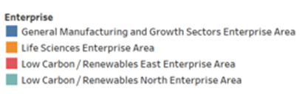
Figure 2.4a: Map of EAs by Sector

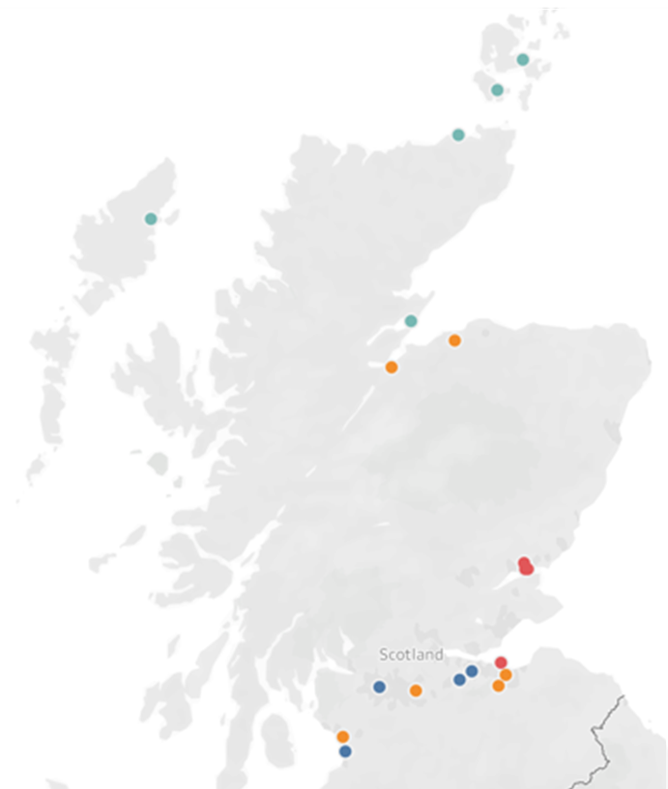
Figure 2.4b: Map of EAs by Financial Incentives Offered
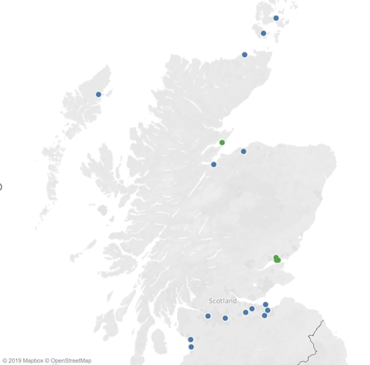

  - The Policy Context for EAs
The purpose of EA designation was to create a business environment to support employment, investment and growth. At the time EAs were introduced, the Government Economic Strategy (2011) was focused on accelerating economic recovery following the recession. There was a strong need to kickstart economic growth and build business confidence in order to encourage investment and job creation. As part of measures to create a ‘Supportive Business Environment’ efforts were to be targeted on growth companies, growth markets and growth sectors, with EAs being one of several mechanisms identified to support this.
As a result, EAs were established with a focus on key growth sectors including life sciences, low carbon/renewables, general manufacturing, aerospace and creative industries. The sector focus complemented wider economic development activity such as the move to position Scotland as a world leader in low carbon activities and investment in the £70 million N-RIF.
    - Place-Making
The Government Economic Strategy included place-making interventions through investments in physical and digital and the introduction of a Cities Strategy (2011 and updated in 2016) to support cities and their regions to maximise their potential as engines of growth. As an area-based initiative, EAs had the potential to support wider place-making activities, particularly following the introduction of City Region Deals in 2014. The Scottish Government is committed to 100% coverage of Scotland by City Region and Growth Deals and reflects the move towards more locally defined solutions to local regeneration and economic growth needs.
Through Regional Growth Deals in particular, local partners have much greater control over place-making interventions and greater flexibility to respond to local needs and opportunities. A review of deals currently in place indicate that future deals are likely to provide significant levels of investment in infrastructure and sector support measures. City and Growth Deals may therefore provide the capital investment which could unlock constrained EA sites and be a catalyst for development where this has been limited to date (see stakeholder analysis in section 4). They may also provide a focus for future City and Growth Deal investment and an opportunity to accelerate the performance of some EAs and build critical mass which will deliver wider agglomeration effects.
However, given the above and SE’s policy focus on place, if EAs are continued consideration will need to be given to how they work alongside wider policy interventions (which have changed considerably since designation) to add value.
    - Inclusive Growth
The publication of Scotland’s Economic Strategy in 2015 reflected growing recognition that economic growth also needed to be equitable and inclusive. The strategy signalled a clear direction of travel for all levels of government in Scotland; taking a much broader approach to boosting competitiveness and tackling inequality through a full integration of economic and social policy.
Area-based initiatives can provide a mechanism through which an integrated package of support (finance, skills, infrastructure) can be promoted. However, consultations with key agencies providing enterprise and skills support, suggest that EAs do not necessarily influence the targeting of support, with agencies primarily seeking to provide a consistent offer to all businesses across Scotland, rather than a proliferation of geographically targeted interventions which may create a ‘postcode lottery’.

    - Internationalisation and a Destination for Investment
Within Scotland’s Economic Strategy, internationalisation was identified as a priority theme. Given the economic shock of the recession, increasing internationalisation (by increasing exporting within the existing business base and creating the underlying conditions to make Scotland a major destination for investment) were seen by policymakers as opportunities to increase the resilience of the economy. This was further elaborated upon in Scotland’s Trade and Investment Strategy, launched in March 2011 which set out the Government’s key objectives and priorities to increase Scotland’s international trade and investment performance.
The 2016-2021 Trade and Investment Strategy set out a much broader agenda for internationalisation, with the attraction of significant inward, capital and risk investment being a key component of the Strategy’s 8-point plan. With direct support for marketing and internationalisation available to businesses locating on EAs and an offer to increase the attractiveness of Scotland as a place to do business, EAs were directly aligned with the strong internationalisation agenda within Government policy. This has most recently been developed in Scotland: A Trading Nation – A plan for growing Scotland’s exports (2019) which sets a direction on how best to grow Scotland’s exports and how to best focus resources and policies to deliver that growth and demonstrates an on-going commitment to establishing Scotland as an attractive location for inward investors.
Stakeholder consultations suggested that EAs can play a role in marketing Scotland’s offer to potential investors at an international level and provide a clear mechanism through which regional specialisms and expertise can quickly be communicated. It was noted by several stakeholders that this could become increasingly important post Brexit, however the extent to which EA status has an impact beyond its value as a marketing tool (i.e. on businesses’ location decisions) has been questioned by some (see stakeholder comments presented in section 4).
    - Innovation-Led Growth
Promoting a culture of innovation was a key theme within the 2011 Government Economic Strategy. Encouraging more businesses to innovate and engage with the knowledge base was identified as a key mechanism to increase business productivity. Research and knowledge assets are recognised as one of the factors which can attract knowledge-intensive businesses to an area, and the clustering of like-minded businesses and research assets within defined geographical areas has been identified as an opportunity to develop sector specialisms.
More recently, innovation-led growth has increased in prominence as policy has sought to respond to the productivity gap and the need not only to create jobs, but to grow and attract the businesses that will bring more highly skilled and value-added jobs in key growth sectors. The publication of the UK Industrial Strategy in 2017 was one of the major policy developments in recent years and has a strong focus on raising productivity particularly through innovation-led growth and smart specialisation agendas.
Aligned with the UK Industrial Strategy, Scotland’s Economic Action Plan (2018-2020) has sought to position Scotland as a leader in the technological and social innovations of the future and put Scotland at the forefront in transitioning to a carbon neutral, circular economy. The Innovation Action Plan for Scotland (2017) reiterated Government commitment to innovation-led growth and set out the strategic aim of Scotland being ranked in the top quartile of OECD countries for productivity, sustainability equality and wellbeing.
The on-going importance of innovation-led growth in economic policy provides a rationale for interventions which can provide a spatial focus for businesses, research institutes, and higher education institutes (HEIs) to co-locate. In England, University Enterprise Zones (UEZ) were piloted in Nottingham, Bristol, Liverpool and Bradford between 2014 and 2017 to encourage universities to strengthen their roles as strategic partners in local growth.
The Zones are partnerships between Universities and Local Enterprise Partnerships which provide funding to build office space to house start-up businesses (incubator space); and support from UKTI to create an investment proposition. UEZ status is designated following a competitive bidding process in which delivery partners set out their proposition and rationale for intervention. UEZ’s are therefore focused on local needs and opportunities. A new round of UEZ funding has recently been announced.
Within Scotland, EA policy has not been specifically targeted on driving innovation-led growth or maximising the potential of HEI assets (although some EAs are located near to research assets). Moving forward however, EAs (or an area-based initiative more generally) could have the potential to support innovation clusters and extend the economic impact of HEI assets. This would provide an opportunity to build on university/SE initiatives such as the National Manufacturing Institute of Scotland (NMIS) and develop a more long-term approach to furthering industry/HEI collaboration.
It is evident that EAs have the potential to contribute to several different policy areas, and, as national policy has moved increasingly towards place-based and inclusive growth agendas, there is a need to agree the strategic role and focus for EAs moving forwards.
  - The Economic Context for EAs
When EAs were first established in 2012, the economy was in post-recession recovery, as Scotland’s productivity, wages and employment levels were still below pre-crisis levels. As identified below, although some headway has been made in the intervening years, the overarching problems are still much the same. Analysis at the local EA level shows little local variation, with local areas broadly following national trends.
    - Economic Growth
In the lead up to 2012, economic growth had slowed in both Scotland and the UK as a whole. Since then, the growth rate has improved and GVA per head in Scotland increased from £21,494 in 2011 to £25,685 in 2017 (see Figure 2.5) but continues to lag behind UK levels of productivity. That said, both the OECD and IMF have forecast an economic slowdown in a large majority of the world’s major economies over the next two years. OECD has forecast the UK’s growth at 1.2% in 2019 and 1.0% in 2020, well behind the world average of 3.2% and 3.4% respectively.
Figure 2.X: Scottish GVA per head (2007 – 2017)
Figure 2.5: GVA per Head
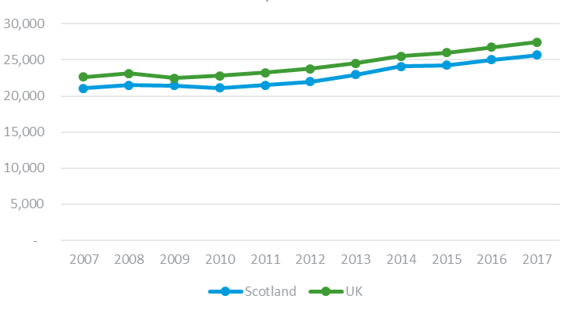

£

Source: Regional Gross Value Added (income approach), ONS

    - Employment
The employment rate in Scotland significantly declined during the recession and continued to decline thereafter, reaching its lowest point in 2011/12 at 70.5%. A slight increase followed in 2013 and rates subsequently returned to pre-crisis levels in 2015 (see Figure 2.6). That said, there is still significant room for improvement - the employment rate peaked at 74.2% in 2017 and 2018 saw the first decrease since 2011. This trend is largely in line with that of the UK as a whole, although the UK’s rate of recovery has been more consistent and at a faster pace. It seems likely that jobs will continue to be created, with 23% of SMEs expecting to employ more people in 12 months’ time and only 9% expecting to employ fewer (Small Business Survey, 2018).
Figure 2.6: Employment Rate
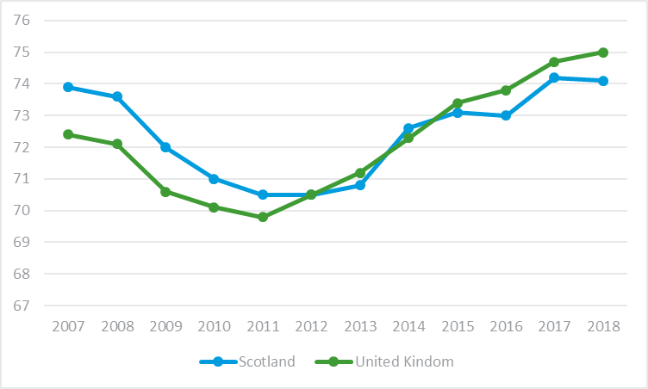
Source: Annual Population Survey, ONS (NOMIS)

Scotland’s unemployment rate follows a similar trend (see Figure 2.7). In 2012, unemployment reached its highest level since 2008 at 8.7%. However, since 2012, the situation has vastly improved. The unemployment rate has fallen consistently and largely in line with the trends throughout the UK. Despite slight increases in unemployment in 2015 and 2016, Scotland’s unemployment rate has fallen below the UK average in 2019.
Employment forecast data produced for SDS by Oxford Economics in 2017, predicts a net increase in total employment in Scotland from 2,748,900 in 2017 to 2,833,800 in 2027, an increase of 84,900 jobs, representing a 3% increase over the period. Following a period of rising unemployment from 2016 (partly resulting from challenges in the oil and gas sector and associated supply chain), beyond this, steady (although limited) employment growth is forecast from 2020 onwards. However, this is predicted to be slightly behind the rate of UK jobs growth.
Figure 2.7: Unemployment Rate

Source: Labour Force Survey (NOMIS)
    - Productivity
During and just after the recession, labour productivity increased significantly in Scotland. However, 2011 proved to be a turning point. Figure 2.8 shows that from 2011 to 2017 labour productivity (i.e. the average amount of economic output that is produced by a unit of labour input, measured in terms of jobs and hours worked) stagnated, with a brief spike in 2015. This slowdown in growth was attributed by some to employment growth having skewed away from the most productive sectors. Recently, productivity has begun to increase again, although Scotland is still lagging slightly behind the rest of the UK and significantly behind other major economies. Scotland sits mid-table amongst OECD countries for productivity, falling well behind other European countries such as Ireland, Belgium and Germany. This is of particular importance as the working population in Scotland is predicted to decrease in the coming years and as such productivity will be even more vital to the economic growth of the nation.
Figure 2.8: Labour Productivity Scotland
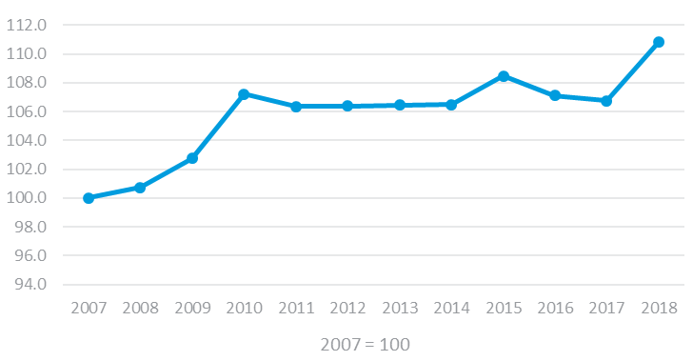
Source: Labour Productivity Statistics Q4 2018, Scottish Government
    - Export/Import Rates
Prior to 2012, there had been a steady increase in the level of Scottish imports and exports. Both peaked in 2013 before decreasing until 2016 when the level started increasing once more (see Figure 2.9 below). Currently, Brexit is making the future import/export rates unpredictable due to the uncertainty around what the future trade deal with the EU will look like. As it stands, 45% of Scottish international exports are for the EU and, as such, the deal struck will surely have a large impact on these figures. However, 57% of SMEs who currently export plan to increase their level of exports over the next few years (Small Business Survey, 2018).
Figure 2.9: Imports and Exports - Scotland
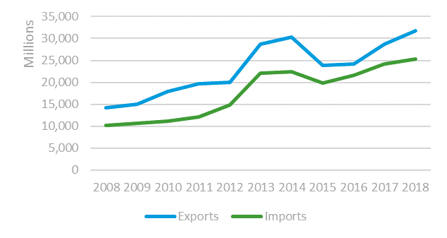
Source: Regional Trade Statistics Data, HMRC uktradeinfo
    - Innovation
Prior to 2012, innovation in Scotland was relatively low. It lagged the UK average in terms of the percentage of businesses that were ‘innovation active’ and placed in the lower quartile when compared to other EU countries. This is one area that has seen significant growth. From 2011 to 2016, Scotland’s innovation performance increased by 42% and Scottish Business Enterprise R&D expenditure reached a record high of £1,247 billion in 2017, compared to only £697 billion in 2011. That said, there is still room for improvement, as Scotland has still not been able to reach the upper quartile of OECD countries in this area. Strides are continuing to be made, however, with 23% of Scottish SMEs claiming to have introduced new or significantly improved processes in the last three years and 22% of these being new to the industry, rather than just their business. Furthermore, in a randomly selected cohort of SMEs taking part in the Small Business Survey 2018, 16% of respondents had invested in R&D in the last three years, with a mean value of £204,738.
    - Business Confidence
After the recession, business confidence predominately stayed in positive territory from 2009 until the end of 2018, with the exceptions being at the end of 2011 and the middle of 2016 (see Figure 2.10). Currently, business confidence in Scotland is negative for its third successive quarter and is at its lowest level since the recession. This is largely attributed to the uncertainties surrounding Brexit, but regulatory requirements and a weakening of sales and profit growth are also likely to have had an impact. Nevertheless, 70% of SMEs aim to grow their sales over the next three years, with 14% of this group expecting them to grow by at least 50%.
Figure 2.10: Business Confidence
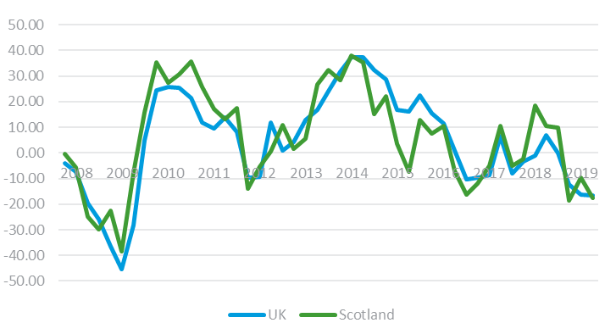
Source: Business Confidence Monitor: Scotland, ICAEW
    - Start-ups and Survival Rates
Over the period 2012-2016, there was a 54% increase in the number of new enterprises across the UK (see Figure 2.11). In Scotland, this increase was only 28%. The proportion of all UK start-ups originating in Scotland also fell year-on-year from 6.5% to 5.4%. However, as shown in Figure 2.12, the 1-year survival rates of Scottish start-ups was greater for each of the five years shown (2012-2016). The five-year survival rates for start-ups in 2012 was also greater in Scotland (43.7%) than the UK (43.2%).
Figure 2.11: Business Starts-ups per 100,000 population
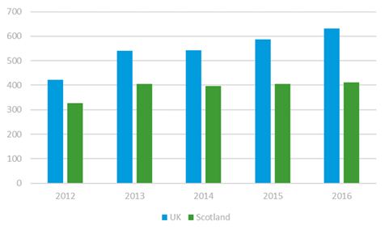
Source: Business Demography, UK: ONS
Figure 2.12: 1-year Business Survival Rates
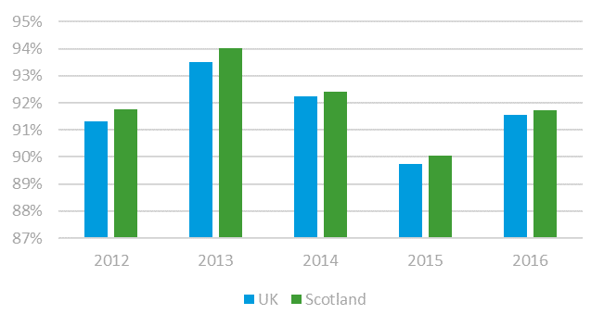
Source: Business Demography, UK: ONS
  - Changes in Business Support Provision
Key changes in business support provision since the introduction of EAs include:
The reduction in Regional Selective Assistance (RSA): RSA is the main national scheme of financial assistance to industry. In 2014/15 support was only available to existing large companies if they were diversifying their activities. Prior to this change it had been able to support expansions. RSA provides discretionary grants to investment projects that will create and safeguard employment in Assisted Areas – areas designated for regional aid under European Community law. It also includes ‘Tier 3’ assistance in other designated areas where Enterprise Agencies can offer support to Small and Medium-sized Enterprises (SMEs) delivered under the EC’s General Block Exemption Regulations. Payment of RSA is made in instalments, typically over several years as job and capital expenditure targets are met. Data indicates that the number of RSA offers made between from 2009/10 to 2014/15 were approximately 90-120 awards per year and that they have fallen to 60-75 per year since 2015/16, with total investment also falling from £24m-£54m from 2009/10 to 2014/15, to £14m-£23m since 2015/16.
Part of the rationale for RSA is that area-based initiatives are required to address regional economic disparities and the provision of direct financial support to businesses unlocks wider economic benefits through multiplier and agglomeration effects. Evaluation of RSA has indicated that the scheme delivers short term additional benefits and therefore its reduction may leave a gap in support provision which capital allowances targeted through EAs could address.
Broadband: The 2018/19 Programme for Government sets out Scotland’s commitment to the Reaching 100% programme. This £600 million investment will unlock superfast broadband of 30Mbps for all homes and businesses in Scotland by the end of 2021 thereby opening new economic opportunities, particularly within rural Scotland. Given this, the broadband incentive offered by EA status is no longer additional.
Business Taxation: Changes have been made to business taxation since the introduction of EAs, particularly following the Barclay Review. The introduction of the Business Growth Accelerator removes non-domestic rates for 12 months when businesses invest in new premises and guarantees to not increase non-domestic rates for 12 months where businesses invest in improvements/expansions to premises. A Non-Domestic Rates Bill is also being brought forward by Scottish Government which will seek to “reform reliefs”.
  - Strategic Fit and Continued Relevance of EAs
    - Policy Alignment
As outlined at section 2.3 above, when EAs were introduced, there was a strong policy focus on boosting economic growth and resilience after the recession. Place-making to create the infrastructure for growth, maximising the potential of cities as economic drivers, increasing exporting and internationalisation, and supporting innovation in business were key features of government policy introduced to create jobs and make businesses more competitive and resilient to economic shocks.
Rather than a significant change in policy direction since EAs were introduced, there has been an evolution of policy, particularly in response to the productivity gap. Supporting businesses to grow and attracting inward investment continue to underpin economic policy. The most recent Programme for Government (2018/19 at the time of writing), commits to increasing investment in physical and digital infrastructure to drive productivity growth, and also the provision of finance to stimulate growth through the development of the Scottish National Investment Bank.
The ambitions of EAs (attracting inward investment and facilitating business growth) still remain aligned with policy. The clustering of economic activity, particularly which promote sector specialisms, maximise the potential of local research/HEI assets or support supply chain development is aligned with the direction of national economic policy.
The introduction of Growth Deals however signals another increasingly important feature of policy – the flexibility to tailor interventions to regional/local needs, strengths or opportunities. The extent to which an area-based approach which offers limited flexibility to tailor support to local needs or changing local economic circumstances should therefore be reflected upon. This has been highlighted by stakeholders (see section 4) as a challenge with the EA policy, particularly as sector opportunities may change over time, and the UEZ model, which allows partners to develop a more bespoke package of support and integration with other local offers/supports, may provide an alternative approach for consideration.
    - Economic Rationale
There was a strong rationale for intervention in 2012 to negate the effects of the economic recession, and although the Scottish economy has grown over the past seven years, productivity lags the UK and other EU countries. Furthermore, economic growth in Scotland is expected to fall behind global trends and after several years of falling unemployment, employment rates are starting to fall in contrast to trends across Great Britain. Business confidence is also subdued, driven by economic uncertainty particularly in relation to Brexit.
Given the current economic uncertainty, it will be important to ensure there is an effective and appropriate portfolio of support available to businesses and careful consideration would need to be given to any withdrawal or reduction of supports at this time.
    - Stakeholder Views on the Rationale for EAs
31 strategic stakeholders were consulted to inform this review. All of these stakeholders indicated that there remains a need and rationale to support business growth and inward investment across Scotland. In line with the findings noted at 2.3 above, stakeholders agree that there continues to be an economic rationale for intervention and there are market failures (externalities) which limit private sector investment in some localities, particularly the type of investment which local partners wish to encourage (i.e. higher skilled and value-added businesses). Addressing the productivity gap, creating more highly skilled job opportunities, capitalising on sector strengths and opportunities, and building a more diverse and therefore resilient economy, all remain important objectives for local and national stakeholders.
Without robust empirical evidence regarding their costs and benefits however, the majority of stakeholders conceded that it is difficult to determine whether EAs are the most appropriate mechanism to achieve these objectives. The majority of stakeholders agreed that EA status demonstrates a commitment to agreed priority sites which are recognised nationally and can be strategically promoted nationally and internationally by local partners, Enterprise Agencies and SDI, and this is part of the EAs added value. They demonstrate at a strategic level therefore that Scotland is open for business and has a clear offer. It was noted by several consultees that EA status is recognised internationally and gives a good indication to potential inward investors that there will be support available.
The assumption that the EA status and associated incentives can unlock private sector investment is however flawed in many instances, with stakeholders indicating that site specific issues and conditions also need to be considered. A significant proportion of stakeholders have noted that the constraints and market failures which have been holding back development on sites are not addressed by EA status. Lack of physical infrastructure, low land values, geographical peripherality, and the financial viability/high risk associated with bringing sites forward which restricts speculative development of the quality and type required by local partners, have not necessarily been impacted by EA status.
It was recognised by most stakeholders that where EA status can offer support is as a marketing tool to facilitate conversations with businesses and potentially attract businesses where quality, serviced sites are already available. Stakeholders also perceive the approach has more value for start-ups and small businesses where non-domestic rates can be more burdensome. It was noted however that in the majority of instances, EA status is just ‘part of the toolkit’ to facilitate business conversations, but it is rarely, if ever, the deciding factor for an investor.
Therefore, whilst all stakeholders agree there is a rationale for intervention and recognition that the market failures noted above still exist and are hindering economic development on key sites, the majority of stakeholders question the extent to which EAs have sufficient ‘teeth’ to address these market failures, particularly in isolation from other investment (e.g. public sector gap funding of physical infrastructure).
The rationale for a one size fits all policy approach has also been questioned. Whilst the opportunity to demonstrate a strategic commitment to develop sites across Scotland has been noted, the lack of flexibility of EA policy to tailor offers to individual needs and circumstances for many stakeholders is counter to the direction of national policy which is increasingly focused on greater local and regional control over interventions. This includes for instance, the ability to change sectoral focus (e.g. when local economies and sector specialisms do not develop as anticipated) or the nature, scale and targeting of financial and other incentives to better respond to local market needs.
Furthermore, for some stakeholders the policy context for EAs has shifted slightly with a need for more focus on equity and dispersal and the delivery of broader place-based outcomes beyond company growth. For some stakeholders (particularly strategic stakeholders), EAs need to move away from property occupier incentive support measures (which do not address the lack of speculative investment in sites and premises) and provide a more integrated and flexible support offer which can address the complexities of local needs and market failures.
Regional Growth Deals for instance include tangible social outcomes valued as part of wider economic response, and work may be required to redefine the market failure in the context of a new policy environment. Strategic discussions regarding the type of economy Scotland wants suggest a focus on a more nurturing, progressive and sustainable economy which encourages growth where small companies take root and places less emphasis on fewer ‘big bets’ in terms of FDI or large corporate investments.

- review of Ea implementation outside scotland
  - Introduction
This section draws on analysis of other countries use of EA policy, their approach to implementation, and its relative success in order to identify if there are examples of effective EA policy which may provide a rationale for the approach (in some form), or conversely if experiences from elsewhere suggest that the approach has limited merit. The purpose of the analysis is not to compare Scotland’s approach with other areas, as all have been developed and delivered within different contexts, and without comparable monitoring data and therefore this cannot be undertaken robustly. Instead, the review seeks to identify success factors and lessons learned and considers how these could be applied within a Scottish EA setting.
  - Summary of the Approaches
The analysis has considered approaches in the USA, France, and England. All approaches are broadly comparable with Scotland in that they tend to have been area-based interventions implemented to address spatial variations in economic performance, and financial incentives (i.e. tax breaks/credits) have been a key element of the offer. The analysis has sought to draw on English examples in areas with a broadly comparable economic context (e.g. excluding EAs such as London Docklands). It is evident however that the specific nature of EA incentives has varied, often in response to different local needs and market failures.
The analysis has been hindered by the lack of robust and consistent monitoring/evaluation data. The National Audit Office analysis of EAs expressed concerns regarding the systems used to monitor progress of English EAs and questioned if targets and outcomes were realistic. These issues were also highlighted by the Welsh Assembly Government in 2018. The Assembly noted ‘Six years after they were announced, there is insufficient evidence to fully evaluate the value of Enterprise Zones in Wales’. The lack of evidence made it challenging for the Assembly to reach conclusions as to the merits of Enterprise Zones.

USA
Between 1994 and 2011 the USA Federal Government established 2,145 unique zones with a further 2,260 State Zones also in operation. While they differ in specifics, all the programmes provide tax preferences to capital and/or labour and other development incentives in an attempt to induce investment expansion or location, and to enhance employment opportunities for residents in economically disadvantaged areas.

France
In France, spatial inequalities between municipalities led to three waves of Enterprise Zone development. As in the UK and USA, France primarily offers tax incentives to businesses to secure investment. Firms locating in a designated zone are exempt for at least five years from business tax, tax on corporate profits, property tax on built lands, and from employers' social contributions. To increase additionality, the level of financial support available to businesses is varied depending on actual financial burden for small businesses and on the structure of their revenues and costs (e.g. payroll tax benefits are impacted by wage costs).

England
The rationale and incentives of English Enterprise Zones are broadly comparable with EAs in Scotland with both focused on the provision of financial (tax breaks and capital incentives) and streamlined planning incentives to encourage private sector investment in key employment sites which would deliver direct and ‘trickle-down’ economic benefits. Enterprise Zones have been a key component of Government regeneration policy and they continue the UK’s approach to local urban regeneration and investment in area-based initiatives which can be traced back to the 1980’s. Incentives include:
- non-domestic rate discount of up to 100% over a five-year period, potentially worth up to £275,000 per business;
- enhanced capital allowances for capital purchases; and,
- simplified planning processes.
The following provides a summary of the key findings and conclusions, with more detailed case studies presented in Appendix 4.
  - Key Findings
There are two key elements of policy/ programme implementation that facilitate robust evaluation. Firstly, clarity regarding policy objectives and goals, and secondly, robust monitoring and management information to measure impact.
Previous evaluations of EAs have highlighted that they are significantly limited by the lack of a clear and consistent performance monitoring framework and in many instances a lack of clarity regarding what constitutes success. Accordingly, the evidence base across France, UK and USA presents a mixed, and often contradictory picture. However, the following uses the available literature to highlight several issues for consideration.

Clear objectives which inform programme design
Incentives need to be geared towards the outcomes sought and the rationale for intervention. While it may seem obvious that form should follow function, the application of a national policy at a local level can inhibit this if the model lacks flexibility. Across England there has been criticism of Enterprise Zones as (for some stakeholders), they have failed to deliver on the localism agenda with the location and approach being primarily determined by national government. As such they are not seen to have provided Zone authorities with the freedom to operate flexibly to meet local need and opportunity.
If determined nationally, EAs also require a sufficiently broad portfolio of incentives which can be tailored to local needs. Enterprise Zones relying purely on tax breaks or capital incentives/subsidies to businesses for instance, tend to be less effective in supporting social outcomes and addressing distributional market failures (e.g. the regeneration of deprived areas and addressing high unemployment) as substitution effects can refocus investment away from labour.
In France, the inclusion of labour incentives (e.g. the requirement for recruitment of 20% of new employees from within the French Zone area) alongside direct financial supports to businesses, provides a more rounded offer and is seen as being key to a small but significant increase in local employment. Within the UK, some commentators have noted that investment in human capital alongside infrastructure should be supported to provide a more holistic intervention, “education is an extremely powerful determinant of local success and failure (of Enterprise Zones) …investment in human capital is critical for long run growth”.
As noted above however, the type and focus of incentives should be informed by agreement regarding the objectives and rationale for intervention which considers local market failure/needs and any potential unintended effects (e.g. substitution and displacement effects). Continual review and updating of the approach is also important to reflect changing needs / policy focus and prevent a mis-match between activities and outcomes arising.

Using EAs to deliver against trade and exporting objectives
As policy objectives and the economic context across England have evolved, there is growing interest in the use of EAs to support trade and exporting, particularly within a post-Brexit economy. In June 2019, Boris Johnson announced plans to consider re-introducing the concept of Free Ports as a way of boosting trade and supporting regional development. Free Ports, or ‘Free Trade Zones’, are areas where goods can be imported, stored and re-exported without border taxes. Within a customs union their use is limited but outside of the EU, the concept is gaining traction among some regional stakeholders as an opportunity to boost local economies. Areas including Teesside and Aberdeen have been identified as potential sites for Free Port status. The potential impact of Free Ports is the subject of debate, but a recent report suggested combining Northern ports with Enterprise Zones has the potential to create 150,000 jobs and add £9bn to the UK economy. Critics however argue that Free Ports provide a potential haven for tax fraud and simply promote the movement of business and jobs from one part of the country to another.
As the EA approach can be applied across several different policy domains (economic development, regeneration, internationalisation for instance), it is important that clear policy objectives are set, and this is used as the basis for determining the most suitable design and delivery model.

Net Job Creation and Long-Term Benefits
There is a lack of robust data from which to determine whether approaches elsewhere (and across Scotland) have successfully supported net job creation, and if so, the factors which have underpinned this. Recent BBC reports highlighted overall concerns that Enterprise Zones do not present value for money in relation to additional net job creation, and research has suggested that Enterprise Zones promote only a short-term boost to local economic growth but with limited long-term impact. Some zones in the USA for instance are now seeing the impact of zone status decline as the trade-offs of investment in zone areas, such as distance from markets, devalue the financial advantages.
Centre for Cities Research
In 2017 the BBC commissioned the Centre for Cities to explore the net impact of Enterprise Zones which found that the number of jobs created was less than 25% of target. Indeed, in some Enterprise Zones there has been a net reduction in jobs created. So, while the Bristol Temple Quarter and Bath Enterprise Zone created 5,493 new jobs, Lancashire had a net reduction of 2,347 as new job creation failed to offset the loss of jobs from the closure of the British Aerospace site. Even in the Humber, where Siemens has announced major inward investment, the total net job creation by December 2017 was -320 and overall it was deemed that EZs have not achieved the scale of employment benefits anticipated.
In addition to there being little consensus regarding the positive impacts of EAs, there is some evidence that EAs also generate negative impacts which can outweigh any positive gains. Displacement, short-termism, and the accrual of benefits amongst unintended beneficiaries (e.g. landowners) have been identified as flaws with the policy which either need to be mitigated or the approach to be revised.

Criticism of English EAs Net Impact

Behind headline figures of inward investment and job creation, the performance of Enterprise Zones and its functionality as a regeneration tool has been heavily criticised. Critics suggest the concept of Enterprise Zones in the UK has failed to grasp the true concept of a laissez faire economic opportunity area that has worked well in areas such as the Far East, a model for the 1980 approach to Enterprise Zones and still largely followed today. Negative impacts included:
- The cost to the public sector for the impacts above was estimated at £1.2 billion, with only 58,000 out of the 126,000 jobs created being additional. Job creation figures for the current English Enterprise Zones are reported as gross and therefore net additionality is difficult to determine.
- Research suggested most of the jobs created are displaced from other areas, ‘pushing industry’ around the UK rather than attracting new investment. This movement can even be at a regional level, transferring employment from the city centre to out of town facilities, damaging town centre vitality. Evidence suggests ‘up to 80% of jobs they (Enterprise Zones) create are taken from other areas. Findings from Scotland however (see chapter 5), suggests that this ‘displacement’ has to be reviewed on a case by case basis and may also be part of the natural churn of the business base, with EAs facilitating business expansion and retention in an area, ‘The conclusion can therefore be reached that the true objective of the new EZs is to act as a catalyst for change, to stimulate development in economically marginalised areas, even if it is at the expense of employment in surrounding areas’ .
- Enterprise Zones promote a short-term boost to local economic growth, but the target areas then fall back in to a longer-term reversal. Many of the original zones in the UK were in areas struggling with long term economic decline and in locations where long-term benefits were difficult to achieve. As with international examples outlined above therefore, this points towards other supporting factors being important in achieving sustainable economic growth in an area;
- As was found in the USA, Enterprise Zones are expensive job creation tools, with research from 1980’s zones suggesting a net cost per job of over £23,000; and,
- Enterprise Zones impact on property prices, which can mean landowners are the true beneficiaries of investment and adjacent areas suffer from land price deflation and negative economic impact.
Overall the findings highlight the need for robust management data from which to accurately determine a programme’s net economic value and a clear logic model for any programme of activity which considers and mitigates potentially negative effects. Although other supporting factors (alongside short-term incentives) may be important in the long-term success of EAs, without robust longitudinal analysis this cannot be verified. Findings from Scotland however illustrate the broad range of factors businesses consider when making location decisions (see chapter 5).

Scale and Location
There is some evidence that Enterprise Zones may work better when they are less fragmented and larger in scale, however it is important to note that a broad range of other factors will also influence zone success. Some EAs have also been criticised for supporting delivery on edge of town sites rather than city centres which minimises the potential of EAs to support town/city centre vitality and the attraction of higher value added/knowledge-based industries. As noted above however, flexibility to implement tailored responses to local needs is often paramount.

Greater Birmingham and Solihull LEP (GBSLEP) - A City Centre Model
GBSLEP was the first city centre model in England which was based on the USA model of tax increment financing (TIF) that allows borrowing against future business rates income. This TIF has enabled massive infrastructure expenditure (£100m+) for capital investment in site preparation and early intervention on infrastructure unlocking city centre sites.
The TIF approach has proved to be a powerful instrument which has accelerated site development in the city centre with immediate gains and impacts as a result of the investment in public realm, land reclamation and non-private sector investment items (e.g. early moves and readiness to take advantage of HS2 in 2026 with the main station in the growing Creative Quarter).
TIF programme for the EZ runs to 2046 (end repayment date). Flexibility in the approach means that if business rates fluctuate the programme slows rather than stops as businesses can only borrow against future business rates income. The local authority also brokers Joint Ventures which has led to two major city centre development sites (Paradise and Smithfield) coming forwards.
Promotion and marketing are undertaken through the West Midlands Growth Company which handles FDI and targets relocations. The team and their activities are part funded by the EZ which provides an effective and important hand holding service to inward investors. This service has helped to unlock additional investment such as doubling KPMG’s investment in the area and securing the HSBC HQ for UK retail banking which created 6,000 jobs. The support service breeds confidence for investors and occupiers as well as strengthening stakeholder commitment and cooperation.
A streamlined planning service is provided by the local authority including use of compulsory purchase orders, and collectively this (alongside other incentives) works as an effective package in the EZ. Other support is however also important. Skills gaps and shortages can be a major drag on growth and productivity, and it is vital therefore to ensure there is a strong, skilled pipeline of talent as well as access to people who can meet current demand. Local colleges and universities are consulted regularly to build their role and activities into a partnership embedded eco-system. Qualitative feedback suggests that companies’ value this and it is important in their deliberations about coming to the city centre.
Although the EZ targets sectors (financial services, related professional services, digital and creative media, Fintech and related data analytics services and city centre leisure/support facilities), the inclusion of several priority sectors provides flexibility to respond to opportunities.
Although formal evaluation has not been undertaken, time additionality has been the main advantage delivered. Overall, it is perceived that “things get done faster” and the City is ready to take advantage of new opportunities.
Moving forward the city is considering a scaled-down version of the EZ for smaller settlements in the area (towns of 50-100k population). This is being undertaken as part of the LEPs engagement with local authorities to think about the future of their towns and town centres as their roles and functions change e.g. some are becoming dormitory towns and not all will have the same mix of investment and services, and also to reflect the changing nature of the high street.

Governance and Integration
EAs governance and management arrangements have predominantly been determined by preferred funding models in place at the time e.g. across the UK the use of arms-length regeneration companies, local authority control, or LEP oversight have all been evident.
Regardless of the approach, the analysis indicates that it is often the extent to which governance/management arrangements facilitate integration of EAs into other place-based regeneration and economic growth activity which is important. The governance arrangements in the English LEPs ‘situates management of Enterprise Zones within a wider economic development plan, and their governance is centred on a business led partnership model’. Whilst it is difficult to generalise across Scottish EAs, this approach does not appear to have been explicitly adopted across Scotland, although Regional Growth Deals may allow for a more co-ordinated, place-based approach moving forwards.
Sheffield Enterprise Zone
The Sheffield Enterprise Zone has been lauded as an excellent example of Enterprise Zones’ potential where they build on local assets, strengths and existing critical mass. The Zone benefits greatly from its location close to world class businesses including Boeing, Siemens and Rolls Royce, which has been a feature of marketing activity by the Sheffield LEP. The success of the Zone is partly attributable to the close links with the University sector on the Zone, Sheffield University located its Advanced Manufacturing Research Centre (AMRC), a world-class centre for research into advanced manufacturing technologies used in the aerospace, automotive, medical and other high-value manufacturing sectors. The same site is also home to the separate Nuclear AMRC. The AMRC and Nuclear AMRC are both members of the High Value Manufacturing Catapult, a consortium of seven leading manufacturing and process research centres, backed by the UK’s innovation agency, Innovate UK. Critical mass and the clustering of complementary activities and institutions is therefore a key feature of the Zone’s success.
Inward investors include Nikken Kosakuso Europe, who opened their Nikken Innovation Centre Europe in December 2015. The Innovation Centre provides equipment to help companies become more competitive by increasing production rates and quality while reducing costs. In the same month, the AMRC with Boeing also took possession of a new Factory 2050 building which is at the heart of the University of Sheffield’s new advanced manufacturing campus on Sheffield Business Park.

Sector Focus
Although Zones are often established with a view to securing investment in specific industries, such as renewables or automotive, they must be flexible and able to respond to changes in sector development or new opportunities. As noted above, integration of EA sites’ development strategy with a wider development plan for the area is important to building critical mass and sustainability. There is some evidence that successful Enterprise Zones with a clear sector focus, also have other supporting assets and critical mass to exploit sectoral opportunities and gain competitive advantage over other areas. Zone designation alone is highly unlikely to attract a sectoral cluster. Zones should, where practical, build on existing strengths. Where the scope for this is weaker, a clear commitment to a sector(s) is important but the potential limitations need to be carefully considered and some flexibility built into the approach.

Barriers to Success
Many of the considerations outlined above are encapsulated in the World Bank’s global review of Enterprise Zones identifying major “lessons learned” from zone development. Clearly there are significant global economic variants but failure of EAs could largely be attributed to:
- uncompetitive fiscal incentives;
- restrictive controls on zone activity such as sector development;
- weak management bodies leading zones and zone marketing; and
- zones becoming ‘enclaves’ of economic activity and not fully integrated to regional and national economic policy.

  - Conclusions
As stated in the introduction, the above analysis is not intended to provide a direct comparison to Scotland’s EA experience as there are too many variables which cannot be controlled. Instead the analysis aims to provide insight into lessons and issues which may help to inform thinking regarding the future of Scotland’s EA policy.
It is evident that there is no agreed model for a ‘successful EA’ which could or should be replicated, and there is no consensus that EAs offer value for money. Despite the growing body of international research into the impact of Enterprise Zones (of various format and design), there remains a lack of robust and comparable data and this would need to be rectified if the EA policy was to be continued in Scotland.
Ensuring programme design is informed by clear policy objectives and that it considers/mitigates potential negative impacts is key, as well as providing flexibility to tailor approaches to local needs. There is also a degree of consensus that, on their own, EAs are not an effective tool for economic regeneration, and this is mirrored in the feedback from Scottish stakeholders. Supporters of Enterprise Zones suggest successful zones will depend on a wider, coherent industrial strategy in which investment in training, research and innovation underpins sites and infrastructure development:
‘Considerations must be made to methodically and clearly understand how zones can supplement a broader local development strategy, one that draws on the EZ’s strengths to maximise the potential for a local strategy’s success’.
Our review also supports the view that EAs are typically more successful when they are integrated into a wider economic development plan for an area and a broader offer to investors. Critics however highlight the comparative cost of investing in zones, low levels of additionality and the impact on land prices for landowners as reasons to focus resources on a broader economic approach. They suggest:
‘Enterprise Zones are not the answer. Government should focus on the long-term drivers of economic growth: innovation, trade, skills, infrastructure and entrepreneurship. The recovery will be led by innovation, with a small proportion of high growth firms producing the majority of all jobs. The government needs to focus on these long-term issues, rather than short term measures which are likely to move jobs around and have little sustained impact on economic growth.’
- stakeholder feedback on EA Performance and Impact

  - Introduction
The following provides an overview of key findings from 31 stakeholder consultations.
  - Performance
Overall consultations suggest that EAs are not well understood. Although the majority of local and strategic partners would rather have them than not, their USP is unclear, stakeholder experience is varied, and policy changes have happened without specific consideration of EAs which were primarily intended as a short-term response to adverse economic conditions, not a long-term policy. Therefore, over time, the purpose and focus of EAs has become less clear.
    - Factors Limiting Investment in EAs
Stakeholders acknowledge that EA performance has been variable, but most did not have a detailed appreciation of their quantifiable impacts and benefits due to a lack of monitoring and management information (e.g. take-up, influence, impact and additionality indicators and cost data).
Where EAs have had limited or no private sector investment, the primary reasons for this are outlined below.
Site constraints: Some sites have not been attractive for development due to a range of factors including poor accessibility/peripherality and the need for investment in physical infrastructure. Several stakeholders have indicated that it is often not financially viable for developers to invest in the type of modern, fit for purpose industrial space that businesses want, and if existing building stock is unavailable, old and out of date sites remain unattractive to investors regardless of EA status (i.e. EA status is not addressing the problems which are preventing investment).
It was noted by some consultees that whilst Local Enterprise Partnerships in England have had access to devolved funds for capital investment in infrastructure, there has been limited funding to gap fund capital developments in Scotland. The competitive nature of funding has also been a constraint in some instances.
Irvine
Despite some success in attracting businesses, a large site on the Irvine EA has yet to secure any investment. The site had been earmarked for a new medical manufacturing centre which would create a hub to drive growth in the life science sector. A competitive location bid for the facility was however, unsuccessful and the site remained undeveloped.
Ayrshire’s Growth Deal will however provide capital investment for over 150,000 sq. ft of new, purpose built advanced manufacturing space which it is hoped will unlock investment in the site. Local partners would like to see EA status retained to assist with the future promotion of the site following capital investment.

Where sites are in private ownership, a lack of appetite to invest/risk aversion has also been a constraint, and in some instances geographic peripherality (or perceived peripherality amongst businesses) restricts the potential market for sites (e.g. localities are perceived to be too remote from major transport routes/infrastructure, professional services, major urban centres and other businesses). Strategic marketing of localities could help to address this.
Changes in sectoral strengths: in some instances, the sector focus of EAs has been restrictive, particularly where economic opportunities identified in 2012 have not materialised as anticipated (e.g. development of the renewables sector in the Orkneys and life sciences in Forres as outlined below). Some stakeholders also noted that the sectoral designation of EAs has restricted the provision of support or active marketing to businesses within complementary and supporting sectors. This was identified as being important if EAs are to build critical mass and attract a diverse mix of appropriate businesses which will also increase the resilience of the business base. More flexibility to assess the relevance of businesses to an area on a case by case basis was therefore suggested.
Forres Enterprise Park
The Life Science focus of the Forres Enterprise Park has been limiting as the location does not meet the needs of life science businesses which typically prefer to be located near to HEIs and health infrastructure. Other sites (such as Inverness Campus) have proved to be more attractive to businesses.
However, over the past seven years, the area has been successful in attracting investment from the aerospace sector which had not been foreseen in 2012. The EA meets many of the needs of the sector (e.g. supply of good quality labour from a nearby RAF base and proximity to good potential launch sites). There remains potential to build on success to date and support supply chain development, however EA incentives would not be accessible to these businesses due to the sector designation.

Policy changes: Within one region it was suggested that a reduction in the expected level of government support for the renewables sector has hindered the performance of renewables-focused EAs. This was particularly identified as an issue within isolated areas where target markets are more limited.
Wider economic conditions: Although the Scottish economy has seen some growth generally since EA designation in 2012, this has been variable by location and intensity. Recovery has been slow in most areas and some stakeholders feel that the scale of investment in some sites has been subdued with consequent effects on the length of time to build interest and momentum, particularly following the economic recession which had a significant impact on business confidence. The lower level of major enquiries coming in through SDI has seen more focus shift towards smaller scale business growth including start-ups and university spin-outs in sectors such as life sciences.
The availability of other business support: In West Lothian the EA was established as part of the response to the closure of major employer in the food and drink sector. Although the area was successful in finding employment for the vast majority of people who were made redundant, this was primarily through migrant workers moving to other areas and natural expansion of existing businesses rather than inward investors attracted by the EA status. In addition, a £29m support package was available to the area to minimise the effects of the closure and this was felt to provide an easier mechanism through which local economic objectives could be delivered e.g. business grants were offered which were straightforward and easy for businesses to access. As a result, there has been no investment on the EA site which is currently not serviced and therefore unattractive to investors. For many businesses creating and/or safeguarding a significant number of jobs, RSA has remained a primary route for assistance capable of delivering attractive levels of financial support.
Location: A number of stakeholders have indicated that the location of EAs can be limiting. It was noted that EAs are often peripheral to urban centres and can therefore lack the characteristics that help to create vibrant and attractive areas for investment e.g. people and wider social/economic infrastructure. Integrating EAs (such as through investment in physical connecting infrastructure or measures to build supply chains and business to business interaction) and also maintaining EAs as attractive environments takes time and has cost implications for local partners.
    - Factors Supporting Investment in EAs
None of the stakeholders consulted to date suggested that EA incentives have been instrumental in attracting investment to sites but agreed that businesses’ location decisions are complex and multi-faceted and that there are often too many variables at play to attribute investment in an EA purely to EA status or incentives. However, the majority indicated that EA incentives rarely seemed to be the sole deciding factor, although several noted that there is a lack of data with which to robustly determine this.
EA status is useful to support marketing and provides an additional benefit to facilitate negotiations with businesses, but all consultees noted that EA status and incentives were just ‘part of the mix’. Several comments refer to the EA status as being ‘nice to have’ rather than essential. In some cases, such as in the life sciences sector, it has been seen as “the cherry on the icing on the cake” and EA status has not always been a prominent element of the marketing message on some sites (e.g. Forres). Stakeholders highlight that EA status is valued as a badge for marketing and generating interest in sites and locations, although it is also important that this is supported by tangible and attractive benefits to businesses in order to meet expectations.
It is often the case that success factors are site specific, but can be broadly grouped as follows:
Agglomeration effects and proximity to other supports/infrastructure: There are examples of where EAs have reinforced other advantages that sites have to attract business. However, this has been a following rather than a leading role in promoting locations for business.
Inverness Campus
Inverness Campus offers a high-quality environment and benefits from being located adjacent to a HEI and hospital which is a key pull factor for life science businesses. Although EA status forms part of the conversation with businesses, proximity to the University, the quality of life/environment, and account management service were more important factors in the site’s success. Since the Campus opened in 2015 it has secured 11 new businesses, but it is expected that investment in the site will accelerate over the next few years with a target to secure an additional 30 businesses over the next five years. Agglomeration effects have therefore been important to the development of the site and others such as BioCampus. This provides a strong continued rationale for investment in area-based initiatives and certain sector specific clustering (such as life sciences) with provision of appropriate infrastructure and connectivity, physical and digital. However, it is not the strength of the benefits in the EA offer which has been instrumental in the success of these sites. In some cases, businesses were unaware of being in an EA and more focused on the cluster benefits such as in life sciences.

Some locations with EA status show development around other locational advantages e.g. Forres Enterprise Park’s close proximity to an RAF base which provides a supply of highly skilled workers.
Investment in infrastructure: Inverness Campus, Forres Enterprise Park and Nigg are all examples of EAs which have benefitted from major public sector investment in physical infrastructure which has unlocked growth and private sector investment. Global Energy have invested heavily in the infrastructure at Nigg, with approximately £1m of public sector funding also put into the site. Forres Enterprise Park has also benefited from public sector investment in road infrastructure. The Scrabster EA in contrast has not received any public sector investment to address site constraints and there has been no activity on site to date. As noted at 4.2.1 above, EA status alone does not impact private sector investment from developers, although where the infrastructure and buildings are already in place, non-domestic rate discounts can help to offset some of the costs to businesses of upgrading/adapting premises to meet their needs.
Active management: The findings suggest that EAs have been more successful where they have been part of a wider regeneration plan which has been actively managed. Areas which put forward a strong proposition which already had partner support have generally been viewed as being more successful than those which were less well developed and lacked a clear vision or action plan.
Where EAs have been more actively managed (by local partners and enterprise agencies), EA status has often been viewed as playing a supporting role, helping local partners to build a case for funding and demonstrate commitment to investment in and around the EA site(s), rather than being the key catalyst for growth.
Irvine Bay Urban Regeneration Company (URC)
Irvine EA was designated within an area which had been earmarked for regeneration. The EA was therefore part of a wider regeneration masterplan driven by an Urban Regeneration Company. Being designated within a wider regeneration area, the EA has benefitted from on-going investment in the area and will continue to do so through marketing and promotion and further investment planned as part of Ayrshire’s Growth Deal.
While the findings do not suggest that EA status has driven activity in the area, it is deemed to be a supporting factor which helps to promote the area as an exciting place to invest.
  - Marketing
The consultation findings highlight that EA status is attractive as part of the marketing mix and stakeholders emphasise the importance of effective marketing.
Several stakeholders have commented that marketing effort has drifted over time, particularly as the EA offer has been overtaken by other supports. Strategic consultees have noted that marketing is patchy and needs significantly greater coordination and a clear standard setting. The coordination of marketing, working more closely with property market agents and SDI on emphasising the point of difference from having EA status for instance, could be improved. This would help highlight the benefits of EA status and provide clarity on the routes to access to other benefits. Benefits do however need to be tangible and attractive to businesses.
There are instances where agents have promoted sites that do not have EA status but are located adjacent. This reflects the site-specific ‘red line’ boundaries and the enthusiasm of some agents to market the EA concept to generate interest in an area and sites. The EA ‘badge’ therefore appears to provide an opportunity for local partners to market the wider cluster and agglomeration benefits of location near to an EA.
The role of SDI has also been raised in regard to marketing, highlighting a “restriction” on promoting Scotland rather than individual sites. Usually, marketing has been developed at a local level with sites and vacant premises being marketed via websites, presentation packs, brochures and commercial agents. The benefits of EA designation features but is not a leading marketing or sales proposition. In many cases, the marketing efforts have continued locally in the face of difficult market conditions and lack of other attractive incentives that could draw new businesses into the EA. e.g. a unit on the Forres Enterprise Area was vacant for three years and actively marketed over this period without success.
It is interesting to note that where EA sites are part of a wider development which has a clear brand (e.g. Creative Clyde, Inverness Campus and Forres Enterprise Park), it is the wider development opportunity which is primarily marketed and attractive to businesses rather than the EA as a standalone offer. There is no evidence to show that the EA status and benefits marketed as a standalone offer would be attractive enough to influence an occupier decision.
In many instances marketing has been proactive, and there are examples of innovative approaches being adopted alongside traditional marketing and promotion channels. For instance, Inverness Campus has approximately 100 Ambassadors (businesses, HEI and hospital staff) who actively promote the site when they are at events and networking groups. As a result, most enquiries to the site are generated by word of mouth.
  - EA Incentives
The majority of stakeholders consulted believe the EA incentives are not significant enough to make a difference to investment location decisions and the offer has been eroded over the years by other initiatives and policy shifts. It is agreed that financial packages are often the top consideration for businesses looking for incentives, but the EA offer is deemed to be ‘modest’ and incentives are not strong enough to attract businesses in isolation.
Whilst some stakeholders conceded that the non-domestic rates relief may be beneficial to start-ups and small businesses (although the Small Business Bonus may now have a bearing on the additionality for small businesses), overall the offer was not felt to provide substantial additional benefits to businesses (i.e. on a scale which would impact a relocation or investment decision).
Local partners noted that they have various other supports available to businesses such as grants, discretion to offer rate relief, planning protocols, and funding such as the vacant and derelict land fund which can be accessed by any business. As a result, the EA offer was noted as being ‘less special’ than possibly in the past.
Broadband access is now a standard requirement of all businesses and it is widely accepted that areas unable to offer fast broadband will not be attractive to growing businesses.
Businesses in EAs do not have access to an enhanced skills or business support offer, and most consultees indicated that planning processes are not a significant barrier to investment (some areas already have planning protocols in place for inward investments) and did not see any evidence of streamlined processes. Few consultees recognised capital allowance as a significant part of the EA package with the exception of two large businesses.
For most consultees the EA offer to businesses is primarily about reduced non-domestic rates, with other incentives not deemed to offer any additional benefits. It was noted by two consultees that with the financial package counting towards state aids, it may be that the impact of the EA is that it reduces the level of funding which could be levered into the business through other public funding programmes. The EA offer however has the benefit of being guaranteed and therefore something which can be used in marketing.
Several stakeholders indicated that when there are opportunities to secure new investment, local and national partners generally work well together to build a package of support tailored to business needs. SDS for instance was able to offer an accelerated apprenticeship scheme to support Global Energy’s investment at Nigg. However, it was also noted that this would take place regardless of whether the investment was in an EA.
  - Impact
The lack of performance monitoring data at firm and EA level (to capture the influence, impact and additionality of EAs) means most stakeholders have been unable to determine their impact. There is a perception that EA status has ‘helped’ in some instances, but nearly all stakeholders have questioned the extent to which changes within EAs can be directly attributed to EA status. Where sites have been successful, this is attributed to other factors and EA incentives are not perceived to be a significant factor in businesses’ investment decisions. Where EAs have not been successful, it is recognised that EA status alone is insufficient to overcome all the factors which can limit investment.
However, the kudos of having the EA designation as a badge is seen as useful in marketing and also in providing a focus for the targeting of economic development activity. A number of stakeholders have indicated that EA status has helped to build a case for investment, particularly when this is packaged as part of a wider vision for an area.
There is some appetite for expansion of the EA areas and revision of boundaries to meet local development opportunities. This does not appear to be based on detailed appraisal of the market context, the effect of displacement or the net additionality that could be created. Such net impact considerations are underdeveloped or non-existent and would need to be addressed if EA policy is to continue.
  - The Future of EAs
    - Support for EA Retention
Despite most stakeholders indicating that EAs are not wholly fit for purpose and there is limited quantitative evidence of their impact in terms of addressing the market failures which constrain investment, only one stakeholder has indicated that they should be abandoned. Most stakeholders would like to retain them as a ‘relatively low-cost marketing tool’ (and also as a mechanism to prioritise sites for strategic investment and promotion). Although as a stand-alone initiative EAs are felt to have had limited impact, particularly in the more rural and peripheral areas, it was highlighted that ‘something’ is required to help start conversations with potential investors, and the EA badge reinforces commitment (from the public sector) and a sense of status which adds to a locality’s marketing messages
    - Need for Reform
Most stakeholders suggested that if continued, EAs should be reformed to make them more attractive and effective. A ‘one size fits all’ approach does not allow for offers to be tailored to local needs, markets and site-specific issues, and greater local flexibility is key.
There were differing views regarding the sector focus of EAs and whether this should be retained. Where the sector focus had been successful, such as with life sciences at Inverness Campus, stakeholders generally saw merit in an approach which sought to develop sector specialisms and competitive advantage. Where sector development had not occurred as envisaged, such as with renewables, stakeholders tended to prefer a more flexible approach that recognises the dynamics of the economy and shifts in policy emphasis. As noted above, the sector focus also restricts the provision of support to complementary / supporting businesses which local partners may wish to attract to diversify and build the resilience of the local economy.
Consultations with strategic stakeholders noted that as EAs are company focused rather than place focused, their alignment with SE’s more recent Place and Inclusive Growth agendas is less clear. Although SDS still operates through sector and regional teams, SE’s Business Infrastructure and Partnerships team is now structured into Place Teams. This may have implications for how EA sites are designated/selected if retained moving forwards, and it was suggested that clearer alignment with wider place-based growth initiatives, rather than just sector specialisms, should be demonstrated. It was noted that SEs operational framework is becoming broader and less specific to sectors and therefore any future EA policy needs to provide a long-term and flexible solution to local growth challenges.
Suggestions included:
- focus EAs on an enhanced financial package providing direct financial supports to businesses and/or directly to developers;
- provide an enhanced skills and training offer as a skilled workforce is frequently cited as a key requirement for businesses;
- allow greater flexibility to tailor support packages to local needs (e.g. flexibility to change or broaden the sector focus, or flexibility to target financial benefits on developers); and,
- allow greater flexibility to move EA boundaries as sites expand and develop.
Overall there was support for the retention of some form of area-based initiative. As noted above, this was perceived to be important to support investment in areas where there are constraints to investment (rural, isolated for instance), however EA status and incentives alone were not deemed to be sufficient to stimulate or unlock investment in isolation.
  - Summary
There are several contradictions in the stakeholder feedback received. Although stakeholders generally acknowledge that EAs have had limited (or unknown) impact, they are keen to retain them. A range of other factors, particularly capital investment in sites and premises appear to have had more impact in terms of stimulating investment, yet there remains support for an enhanced EA offer; and although most stakeholders have expressed the need for more flexibility to change EA boundaries and sector focus, the majority still see value in area-based initiatives.
The findings support the view that clustering of complementary activities and services do have the potential to support and stimulate local economic development, with the Inverness Campus being a good example. The Inverness Campus however also demonstrates that clusters need critical mass, active management, a USP, and a range of other features to be successful such as access to a skilled supply of labour. The EA status and incentives alone do not appear to be sufficient to drive this effect but are helpful to market sites once infrastructure is in place. This mirrors the findings from the analysis of other EAs in England and overseas, which points towards EAs as a supporting factor rather than sole driver of local economic growth.
It is perhaps understandable that when faced with a choice to retain or abandon EAs, most consultees would prefer to retain EA status as an additional offer to business and a marketing tool but acknowledge that EA status alone will not stimulate investment. EAs are a relatively low-cost investment and do bring perceived benefits from having a specific designation or badge. Disentangling benefits and impacts attributable to specific measures such as EA status is difficult and there is no evidence of specific net impacts.

- business feedback
  - Introduction
Section five provides an overview of feedback from telephone consultations with 14 businesses located in EAs. Contact details for all businesses known to be located within an EA were provided to RSM and all businesses were provided with the opportunity to contribute to the evaluation. Interviews were conducted with all businesses willing to take part. Therefore, the findings are not a representative sample and only reflect the views and experiences of those consulted.
  - Awareness and Understanding of EA Status
Only two consultees were unaware of EA status, but remaining consultees were typically unclear as to the exact nature of the EA offer and frequently confused this with a wider package of support they may have accessed through other agencies. For instance, one business indicated that the EA’s financial incentives were a key factor in the decision to locate to an EA (Irvine). However further questioning suggested that it was a package of much broader financial assistance which had been accessed and included a £300,000 investment from RSA and £50,000 from various SE sources (e.g. innovation grants, skills and training support, R&D grants). Several other businesses also listed wider business support services and grants as EA incentives they had accessed.
In some instances, there appears to be a perception amongst businesses that being located in an EA provides access to a much broader range of incentives than is actually the case. The account management function appears to be an important factor here, with several businesses commenting that their account manager “sorts all that out” for them.
  - Appropriateness of EA Incentives
Given the confusion between EA and other incentives and supports noted above, it was difficult to determine whether businesses thought the EA incentives were fit for purpose. For instance, one consultee indicated that they would like to benefit more from EA incentives, but they felt there was too much “form filling” and “the criteria keeps changing”. Several businesses suggested that paperwork should be simplified, while one consultee noted that there should be more advertising of the incentives available.
Other consultees commented on the quality of support from SE and their account manager, but overall the consultations did not demonstrate a strong appreciation or understanding of EA-specific incentives.
“Support is well sign posted by our account manager”
“I’ve applied for other funding in the past, but the quality and level of support from SE is excellent”
  - Influence of the EA
Only two businesses indicated that EA status was a factor in their location decision. One business indicated that although there were other reasons for their location in BioQuarter, zero non-domestic rates was an attractive offer (with other elements being less relevant). The other business indicated that they were fully aware of the EA offer and had not considered any other locations as a result of this. Interestingly however, this business was founded in Ayrshire and decided to locate on the Irvine EA because the owner was aware of the incentives available through word of mouth/other local businesses. Although it is not necessarily the case that the business moved only to access EA benefits, several other businesses consulted had also moved into EAs from surrounding areas (but indicated this was not driven by incentives). Although there is the potential for EA status to displace activity from surrounding areas, it may also help to retain businesses that are expanding or require new sites and premises.
“As a mature business we have a long relationship with SE and we are currently account managed. We view the EA specific incentives as a minor form of support but realise that zero rates would greatly help small start-ups. We would be more attracted to other forms of support such as RSA, skills and international marketing/export support”
“EA incentives are certainly not business critical. Although the rate relief could be significant at early stages, it becomes less so as the business grows”.
A small number of businesses indicated that they only became aware of EA benefits after they had already made their location decision and therefore the offer was not a factor in their decision-making process. Businesses primarily indicated that proximity (either to labour, other businesses, services) and the suitability of premises and sites were key factors in their location decisions.
Examples of the Factors influencing Businesses Location Decisions
Business A: A spin-out from the University of the West of Scotland decided to move into a shared incubator in BioCity based on the suitability of premises (in terms of size and scalability), the provision of skills support, international marketing and R&D support.
Business B: moved to BioCity as it was viewed as a premium site which would support international marketing and the suitability and availability of premises.
Business C: A manufacturing business located to the BioQuarter due to its proximity to Edinburgh and Glasgow airports, access to local and international logistics companies, access to local academic expertise and specialist testing laboratories.
Business D: A manufacturing company based in Irvine indicated that their decision to move was based on a need for increased capacity due to growth. EA status was not fundamental in their decision to relocate, but rather logistics and proximity having an existing presence in the area. The company did not consider moving to another area.
Business E: A biotechnology company had always been indigenous to the area around BioCity and were fully aware of all EA incentives. They did not consider any other locations. Although the business had benefitted from non-domestic rate relief, the key factors in their location decision were:
- Suitability of premises in terms of size and scalability;
- Skills support;
- Quality of the local skills base;
- International marketing;
- Clustering and the knowledge base; and,
- R&D support.

  - Impact of the EA
Several businesses said they were unable to determine whether the EA had any impact on their business and cited other factors (a good business plan, global market conditions for instance) as being more important determinants of performance.
Overall, businesses were reluctant to attribute improvements in business performance specifically to their location within an EA, although one business indicated that non-domestic rates relief had, “had a major impact” and the company would not have achieved the same level of growth due to the challenge of managing cashflow in early stage business growth.
“We see the value of rates that we would have paid (£0.5m approximately) as freed up cashflow which we then used to employ additional staff. This equates to the equivalent of 10 full time staff. It is simply a conversion from zero rates to increased employment in our view”
Other feedback regarding impact included:
- One consultee indicated that their move to the Prestwick EA had increased their capacity and allowed them to take on additional staff with plans to further increase employment over the next five years. The proximity to the airport was also important to their business.
- One business has achieved 3% growth in the first 3 years and have forecast 30% growth within the next 3 years. This is not however all directly attributable to the EA.
“We probably wouldn’t be achieving high levels of growth without SE support, but it isn’t really down to our location”
The consultee noted that while there are tangible agglomeration benefits in the area and that the business has benefited from knowledge spill over, this is a result of extensive networking events held by SE and other local trade industry agencies.
A company located in BioCity had benefited from non-domestic rates relief, international marketing grants and R&D tax support. The consultee also indicated they had benefitted from funding to cover up to 40% of workforce development costs. Incentives were perceived to be ‘very good’ but the business had recently been issued with an unexpected £30,000 bill for non-domestic rates which they are disputing, and if not resolved could prompt them to move from the area.
“if the rates relief was due to expire, this was not very well signposted”
Staff levels have increased within the business from 10 to 40 and turnover has increased from £1m to £4.5m. It was noted that it would be difficult to attribute this growth simply to location, but BioCity was felt to have had some positive impact. For instance, the business regularly attends networking events organised by BioCity which have been beneficial in understanding industry trends and knowledge spill over.
- A business based at BioCity has increased their staff levels from 18 to 30 but noted, “it would be difficult to attribute any quantitative impacts based on location alone”.
- One business noted that non-domestic rate relief has helped cashflow, but “there’s limited impact otherwise”.
A small number of consultees noted that there have been some agglomeration benefits from EA location, although this is very much influenced by the businesses interest and propensity to network and engage in wider events/activities in the area, and there is little evidence from consultations that businesses would not have accessed events and business networks had they been located elsewhere.
“I think there are knowledge spillover benefits from the networking events held by SE and other local trade agencies, but I can’t specifically attribute this to EA location”
“We envisaged that the proximity to other start-ups would help the business, but this has not materialised”

  - Public Sector Support for Growth
Brexit and the risk posed to businesses was raised by two consultees as something the public sector should be addressing.
“We’re currently engaged with a single contract based in the E.U which accounts for 25% of the business. There isn’t enough government support at ground-level to help us manage this”.
“We need more regional support on the implications of Brexit. We’re currently stockpiling. I’m not too concerned about the impact on export sales as 90% goes to the U.S, but I’m concerned about the implications it could have on our supply chain – everything is procured from domestic suppliers in the UK”.
“60% of our sales are currently EU exports”.
It was also suggested that support could be better signposted, particularly for start-ups, and more support to develop partnerships with universities would benefit companies in terms of skills and R&D support. Account Managers could help to forge these links and broker more relationships with businesses. Other specific ‘wants’ were identified as better supporting infrastructure around EAs, access to wider grants and business support, and support for international marketing/exporting. The findings illustrate that ‘wants’ vary between business, and with a range of supports already available to businesses to address some of these issues, better brokerage and active site management may enhance the value of location within EAs.

- conclusions
  - The Relevance of EAs
EAs were a short-term response to the economic conditions prevailing at the time of the policy development. Although they remain broadly aligned with policy and there is a continued rationale to support local economic growth, they do not address the primary market failure which constrains investment in key employment sites (i.e. low land values and the difficulties of securing private sector investment in premises and infrastructure) and are not perceived to be a crucial factor in businesses’ location decisions. With the growing commitment to broader place-based and inclusive approaches to development, the rationale to invest in a spatially targeted initiative specifically to attract inward investment is less clear.
Stakeholders consultations note that the primary market failure which prevents employment sites from coming forward for development is lack of private sector investment in sites and premises due to the costs of development and low financial returns (driven by low land values). Enterprise Areas alone do not address this market failure but may have some value as a marketing tool and brand where they sit alongside wider place-making interventions and investments.
This view is supported by analysis of comparator areas which indicates that there is a degree of consensus that on their own EAs are not an effective tool for economic regeneration, and successful EAs will depend on a wider, coherent industrial strategy in which investment in training, research and innovation underpins sites and infrastructure development. The success of the Inverness Campus EA is a good example of this.
A shift in policy emphasis towards productivity and innovation-led growth and creating the conditions which underpin growth (investment in infrastructure, human capital, and R&D) suggests tightly defined and rigid area-based interventions may have less relevance moving forwards, particularly as it is recognised that maximising the potential of local sectoral specialisms and building a resilient economy may require increased cross-region/border co-operation and an appreciation of the wider assets and supply chains which cut across sectors but are important to support business growth. EAs would also need to be more closely aligned with wider place-based and inclusive growth agendas if continued (i.e. a reduced focus on short-term business benefits and an increased focus on nurturing long-term sustainable growth).
  - Impact
The actual effectiveness of the EAs has yet to be demonstrated for most stakeholders. The majority of stakeholders do not attribute any success in EAs solely to EA status, with many suggesting that the same results would probably have been achieved anyway. This is aligned with the experience from other EAs in England, Wales and overseas where direct economic benefits have been challenging to quantify. For the majority of stakeholders however, EAs are recognised as part of the intervention package working alongside other incentives and were never intended to be a solution in isolation to other incentives that address market failure and growth potential.
The findings suggest that sites securing investment tend to have been more actively managed, have a clear focus/rationale, build on local strengths and assets, and have benefited from wider investment which complements and supports the EA offer. However, there is limited evidence that EA status has been the critical component or catalyst for this activity. For most stakeholders, the value of EAs is primarily as a marketing tool once other market failures (e.g. public sector investment in infrastructure to address low land values) have been addressed. Furthermore, consultations with businesses do not suggest that EA incentives are currently a major factor in their location decisions and highlight other considerations (e.g. quality/suitability of premises, proximity to markets/supply chains/support infrastructure, and the broad portfolio of business/skills support) as being important.
The findings suggest that the value of EA incentives has been eroded over time as other supports have become available, and the extent to which EA incentives remain additional has been questioned. Although a small number of businesses have indicated that non-domestic rate relief has supported their growth, there is limited evidence that it has impacted location decisions. The logic of the EA policy (i.e. that the package of incentives will stimulate private sector investment in localities) appears therefore to be flawed and is highly dependent upon a range of other factors and variables also being in place.
Should EAs be retained, there needs to be a review of the policy logic and theory of change agreement at a detailed level on what benefits are important, how EAs will effect this change and how they need to be structured and delivered. Consideration would also need to be given to the monitoring and evaluation framework required to enable a robust assessment of impact which can be disentangled from other support.
  - Flexibility
Most stakeholders support continuation of EAs in some form, ideally with a sharper set of incentives to attract business and greater flexibility to tailor the offer to local contexts. The economic and market changes are seeing a shift towards more small-scale enquiries and expansions rather than a high volume of major enquiries, and some of the major opportunities forecast in sectors such as renewables have yet to emerge. Such changes will require an adjustment in the type of space and property terms that are more suited to short term occupier requirements and the principle of flexibility in terms of occupancy to allow for future growth and expansion. The distinct difference between locations and local economies has created interest in how the EA concept could be flexed and continued as part of the tools to address the challenges of business and economic growth.
The flexibility to devise forward looking incentives with EAs as a distinct part of the wider offer to address the challenges of economic growth is seen by most stakeholders as worth pursuing. Where an EA has been created and promoted as part of a response to crisis (such as factory closures in West Lothian for example), or without a clear growth proposition, there is no evidence of success.
  - The Future
    - Findings from the Evaluation

Support to Retain a Modified EA Policy
The market failure that underpinned the creation of EAs (i.e. the need to stimulate private sector investment in business growth in specific geographies in Scotland) remains. However, the evidence available suggests that EAs alone lack the ability to address this failure on a significant scale. The logic behind the policy (i.e. that EA status and incentives result in increased private sector investment) has not consistently been demonstrated in practice, with EAs being applied differently in each locality. Where successes have been documented, there are other critical success factors which have supported this. In particular, how EAs have been delivered has been a key consideration. Despite the limitations of the approach, the review has found very limited support for abandonment of EA policy (particularly in light of the economic uncertainty surrounding the exit of the UK from the European Union), although stakeholders have conceded that the economic justification for retention of EAs in their current form is weak and changes may need to be made to the policy and delivery model moving forwards.

A Long-term Response, Tailored to Local Needs
The majority of consultees favoured retention, but with modifications. In particular, this included greater consideration of the subtleties of the public sector response going forward and flexibility to tailor EAs to local needs and conditions. Interventions with a longer-term focus, embedded in local economic growth activities were favoured, rather than continuing with an inflexible short-term responsive measure.

Active Site Management and Brokerage
Where in place, businesses have benefitted from active management of EA sites and brokerage of wider support provision. A brokerage function to more closely align powers and interventions between agencies (e.g. where Growth and/or City deals are planned or in place) could enhance the EA offer, facilitating the routes to direct funding for beneficiaries based on an improved understanding of the investor requirements and public sector intervention tools.

Addressing the Limitations of the Current Approach
However, if EA policy is continued (under any form), it will be vital that the limitations of the current EA policy are addressed. This will require consideration of:
- the delivery model: EAs should have a clear delivery model which sets out marketing, governance, management and delivery arrangements and ensures the EA is ‘owned’ by local partners and integrated into local growth activities and forms part of local economic development plans. EAs that have been proactively managed and integrated into other local economic and skills initiatives have, overall, been more successful than those that have relied on the market or have operated as standalone initiatives;
- marketing: the majority of stakeholders have indicated there is value in EA designation as a marketing tool, but the majority of marketing activity has focused on specific development opportunities. Several stakeholders noted the need for more strategic marketing of Scotland’s priority sites by SDI (in partnership with local agencies) where there is an opportunity to attract inward investment; and
- monitoring and evaluation framework: robust monitoring data is required to determine the direct attributable impact of EAs and the extent to which they offer value for money. This will allow Government to make a more informed decision regarding the continuation of the policy moving forwards, considering both quantitative as well as qualitative insights. Each EA should be required to detail their intended activities and the outputs, outcomes and impacts which will be delivered. Integrated centralised and local monitoring processes should be put in place to measure progress against output and outcome delivery as well as details of any evaluation activity which will be undertaken to provide qualitative insight on progress and performance. This should be undertaken if EAs, in any form, are taken forward.
Once agreed, EAs should be underpinned by a local implementation plan which details how the EA will deliver intended outcomes (logic model and theory of change), how the EA will be managed, and how it will be monitored and evaluated. Given the evaluation findings and experiences across England, it will be vital that any future EA policy is underpinned by a robust monitoring and evaluation framework at strategic and operational levels.
    - Future Options
Based on the findings of the review, the following options could be considered:
Table 6.1: Options
Option | Pros | Cons
Abandonment of the policy | - The lack of evidence of significant direct attributable impact does not support continuation of the policy  - Abandonment provides an opportunity to completely rethink needs and policy solutions rather than try to remould an approach which most stakeholders agree does not address the primary market failures  - The limited funds can be diverted into more impactful measures which are better attuned to new policy agendas and local needs  - The risk of costs increasing is removed (e.g. if continued, there would need to be investment in robust monitoring of the policy impact) | - Not aligned with stakeholder views/wants and therefore may be politically sensitive  - Although impact data is limited, the approach has delivered some benefits which would be lost in the future  - Although many businesses are unaware of EA policy, any publicity generated by abandonment could negatively impact businesses’ perceptions, particularly if not replaced with other supports and in a time of economic uncertainty and low business confidence  - Does not support the delivery of national policy objectives especially the localisation focus
Continue the policy in its current form  This could be a long-term continuation of the current approach, a short-term option (i.e. to allow for the development of a longer-term modified approach or change in approach, or to draw a line under the existing policy giving businesses ample warning of and time to adjust to the removal of support.) | - Opportunity to build on lessons regarding what works and maximising the potential of EAs in the future  - Limited financial risk as approximate costs are known, and the cost of the policy does not significantly increase  - Potential to support the delivery of national policy objectives (more robust monitoring would be required to demonstrate direct contribution)  - Opportunity to build on a known and established ‘brand’ | - Not aligned with stakeholder views/wants  - Lack of a clear economic rationale for continuing the policy in its current form  - Political risk associated with continuing a policy which is not considered wholly fit for purpose  - The policy is unlikely to deliver the desired economic benefits in isolation  - Little attributable impact is generated and therefore value for money is not achieved  - There will be a need to invest more heavily in robust monitoring and evaluation of on-going implementation  - Although an EA is a known ‘brand’ or ‘badge’ its value and impact is not widely understood
Continue the policy but with modifications | - Aligned with the views of stakeholders, although no guarantee that businesses currently benefitting would benefit from future policy (e.g. some sites could be discontinued while others could be established).  - Provides an opportunity to contribute to the delivery of strategic policy objectives  - Provides an opportunity to deliver attributable economic impacts which will offer greater value for money  - Provides an opportunity to incorporate learning and good practice based on experiences to date, and address current weaknesses/limitations  - Provides an opportunity to rethink the policy logic and theory of change to ensure that activities, the delivery model, and offer will deliver tangible and measurable economic benefits  - Allows the EA brand to be continued and developed  - Potentially supports the retention of businesses in EAs | - Financial costs are likely to increase, and a full cost/benefit analysis will need to be undertaken to determine if the revised approach is likely to deliver value for money.  - Will require time/resource input to develop and launch the revised approach and secure wider stakeholder support. This will divert resource away from other activities (i.e. there is an opportunity cost).  - Risk that modification is insufficient to deliver the step change in performance required and the approach fails to fully address current limitations

The evaluation findings suggest that the dynamics of the market and the economy require flexibility to re-designate and change/modify sites and drop the EA status in some areas where it has shown little effect or relevance to location and investment decisions and consider other locations where a revised form of EA could be designated with integrated and focused incentives promoted in a targeted and coordinated way.
Overall however, stakeholders have struggled to collectively provide a clear vision for EAs moving forwards. Most would prefer ‘something’ to support local growth rather than ‘nothing’, but it is recognised that the limitations of the current approach need to be addressed (i.e. continue the policy but with modifications). There is no consensus amongst stakeholders as to what a package of ‘modified’ incentives should comprise, with most suggesting that the design of EAs should be determined locally. This is aligned with the evaluation findings which indicate that local factors and how EA policy has been implemented have largely determined EA success, rather than the nature of the offer. A modified approach is not therefore just about reviewing the incentives, but also needs to consider the requirement for a different approach to EA management and implementation.
With limited data regarding the costs and quantifiable benefits of EAs to date, and without a clear steer from stakeholders, the evaluation cannot recommend how a modified approach should be designed or delivered but can explore the issues to be considered.

6.4.3 Option 3: A Modified Approach
The following outlines the key stages and decision points which would need to be considered under a modified option. As any modified approach is anticipated to require a full review of the EA policy, offer and delivery approach, it identifies the elements of a revised model which should be nationally determined, as well as those which could be left open for local partners to agree with Scottish Government on a case by case basis.

Stage 1: Review the Strategic Objectives of EAs
Any modified approach must start with a review of strategic objectives. Scottish Government must clearly articulate the market failure and wider rationale for intervention to be addressed and be satisfied that EAs still offer the most appropriate response. There is limited evidence from the evaluation that EAs are an effective policy response and therefore a full assessment of other possible responses should be explored, including alternative approaches such as Freeports.
If Scottish Government are content that EAs remain a viable policy response, the evaluation findings suggest that before considering how the incentives should be modified, there is a need to take a step back and consider what a revised approach would seek to achieve given the new policy environment, inclusive growth objectives and the funding landscape (e.g. Regional Growth Deals) and how a revised approach would fit alongside other initiatives such as Regional Economic Partnerships. An increasing policy emphasis on the concepts of place and inclusive growth in Scotland could influence future policy objectives as well as the selection criteria of a competitive bidding process. There are several policy areas which EAs could potentially support (as outlined in Figure 6.1), and there is a need for this to be strategically determined by Scottish Government.
Figure 6.1: EA Policy Alignment
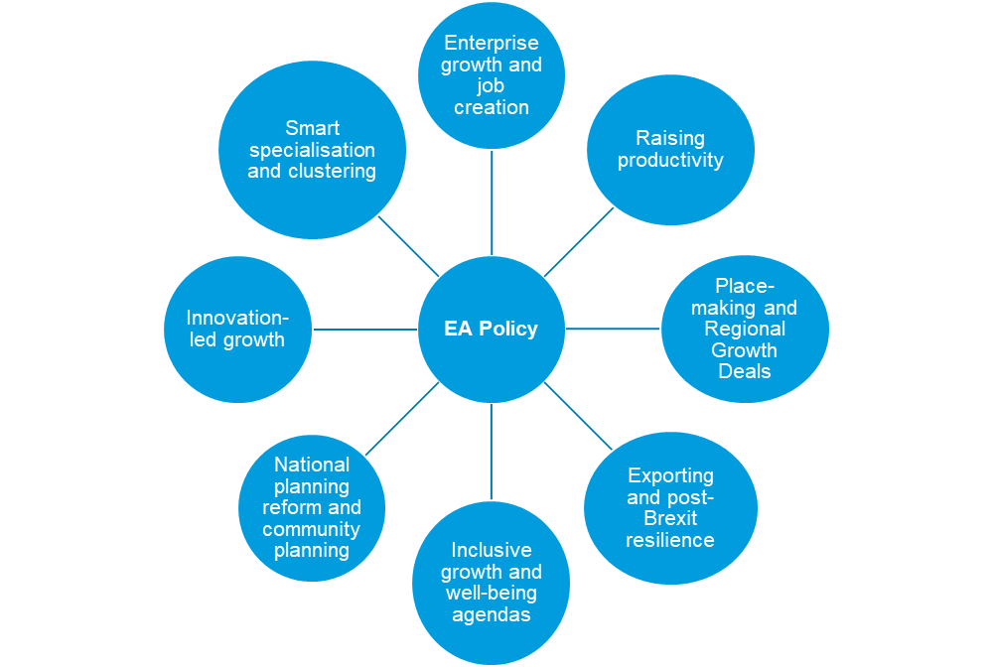

With several different policy areas where EAs could add value, any decisions made regarding strategic focus would have a significant bearing on the types of incentives required, the outcomes generated, and delivery model adopted. For instance, a focus on business growth is likely to prioritise jobs growth over inclusion impacts.
This policy focus needs to be set nationally with Scottish Government determining whether this is a targeted policy (i.e. with a focused policy objective), or broad, to provide flexibility for different localities facing different issues to tailor EAs to local needs. The evaluation findings and good practice review suggest that:
- a targeted policy focus provides a more top-down approach which provides clarity regarding the intended role and function of EAs. This will limit the range of responses and incentives required, facilitate strategic monitoring and impact assessment, and allow Scottish Government to be clear regarding the types of outputs and impacts sought.
- a broad policy focus provides greater flexibility to local partners to shape EAs to local needs and facilitates the potential contribution of EA policy to wider well-being/inclusive growth agendas and community planning approaches as well as enterprise policy. This approach is likely to result in the need for a much broader range of responses and incentives which could dilute impacts and will make impact assessment more challenging.

Stage 2: Determine the Delivery Model
Under any modified approach, Scottish Government would need to decide the level of flexibility which would be given to local partners to shape EAs or whether the EA offer would be nationally set. Options for consideration include:
- Option A: A fixed national EA offer determined by Scottish Government: Government would agree EA designation and incentives nationally. Incentives would be fixed with no local flexibility. This approach would be easier to manage and monitor than more flexible approaches, with costs understood and agreed from the outset. This approach would not address stakeholder’s requests for local flexibility, however, partners could be encouraged to consider how EAs could add value to, and be more closely integrated with, wider economic development and place-making activity through their chosen delivery model and implementation plan which should form part of any investment decision. Consideration could also be given to enhancing core incentives (see stage 4 below) to address some of the limitations of the current EA approach.
- Option B: A core national offer determined by Scottish Government but with flexibility for local partners to submit a business case for additional incentives to address specific local needs. This approach is broadly favoured by stakeholders seeking the retention of selected core incentives, but with greater flexibility to respond to local needs. This approach would be more time consuming to manage than the current approach. Total costs would not be clear from the outset but could be substantial.
The evaluation findings suggest that flexibility to tailor EAs to local needs should be considered as part of any future approach. There has been variable performance across EAs to date and therefore future EAs should only be designated where: there is a robust business case that this will address identified market failures; there is evidence and assurance that the private sector would respond to the new opportunity; and, that it would deliver value for money. The findings suggest that EAs are less effective when implemented as standalone initiatives. Regional partners should demonstrate the intended role and added value of EA designation to local and regional growth objectives by producing a business plan for agreement with Scottish Government. The business plan should identify any additional (enhanced) incentives required to successfully deliver the EA, including how local resources will be levered to enable this as well as any ‘ask’ of Scottish Government.
- Option C: A flexible approach with no national core offer and freedom for local partners to submit a business case for a locally-designed EA. As noted under option B above, this approach is partly supported by the evaluation findings but risks losing some of the core incentives which have been valued by businesses to date. This approach would be more costly to manage and monitor than other options, with total costs unknown from the outset. The approach may reduce the strategic cohesion of the policy and therefore its overall strategic impact.

Stage 3: Determining the Core National Incentives
Options A and B above would both require agreement regarding the core national EA incentives to be offered. There is support for retaining selected ‘core’ incentives. Stakeholders have broadly agreed that the financial incentives (non-domestic rate reduction and enhanced capital allowance) and streamlined planning processes of the current EA approach are additional and should be retained. However, there is also consensus that the current incentives are not significant enough to impact business investment decisions in isolation, and the inclusion of other incentives should be considered. However, stakeholders have not been able to outline how incentives could be enhanced to strength EA policy. The evaluation findings suggest that in addition to the aforementioned ‘core’ incentives, consideration should also be given to funding for a dedicated EA management function.
To be effective and generate direct impact EAs need to be adequately resourced and managed. Active site management has been identified as a key success factor within Scotland’s EAs and English Enterprise Zones. The guarantee of a dedicated EA site Manager for each EA to co-ordinate and broker other support could therefore be considered as a core element of the EA offer. This role should include proactive engagement with individual businesses as well as strategic management of the EA to maximise the impact of agglomeration effects such as:
- co-ordinating business to business networking and events;
- brokering relationships and business support;
- monitoring and impact assessment/data collection;
- marketing, liaison with SDI and development of the site proposition; and,
- being a point of contact for enquiries.
The key options for assessment are therefore:
- agree to retain a core national offer of non-domestic rate reductions, streamlined planning processes and (possibly) Enhanced Capital Allowance; or
- agree to retain a core national offer (as outlined above) with the addition of a funded site management function.
The evaluation findings do not suggest that there would be merit in further developing a national incentive offer which exceeds the above, particularly given the limited evidence of direct attributable impact. To do so would also be counter to the need for local flexibility which has emerged as a key success factor and would risk duplicating local and other mainstream provision. The evaluation findings suggest that any additional incentives should be determined locally and negotiated with Scottish Government, with a requirement placed on local partners to demonstrate how these will add value, potentially lever additional resources, and address gaps in local support provision.

Stage 4 (if applicable): Agreeing Locally-Determined ‘Enhanced’ Incentives
Options B and C above would require consideration of additional incentives which could be agreed with local partners and supported by Scottish Government. It is envisaged that this would largely be determined by local needs and agreed via the submission of a business case to Scottish Government for negotiation and agreement to ensure any additional incentives add value to mainstream provision and offer value for money. These enhanced incentives should be determined by local needs, but could include:
- an international marketing and exporting support offer - adding value to local exporting, place-making activities and the activities of SDI;
- innovation support - to broker innovation relationships;
- facilitated business to business networking/events - to maximise the potential agglomeration effects of EAs;
- investor brokerage/access to finance support - using the clustering of businesses to attract investor interest as well as targeted support to access financial supports; and,
- enhanced skills/training offer – providing a targeted offer to address specific labour market issues or business needs.
Any enhanced incentives should only be agreed if it is clearly demonstrated that they do not duplicate existing provision and address a gap in local business supports. This will be particularly important as the findings suggest that effective account management and brokerage to link businesses into existing provision may be sufficient to meet the majority of business needs.

6.4.4 Options Summary
Based on the above it is evident that any modified approach would need to be developed sequentially starting with the overall justification for intervention. Table 6.2 below provides a summary of key decision points and an indicative list of associated options for consideration:
Table 6.2: Options Summary
Decision Point | Options for Consideration
1. EA policy | - Abandon  - Continue in current form (short-term or long-term)  - Continue with a modified approach
2. EA rationale | - A targeted intervention focusing on one policy area or market failure  - A broad-based intervention providing an opportunity to address a range of policy issues and market failures
3. Delivery model | - Fixed nationally – a standardised approach  - Core elements fixed nationally with some local flexibility – a co-produced approach  - Complete flexibility for EA design and delivery model to be determined locally and agreed with Scottish Government on a case by case basis – a devolved approach
4. EA offer | - Retain non-domestic rates reduction, streamlined planning processes and (possibly) Enhanced Capital Allowance as a fixed national offer  - Retain the above EA incentives and include funding for site management as a fixed national offer  - Include additional fixed national offers or allow local partners to request an offer which would meet local needs and market failures. Options for consideration (subject to evidence of additionality, value for money, and need) could include:  - Sector-specific and supply chain development interventions;  - an international marketing and exporting support offer - adding value to local exporting, place-making activities and the activities of SDI;  - innovation support - to broker innovation relationships;  - facilitated business to business networking/events - to maximise the potential agglomeration effects of EAs;  - investor brokerage/access to finance support - using the clustering of businesses to attract investor interest as well as targeted support to access financial supports;  - enhanced skills/training offer – providing a targeted offer to address specific labour market issues or business needs; and,  - opportunities to target financial incentives on developers rather than end users.

appendix 1: Site summaries
Arnish
Designated | April 2012
Location | Western Isles
Area | North Enterprise Area
Sector Focus | Low Carbon / Renewables
Selection Rationale | Site developed by HIE as prime location for growth of renewable energy sector. Inclusion as a strategic site for integrated manufacturing in N-RIP  Wage levels are around 10% below the national average and 42% of the workforce are employed by the public sector. Creating new high paying jobs here is a top priority for HIE.
Core Incentive | Rates Relief
Site Description at designation | This site is currently spread over 43.9 hectares, with a mixture of both greenfield and brownfield land. There are 6.47 hectares available for new/redevelopments. The land is owned by the Stornoway Trust and leased by HIE.  Previous HIE investment in quay extension, roads, infrastructure and utilities services has created a multi-user/cross sector facility, as opposed to the preceding single user oil/gas sector set-up.
Economic Context | At the time of designation, the Outer Hebrides was one of the most deprived parts of Scotland. There was a very narrow economic base and outmigration which made this area economically fragile. Wage levels were around 10% below the national average and 42% of the workforce were employed by the public sector (twelve percentage points higher than the equivalent Scottish figure). Creating new, high paying private sector jobs was therefore a priority for HIE.  Since designation:  - the employment rate in the local authority has risen 7.6%, from 71.4% in 2012 to 79% in 2018;  - the number of enterprises in the local authority has increased from 1,091 enterprises in 2012 to 1,193 in 2017 – an increase of 9.3%; and  - according to the Scottish Government Annual Business Survey, GVA per head increased 7.7% between 2012 and 2017, with values of £34,527 and £37,184 respectively.  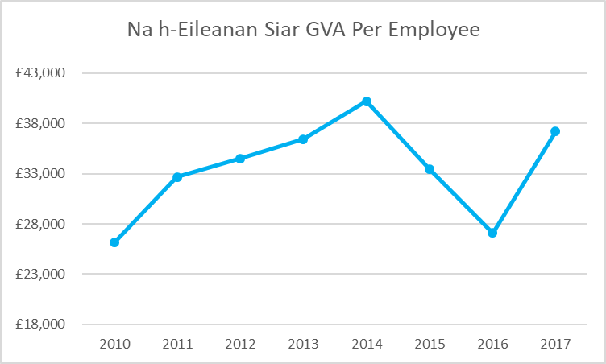
Rationale for Intervention at designation | The site was viewed as a prime location for growth of the renewable energy sector. However, at the time of designation, only one major investor based was located on the site. Additional incentive was required to increase the scale of operation and capitalise on the growth potential of a Tier one investor.
Current Performance as of 2019 | - Total No of registered companies: Three  - Total No. of companies Account Managed by HIE: One  - Total No of Jobs: 165
BioCampus
Designated | April 2012
Location | Midlothian
Area | Enterprise Area
Sector Focus | Life Sciences
Core Incentive | Rates Relief
Site Description at designation | Owned by Scottish Enterprise, the site is 9.26 hectares, sitting in the Bush bioscience cluster, Midlothian. It has 9 serviced plots, one of which is currently unoccupied. The site has a class 4 biomanufacturing restricted use and its utility servicing is currently being upgraded. It has been designed to aid companies manufacturing the latest biotechnology products.
Economic Context | Midlothian has been reliant in past years upon mining and other primary industries and latterly has had a dependence upon commuting to Edinburgh. Its future economic growth in terms of the key sectors is heavily dependent upon the ongoing success of the BioCampus and wider Science Park offering.  Since designation:  - the employment rate in the local authority has risen 3.9%, from 75.4% in 2012 to 79.3% in 2018;  - Number of enterprises increased from 2,074 in 2012 to 2,595 in 2017 – an increase of 25.1%; and  - according to the Scottish Government Annual Business Survey, GVA per head increased 6.8% in the local authority between 2012 and 2017, with values of £35,362 and £37,767 respectively.  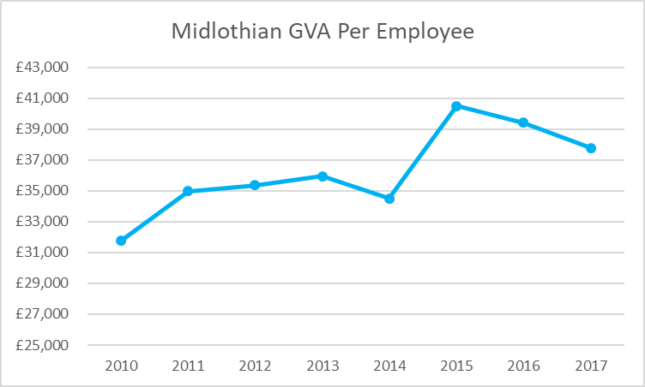
Rationale for Intervention at Designation | This site offers Life Sciences sector opportunities.  EA status will enable faster business and job creation on site and will, therefore, have a significant bearing on realising the site’s full economic capability. This has been assessed by SE as having the potential to deliver net additional direct GVA (excluding multipliers), cumulative 2011/12 to 2015/16 (2010/11 prices) of £29.4m (Upper estimate), and 484 Net additional jobs (Upper estimate).
Current Performance as of 2019 | - Total No of registered Companies: One  - Total No. of companies Account Managed by SE: One  - Total No of Jobs: 250

BioCity
Designated | April 2016
Location | North Lanarkshire
Area | Enterprise Area
Sector Focus | Life Sciences
Core Incentive | Rates Relief
Site Description at Designation | BioCity Scotland Enterprise area is 20 acres, including a 11,150 metres squared former MSD facility. Lab space is available to rent at one-months’ notice and can be scaled back with three-months’ notice. The lab space was built by Organon Laboratories. There are shared facilities at the site, such as glass wash, drying oven and gas and waste solvent stores.
Economic Context | North Lanarkshire is a Tier 2 assisted area demonstrating high levels of economic decline. The Newhouse area is economically disadvantaged, evidence through Scottish Index of Multiple Deprivation indicators and high unemployment / low employment rates.  Since designation:  - the employment rate in the local authority has risen 3.4%, from 71.3% in 2015 to 74.7% in 2018;  - the number of enterprises in the local authority has increased from 8,051 in 2015 to 8,666 in 2017 – an increase of 7.6%; and  - according to the Scottish Government Annual Business Survey GVA per head in the local authority rose 1.8% between 2015 and 2017, with values of £49,561 and £48,672 respectively.  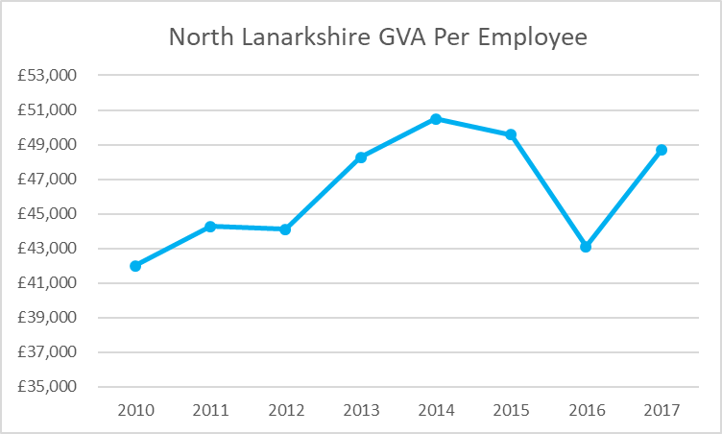
Rationale for Intervention at Designation | BioCity Scotland has been established to operate the building as specialist multi occupancy life sciences incubation space providing smaller scale units for a range of occupiers including start-ups, spin outs and SMEs.
Current Performance as of 2019 | - Total No of registered Companies: Twenty-six  - Total No. of companies Account Managed by SE: Eleven  - Total No of Jobs: 336

BioQuarter
Designated | April 2012
Location | Edinburgh
Area | Enterprise Area
Sector Focus | Life Sciences
Core Incentive | Rates Relief
Site Description at Designation | The site is 28.94 hectares and is owned by SE, University of Edinburgh, NHS and Alexandria Real Estate. It has seen significant public investment in land acquisition, infrastructure, servicing and construction by SE and others since 2002. Nine, the first commercial facility was built in 2012 and provides 7,900 square metres of laboratory and office space for life science companies and EA status has been sought to support the on-going development of the site. Through new infrastructure investment including commercial collaborative space in each new building, it houses the Royal Infirmary of Edinburgh teaching hospital, the University of Edinburgh medical school and leading medical research institutes. They have already invested over £400 million on new facilities and have plans for a further £800 million in investment.
Economic Context | The BioQuarter is located adjacent to Parc Craigmillar URC and  so, will reinforce wider efforts to support its aims and objectives to tackle economic performance issues in this part of Edinburgh  Since designation:  - the employment rate in the local authority has risen 4.8%, from 72.2% in 2012 to 77% in 2018;  - the number of enterprises in the local authority has increased from 17,970 in 2012 to 21,562 in 2017 – an increase of 20%; and  - according to the Scottish Government Annual Business Survey GVA per head in the local authority rose 10.2% between 2012 and 2017, with values of £40,843 and £44,990 respectively.  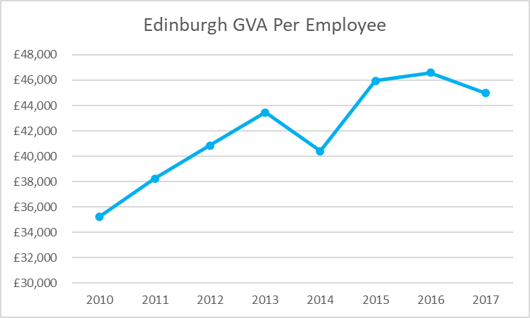
Rationale for Intervention at Designation | The BioQuarter is Scotland’s flagship life sciences project and  acceleration of progress will make a significant impact upon  progress towards achieving the life sciences strategy. The  BioQuarter Programme as a whole is expected to have an  economic impact of £327.0m (total net cumulative GVA over a 25-year period).
Current Performance as of 2019 | - Total No of registered Companies: Nineteen  - Total No. of companies Account Managed by SE: Nine  - Total No of Jobs: 564

Creative Clyde
Designated | April 2012
Location | Glasgow
Area | Growth Sectors Area
Sector Focus | Creative Industries
Core Incentive | Rates Relief
Site Description at Designation | This site is 14.5 hectares, with 14 hectares of brownfield land available for development. It is owned by Scottish Enterprise. The site is comprised of 9 units, all of which are currently unoccupied and 5 of which are being considered for demolition to make way for new development. There are plans to develop 6 units (totalling 34,070 metres squared) for office, retail or leisure purposes as well as possible hotels and housing development. A design team is working up infrastructure proposals to deliver the emerging Masterplan.  The sites are served by existing main access roads (Pacific Drive and Govan Road) and utility infrastructure. Four sites will require access infrastructure and services, three sites are already serviced. The Fastlink bus route (bus with dedicated lanes where practical) is planned to connect the city centre to the Southern General Hospital, passing through Pacific Quay.
Economic Context | Since designation:  - the employment rate in the local authority has risen 5.7%, from 59.6% in 2012 and 64.3% in 2018;  - the number of enterprises in the local authority has increased from 18,631 in 2012 to 22,523 in 2017 – an increase of 20.9%; and  - according to the Scottish Government Annual Business Survey GVA per head in the local authority rose 0.8% between 2012 and 2017, with values of £38,734 and £39,057 respectively.  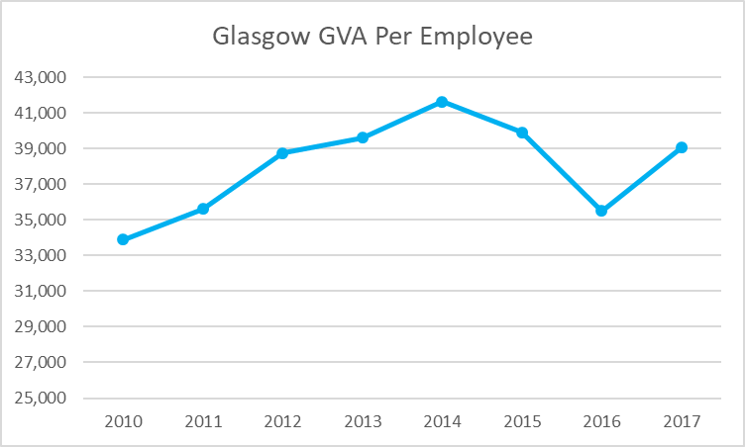
Rationale for Intervention at Designation | Enterprise Area status would enable SE and our partners to attract, support and grow companies in the creative industries and specifically target support at those Creative Industries companies that support the manufacturing sector  EA status will, therefore, have a significant bearing on realising the wider site’s full economic capability. This is set out in a new masterplan prepared for Pacific Quay which envisages around 1,500 – 2,000 new gross jobs. As such it represents a strategic opportunity to grow the Creative Industries sector in Scotland
Current Performance as of 2019 | - Total No. of registered Companies: Three  - Total No. of companies Account Managed by SE: One  - Total No of Jobs (estimate): 160

Dundee Claverhouse
Designated | April 2012
Location | Dundee
Area | East Enterprise Area
Sector Focus | Low Carbon / Renewables
Core Incentive | Enhanced Capital Allowances
Site Description at Designation | The Enterprise Area site is 67 hectares divided between Dundee Claverhouse and Dundee Port. Both sites are currently empty. The Claverhouse Site is owned by Dundee City Council. The site has an access road but requires servicing in line with needs of its users. The Port site is owned by Forth Ports who plan to invest £10 million in quayside enhancements to expand decommissioning and the renewables offering. Both sites are currently empty. The Port site has servicing which will be upgraded in line with the needs of renewables manufacturers and assemblers.
Economic Context | The economy of Dundee continues to lag behind Scotland as a whole, with GVA per capita at 93% of the Scottish Average. Employment levels similarly lag the Scottish average at a similar rate. The provision of EA status will assist Dundee’s regeneration aims and will help to close the gaps between Dundee and the Scottish average in terms of economic participation and GVA per head  Since designation:  - the employment rate in the local authority has risen 2.2%, from 64.8% in 2012 to 67% in 2018;  - the number of enterprises in the local authority has increased from 3,693 in 2012 to 4,1599 in 2017 – and increase of 12.65; and  - according to the Scottish Government Annual Business Survey, GVA per head in the local authority rose 0.6% between 2012 and 2017, with values of 34,846 and £35,059 respectively.  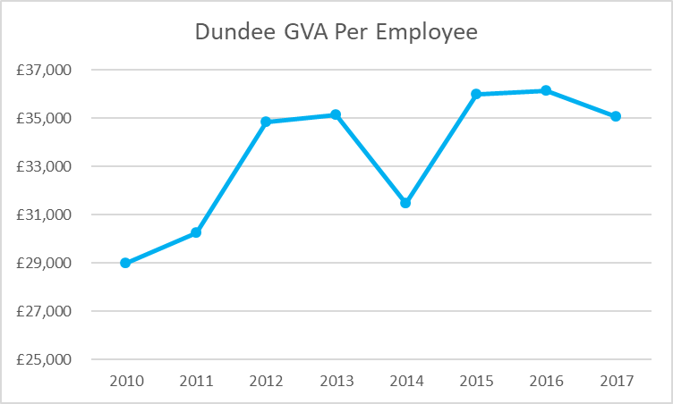
Rationale for Intervention at Designation | EA status will enable faster business and job creation on port site and will, therefore, have a significant bearing on realising the site’s full economic capability. This has been assessed by SE as having the potential to realise 3 separate manufacturing operations, with a total of 700 jobs within a five-year period.  Support sites inland in the ownership of Dundee City Council could house component suppliers to main manufacturers and the availability of EA incentives can play a part in making this more likely.  This site offers Energy Sector opportunities. Upgrades in line with the needs of renewables manufacturers and assemblers.
Current Performance as of 2019 | - Total No. of registered Companies: None  - Total No. of companies Account Managed by SE: None  - Total No of Jobs: 0

Forres Enterprise Park
Designated | April 2012
Location | Highlands
Area | Enterprise Area
Sector Focus | Life Sciences
Core Incentive | Rates Relief
Site Description at Designation | The site comprises 9.3 hectares of greenfield development, with 5 zones available for further development. It is owned by HIE. They currently have 1,110 metres squared of Grade A space available to let.
Economic Context | Closure of RAF Kinloss has had an impact on the local economy and the number of people claiming unemployment benefit has risen by 9.5% in the past year. Average wages are 13% below the Scottish level emphasising the need for diversification into new, higher value-added sectors.  Since designation:  - the employment rate in the local authority has risen 4.6%, from 76.6% in 2012 to 81.2% in 2018;  - the number of enterprises in the local authority has increased from 9,957 in 2012 to 11,087 in 2017 – an increase of 11.3%; and  - according to the Scottish Government Annual Business Survey, GVA per head in the local authority decreased by 0.7% between 2012 and 2017, with values of £40,426 and £40,144 respectively.  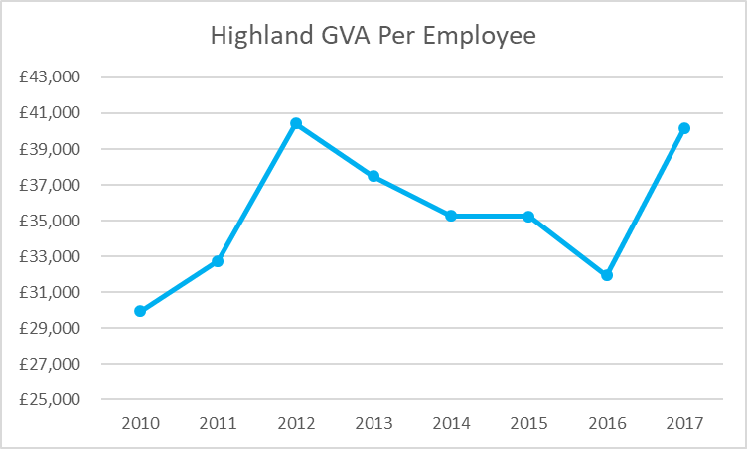
Rationale for Intervention at Designation | The site is suited to high tech manufacturing and has had considerable interest from life sciences manufacturing companies. A cluster of expertise in the P4 Digital Healthcare sector is developing along the Inverness – Elgin corridor which  is attracting interest from multinationals and SME's from Europe and beyond. The regional life science sector has expanded from 50 active organisations in 2009 to 80 in 2011 almost exclusively through activity in P4 Digital healthcare. It requires space to expand and this is a key site offering scope to do so, facilitating the expansion of new investors such as Accunostics.
Current Performance as of 2019 | - Total No. of registered Companies: 18  - Total No. of companies Account Managed by HIE: One  - Total No of Jobs: 470

Hatston
Designated | April 2012
Location | Orkney
Area | North Enterprise Area
Sector Focus | Low Carbon / Renewables
Core Incentive | Rates Relief
Site Description at Designation | The site is an 11-hectare brownfield development with 9 hectares currently available for redevelopment. The site is owned by Orkney Islands Council. There are currently six light industrial units constructed by HIE, totalling 1,230 metres squared, 200 metres squared of which are occupied. There is 1,270 metres squared of light industry space planned and £620k private investment. The site is located off Grainshore Road, which is identified as a ‘main road corridor’ in the Kirkwall Urban Design Framework.
Economic Context | Since designation:  - the employment rate in the local authority has risen 6.2%, from 81.3% in 2012 to 87.5% in 2018;  - the number of enterprises in the local authority has increased from 927 in 2012 to 1,054 in 2017 – an increase of 13.7%; and  - according to the Scottish Government Annual Business Survey, GVA per head in the local authority rose 25%, with values of £38,485 and £48,112 respectively.  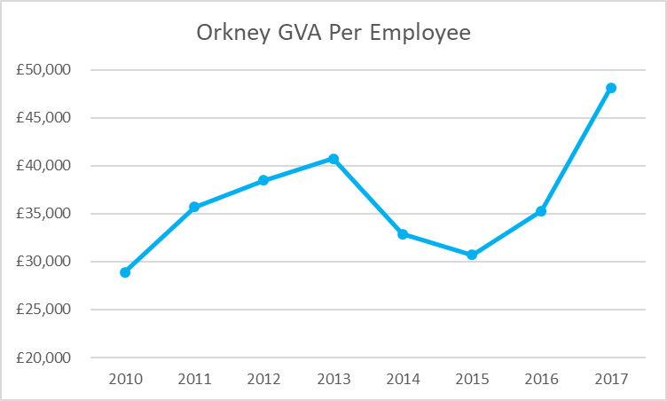
Current Performance as of 2019 | - Total No. of registered Companies: 2  - Total No. of companies Account Managed by HIE: One  - Total No of Jobs: 32

Inverness Campus
Designated | April 2012
Location | Highlands
Area | Enterprise Area
Sector Focus | Life Science
Core Incentive | Enhanced Capital allowances / Rates Relief
Site Description at Designation | The site is comprised of 36 HIE-owned greenfield hectares which are available for development. There is a building offering space to Life Sciences businesses which covers 1000 metres squared over two floors and has been built with expansion potential. A second building is in the process of being developed and will be 2,300 metres squared over 2 floors and could be used as office or lab space. Construction is due to have been completed in Spring 2019.
Economic Context | The Inner Moray Firth area has seen the number of people claiming unemployment benefit rise a further 6% in the year to September 2011, and wage levels in the area are 10% below the Scottish average. Reliance on the public sector for employment needs to be rebalanced and closure of Kinloss as an RAF base will also result in skilled labour in need of new opportunities  Since designation:  - the employment rate in the local authority has risen 4.6%, from 76.6% in 2012 to 81.2% in 2018;  - the number of enterprises in the local authority has increased from 9,957 in 2012 to 11,087 in 2017 – an increase of 11.3%; and  - according to the Scottish Government Annual Business Survey, GVA per head in the local authority decreased by 0.7% between 2012 and 2017, with values of £40,426 and £40,144 respectively.
Rationale for Intervention at Designation | A cluster of expertise in the P4 Digital Healthcare sector is developing along the Inverness – Elgin corridor which is attracting interest from multinationals and SME's from Europe and beyond. The regional life science sector has expanded from 50 active organisations in 2009 to 80 in 2011 almost exclusively through activity in P4 Digital healthcare. It requires space to expand and the provision of incubation units adjacent to research expertise at the campus will provide a platform for sectoral growth.
Current Performance as of 2019 | - Total No. of registered Companies: 10  - Total No. of companies Account Managed by HIE: Zero  - Total No of Jobs: 66

Irvine
Designated | April 2012
Location | North Ayrshire
Area | Enterprise Zone
Sector Focus | Life Sciences
Core Incentive | Enhanced Capital Allowances / Rates Relief
Site Description at Designation | The site is 132 hectares, comprising 15 plots of serviced land at Irvine Innovation and Industry Park, Annickbank Innovation Campus and expansion land at GSK’s Irvine plant. 97 hectares are eligible for Enhanced Capital Allowances and 35 hectares eligible for rates relief. The site is owned by Scottish Enterprise, GSK, Irvine Bay Regeneration Company and a limited number of private sector owners.  There is a full range of potential life science sector uses catered for from R&D, clean room and office to large scale manufacturing. There were 7 buildings (30,660 metres squared) of industrial/office buildings completed prior to April 2012, with 1,210 metres squared of offices occupied.  The site is capable of providing up to 35 MVA of electricity immediately, with up to 100 MVA available if required, together with industrial capacities of gas, water and drainage. In addition to being well served with utilities, it has exceptional broadband connectivity with three suppliers of fibre optic cable both within and close to the site for superfast broadband connection.  GSK was the only Life Sciences company located within the EA site, employing in excess of 500 permanent and contracted staff.
Economic Context | Currently North Ayrshire has difficult labour market conditions, experiencing the highest unemployment rate (by claimant count) by local authority area in Scotland.  Unemployment in North Ayrshire (Jan-Dec 2010) was 11.9% compared to the Scottish average of 7.7%.  A recent TUC Report (May 2011) identified North Ayrshire as the 4th worst employment black spot in the UK based on the claimant to vacancy ratio  The 2009 Scottish Index of Multiple Deprivation showed that North Ayrshire is in the top five Local Authorities with the largest proportion of their data zones in the 15% most deprived with 24% compared the Scottish average of 15%  Since designation:  - the employment rate in the local authority has risen 8.5%, from 61.8% in 2012 to 70.3% in 2018;  - the number of manufacturing jobs increased 4.9% between 2012 and 2017;  - the number of enterprises in the local authority has increased from 3,056 in 2012 and 3,611 in 2017 – an increase of 18.2%  - According to the Scottish Government Annual Business Survey, GVA per head in the local authority decreased by 0.01% between 2012 and 2017, with values of £44,392 and £44,386 respectively.  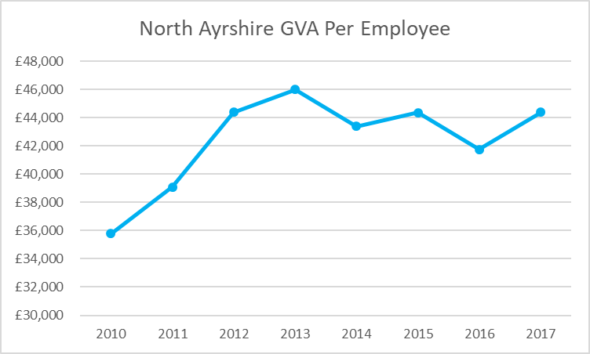
Rationale for Intervention at Designation | It is estimated that EA status for Irvine could help to accelerate the site’s full economic development potential, 70% of which will be within manufacturing, leading to 2615 jobs of which 750 would be high value manufacturing (assuming EA status helps to secure the GSK investment) in the first 10 years.  The economic implications of the proposed bio manufacturing plant would be very significant. Whilst no formal economic impact assessment has been carried out to date, the capital investment is expected to be c£350m and over 500 high value jobs created. For a local development brief/scenario that is similar in nature to this EA proposal, it is estimated that an additional £44m pa GVA could be achieved through 2,615 jobs accommodated in 36,700 metres squared of accommodation.  This site offers Life Sciences Sector opportunities
Current Performance as of 2019 | - Total No. of registered Companies: Twenty-Six  - Total No. of companies Account Managed by SE: Seven  - Total No of Jobs: 800

Leith Port
Designated | April 2012
Location | Edinburgh
Area | East Enterprise Zone
Sector Focus | Low Carbon / Renewables
Core Incentive | Enhanced Capital Allowances
Site Description at Designation | The 60-hectare site is majority-owned by Forth Ports, with a smaller Network Rail holding. It is a working cargo port with some cruise ship traffic and some onsite manufacturing operations and current infrastructure supports these uses.  Plans are being developed for significant new infrastructure to support offshore wind manufacture and assembly at the port, focusing on the need for a new outer berth. This could be ‘future-proofed’ to enable large cruise ship visits in the future. Other infrastructure/ site servicing will be developed as required to support new port uses.  Leith is also one of the Scottish Government approved TIF (Tax Investment Financing) pilot project locations. Plans are being developed for £84m of enabling infrastructure projects in Leith, with a link road between Seafield Road and Constitution Street being the first project under consideration.  The site has some existing buildings for storage and manufacturing uses but is mainly open land used for cargo operations.  Approximately 800 workers on site (2012 port employment baseline) at the two landowners, a pipe coatings company, a marine renewables company, and a series of smaller operations.
Economic Context | Although a Tier 3 assisted area, Leith has not benefitted from the Edinburgh impact over the past few years as the residential market has suffered a severe downturn. Enterprise Area status would help to create local manufacturing opportunity and new employment.  Since designation:  - the employment rate in the local authority has risen 4.8%, from 72.2% in 2012 to 77% in 2018;  - the number of enterprises in the local authority has increased from 17,970 in 2012 to 21,562 in 2017 – an increase of 20%; and  - according to the Scottish Government Annual Business Survey, GVA per head in the local authority rose 10.2% between 2012 and 2017, with values of £40,843 and £44,990 respectively.
Rationale for Intervention at Designation | This is a key location for the development of the supply chain to support the offshore wind sector with the largest potential area of development land of all the east coast Scottish ports. This site offers Energy Sector opportunities.
Current Performance as of 2019 | - Total No. of registered Companies: Two plus a number of smaller companies  - Total No. of companies Account Managed by SE: None  - Total No of Jobs: Unknown

Lyness
Designated | April 2012
Location | Orkney
Area | North Enterprise Area
Sector Focus | Low Carbon / Renewables
Core Incentive | Rates Relief
Site Description at Designation | Lyness is a 14-hectare Orkney Islands Council (OIC) owned site, which has a 6.9-hectare brownfield site available for development.  It comprises a former MOD naval base in Scapa Flow harbour with a £3 million upgrade of pier and shore-side facilities completed by OIC in 2011, 265m of refurbished quay edge, and 4,000 square metres of hard standing. It is currently used extensively by wave developers undertaking device testing at EMEC's Billia Croo site.  OIC is planning and costing site servicing and re-alignment of access roads to open up site development, taking account of existing listed structures, including the naval heritage centre. There are also plans to establish marine gas oil storage facilities and 300,000 square metres of new laydown space to supplement new deep-water berths.
Economic Context | Identified as a key N-RIP Marine site. Lyness has signed up several developers who have shown strong interest in using the site. Working closely with Hatston and Scrabster the agglomerated benefits to the north of Scotland could be considerable through the sharing of expertise and specialist equipment, reducing the cost and time associated with developing each individual site.  Since designation:  - the employment rate in the local authority has risen 6.2%, from 81.3% in 2012 to 87.5% in 2018;  - the number of enterprises in the local authority has increased from 927 in 2012 to 1,054 in 2017 – an increase of 13.7%; and  - according to the Scottish Government Annual Business Survey, GVA per head in the local authority rose 25%, with values of £38,485 and £48,112 respectively.
Rationale for Intervention at Designation | While unemployment remains low in Orkney, the islands have a very narrow economic base. Over 36% of all jobs are in the public sector, compared to 30% at the Scottish level and wages are 8% below the national average. Creating new, high value-added jobs in the renewable energy sector is a priority for HIE
Current Performance as of 2019 | - Total No. of registered Companies: None  - Total No. of companies Account Managed by HIE: None  - Total No of Jobs: 0

Nigg
Designated | April 2012
Location | Highlands
Area | North Enterprise Area
Sector Focus | Low Carbon / Renewables
Core Incentive | Enhanced Capital Allowances
Site Description at Designation | This site has 66 hectares of brownfield land available for development as part of its wider 96-hectare site. It is owned by Global Energy Nigg Ltd.  The covered fabrication facilities on the site are amongst the largest of this type in Europe, offering in excess of 36,000 square metres of climatically controlled environment. The open area of the yard contains a large dry dock, an assembly/ erection area and materials storage areas. The yard has quay frontage providing access to one of the finest deep-water natural anchorage facilities in Europe, with unrestricted access to the North Sea. The facility is well suited and equipped for all types of heavy construction, including new build, inspection and repair, and decommissioning.
Economic Context | Inclusion as a strategic site for integrated manufacturing in NRIP exercise demonstrates its potential to be a real driver again of economic growth in the region. Agglomeration benefits from similar developments at Ardersier could be considerable through sharing of expertise, equipment and lay-down areas  Since designation:  - the employment rate in the local authority has risen 4.6%, from 76.6% in 2012 to 81.2% in 2018;  - the number of people claiming unemployment benefit has fallen from 3% to 2.5% (Jan 2012 to May 2019)  - the number of enterprises in the local authority has increased from 9,957 in 2012 to 11,087 in 2017 – an increase of 11.3%; and  - according to the Scottish Government Annual Business Survey, GVA per head in the local authority decreased by 0.7% between 2012 and 2017, with values of £40,426 and £40,144 respectively.
Rationale For Intervention at Designation | The Inner Moray Firth area has seen the number of people claiming unemployment benefit rise a further 6% in the past year and wage levels in the area are 10% below the Scottish average. Reliance on the public sector for employment needs to be rebalanced and this sector offers the potential to create new, high paying jobs in the private sector.
Current Performance as of 2019 | - Total No. of registered Companies: One  - Total No. of companies Account Managed by HIE: One  - Total No of Jobs: 500

Prestwick
Designated | April 2012
Location | South Ayrshire
Area | Growth Sectors Enterprise Area
Sector Focus | Aerospace
Core Incentive | Rates Relief
Site Description at Designation | The site is 29.1 hectares, with 9.72 greenfield hectares available for development. It is owned by Scottish Enterprise. The Enterprise Area is located within Prestwick Aerospace Park which houses more than 50% of Scotland’s aerospace workforce.  3,900 metres squared of business units were developed before Apr 2012, 1,670 square metres of which are occupied. There is 2,000 metres squared of speculative industrial development being planned. There is 42,320 metres squared of office or industrial development potential on 7 plots. The site is fully serviced except for two plots which are partially serviced. There were two companies located in the enterprise area prior to Apr 2012 with a headcount of 40.  The site has a comprehensive transport infrastructure with motorway access, rail links, sea ports and an international airport on site.
Economic Context | Unemployment in South Ayrshire (Jan-Dec 2010) was 9.0% compared to the Scottish average of 7.7%.  Qualifications in South Ayrshire are marginally lower than the Scottish average across most NVQ levels and the area equals the Scottish average for individuals with no qualifications at 12.3%  VAT Registered Business in South Ayrshire is 8.9% (Scotland 10.3%)  The 2009 Scottish Index of Multiple Deprivation showed that in South Ayrshire 12.2% of the datazones are in the 15% most deprived.  GVA(2008) in South Ayrshire is £17,298 per head which is lower than the Scottish figure of £20,031  Since designation:  - the employment rate in the local authority has not changed, being 69.9% in both 2012 and 2018;  - the number of enterprises in the local authority has increased from 3,335 in 2012 to 3,730 in 2017 – an increase of 11.8%; and  - according to the Scottish Government Annual Business Survey, GVA per head in the local authority rose 11.5% between 2012 and 2017, with values of £39,446 and £43,999 respectively.  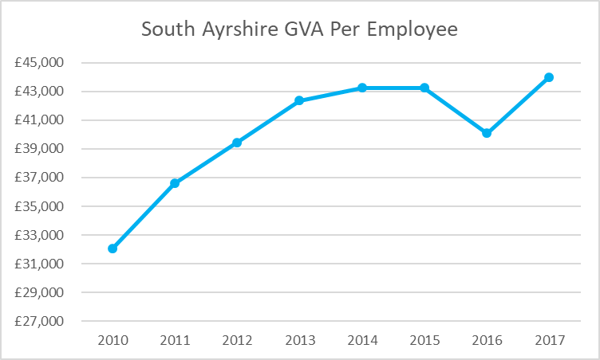
Rationale For Intervention at Designation | This site offers opportunities in the Aerospace sector.  Based on the potential 42,500 square metres of floor space still to be created as well as the speculative business space still to be let, approximately 900 – 1,000 new jobs could be created.
Current Performance as of 2019 | - Total No. of registered Companies: 11  - Total No. of companies Account Managed by SE: Six  - Total No of Jobs: 320

Scrabster
Designated | April 2012
Location | Highlands
Area | North Enterprise Area
Sector Focus | Low Carbon Renewables
Core Incentive | Rates Relief
Site Description at Designation | The site is 14.03 hectares, owned by Scrabster Harbour Trust. Infrastructure investment is required to transform the site from greenfield to a state ready to accommodate new industrial economic activity. Planning permission has been granted for installation of roads, site servicing and drainage to service industrial development. There is likely to be a revised planning application submitted to achieve greater plot ratio and improved access. There are currently no companies located in Enterprise Area site.
Economic Context | Caithness has been identified by HIE as an area of employment deficit due to the economy’s heavy reliance on the Dounreay Nuclear site for jobs and investment over the past half century. Diversifying the economy into new high paying sectors – to replace jobs lost through the run down of Dounreay (around 2,000 in total) – is therefore a top priority.  Since designation:  - the employment rate in the local authority has risen 4.6%, from 76.6% in 2012 to 81.2% in 2018;  - the number of enterprises in the local authority has increased from 9,957 in 2012 to 11,087 in 2017 – an increase of 11.3%; and  - according to the Scottish Government Annual Business Survey, GVA per head in the local authority decreased by 0.7% between 2012 and 2017, with values of £40,426 and £40,144 respectively.
Rationale For Intervention at Designation | Scrabster is identified as a priority site in the N-RIP Northern Marine cluster. Given the right incentives, the site is set to become a real driver of growth in wave and tidal renewable activity in Caithness. Working closely with Hatston and Lyness the agglomerated benefits to the north of Scotland could be considerable through the sharing of expertise and specialist equipment, reducing the cost and time associated with developing each individual site within the cluster.
Current Performance as of 2019 | - Total No. of registered Companies: 0  - Total No. of companies Account Managed by HIE: 0  - Total No of Jobs: 0

West Lothian
Designated | April 2013
Location | Eliburn - Livingston
Area | Growth Sector Enterprise Zone
Sector Focus | Food And Drink Manufacturing
Economic Context | Since designation:  - the employment rate in the local authority has risen 1.9%, from 74.2% in 2012 to 76.1% in 2018;  - the number of enterprises in the local authority has increased from 4,546 in 2012 to 5,365 in 2017 – an increase of 18%; and  - according to the Scottish Government Annual Business Survey, GVA per head in the local authority rose 2.9% between 2012 and 2017, with values of £41,553 and £42,778 respectively.  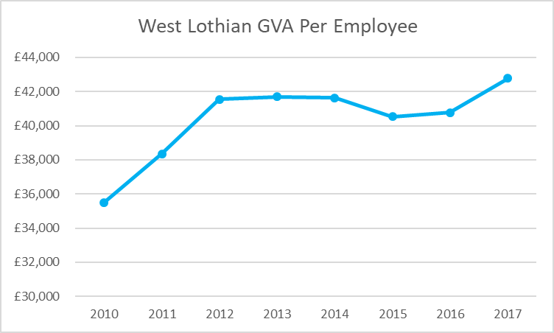
Current Performance as of 2019 | - Total No. of registered Companies: 0  - Total No. of companies Account Managed by SE: 0  - Total No of Jobs: 0

West Lothian
Designated | April 2013
Location | Broxburn
Area | Growth Sectors Enterprise Area
Sector Focus | Food And Drink Manufacturing
Economic Context | Since designation:  - the employment rate in the local authority has risen 1.9%, from 74.2% in 2012 to 76.1% in 2018;  - the number of enterprises in the local authority has increased from 4,546 in 2012 to 5,365 in 2017 – and increase of 18%; and  - according to the Scottish Government Annual Business Survey, GVA per head in the local authority rose 2.9% between 2012 and 2017, with values of £41,553 and £42,778 respectively.
Current Performance as of 2019 | - Total No. of registered Companies: 0  - Total No. of companies Account Managed by SE: 0  - Total No of Jobs (estimate): 0

appendix 2: city region and growth deals
It should be noted that the information in this Appendix was current at the time this report was written.
City Region Deals
City Region Deals are agreements between the Scottish Government, the UK Government and local government designed to bring about long-term strategic approaches to improving regional economies. They are implemented by regional partners and overseen by the Scottish City Region Deal Delivery Board. Each deal is tailored to its city region, reflecting its individual economic strengths and weaknesses, and comprises a programme of interventions to support positive, transformative change. The Scottish Government is committed to 100% coverage of Scotland by City Region and Growth Deals. Current deals are highlighted below.
Glasgow City Region Deal – The Scottish Government are contributing £500 million to the £1.13 billion Glasgow City Region Deal Infrastructure Investment Fund over 20 years. The regional partners estimate that the overall investment of £1.13 billion will deliver around 29,000 jobs in the region and attract around £3.3 billion of private sector investment in infrastructure, business growth and skills.
As part of the City Deal, the UK Government and local leaders agreed to support the establishment of MediCity Scotland located in the campus of BioCity. The UK Government provided £1.2 million of capital funding in 2014/15 matched with up to £2.79 million of local funding, with significant contributions from BioCity Scotland and North Lanarkshire Council.
Aberdeen City Region Deal – The Scottish Government are committed to invest up to £125 million to the Aberdeen City Region Deal, supplemented by up to £44 million committed by Aberdeen City Council, Aberdeenshire Council, and other local partners. The 10-year deal aims to encourage investment in innovation, internationalisation, digital connectivity, and infrastructure across the region.
Inverness and Highland City Region Deal – The Scottish Government have committed up to £135 million to the Inverness and Highland City Region Deal. The UK Government has committed up to £53 million, supplemented by up to £127 million from the Highland Council and regional partners over 10 years. Regional partners estimate that this £315 million package could attract an additional £800 million of investment by the private sector. The deal will support improvements to the region's digital connectivity, digital healthcare, skills, innovation and infrastructure, with the aim of stimulating long-term productivity and economic growth. Highlands and Islands Enterprise have brought £3m of funding into “The Northern Innovation Hub” which is designed to build on the sector strengths of the city region. The hub aims to accelerate business growth through measures to improve business competitiveness at a UK and international level.
Stirling and Clackmannanshire City Region Deal – Both the Scottish Government and the UK Government have committed up to £45.1 million each towards the Stirling and Clackmannanshire City Region Deal. Regional partners will match this investment with up to £123.8 million, resulting in a deal worth over £214 million. Regional partners estimate that over the next 10 to 15 years City Deal funded interventions will unlock private investment worth in excess of £640 million, delivering over 5,000 new jobs across a wide range of sectors in the City Region.
Edinburgh and South East Scotland City Region Deal – Both the Scottish Government and the UK Government have each committed £300 million to the deal over 15 years. Regional partners - including local authorities, universities and colleges, and the private and third sectors – have also committed to invest, resulting in an overall deal package worth more than £1.3 billion. This will deliver inclusive economic growth across the region through housing, innovation, transport, skills and culture. The investment will contribute towards 41,000 new homes, 21,000 jobs, and improving the skills of an estimated 14,700 people.
As part of the deal, the Usher Institute, located at Edinburgh BioQuarter, was earmarked to drive health and social care innovation at scale by drawing on Scotland’s mature and world-leading health data assets, and well established governance and data-sharing protocols developed in partnership with the National Health Service and the Scottish Government.
Tay Cities Region Deal – Both the Scottish Government and the UK Government have each committed up to £150 million over 10 to 15 years towards the Tay Cities Region Deal. Together with regional partners’ contributions, this deal has the potential to secure more than 6,000 jobs and attract £400 million of investment. The overall deal seeks to transform the region by focusing on inclusion, innovation, internationalisation, connectivity and empowerment. The region’s Biomedical sector sustains more than 4,000 high-value jobs in research, development and manufacturing. With the active support of Scottish Enterprise, the City Region Deal seeks to build on the international reputation in Biotech and MedTech industries
Regional Growth Deals seek to build on City Deals to give region’s much greater control over place-making interventions and greater flexibility to respond to local needs and opportunities. The UK Government announced its support for those deals not already being supported (Islands, Falkirk and Argyll & Bute) on 28 July 2019 matching the Scottish Government’s commitment to 100 per cent coverage of Scotland with Growth Deals.
The Scottish Government is committed to City Region and Growth Deals for every part of Scotland and further development of Regional Economic Partnerships (REPs) inspired by them. Further development of strong and productive REPs is being supported to represent every community in Scotland as they are seek as key to maximising the impact of Growth Deals.

Some REPs are already in place and formalised, building on the collaboration required in order to obtain and deliver Growth Deals. To allow for flexibility, the Scottish Government has not been prescriptive about how these should be formed, only that they should have effective governance and strong, purposeful leadership, focussed on regional inclusive growth. The success of each REP will depend on what they do, where they do it, and for whom, rather than what they look like. The private sector is key to their success and should be embedded into partnerships.
.
Ayrshire Growth Deal – The Scottish and UK Governments signed a Heads of Terms agreement for the Ayrshire Growth Deal in March 2019. The Scottish Government committed up to £103 million investment over the next 10 years to deliver inclusive growth across Ayrshire. The UK Government will also be investing £103 million into the region over the next 15 years and regional partners will contribute £45.5 million to a total Deal worth £251.5 million. Regional partners estimate the deal will create 7,000 new jobs and unlock an additional £300 million from the private sector. The Scottish Government’s investment includes £40 million for innovative projects around engineering, manufacturing and digital automation, £30 million for an Aerospace and Space Programme, £18.5 million for tourism and regeneration and £14.5 million for regional projects around skills, community wealth building and digital infrastructure.
Both Governments, and North Ayrshire Council, will support new developments at the i3 Irvine Enterprise Area Advanced Manufacturing Space in Irvine, which will create a regionally significant and nationally recognised centre of excellence in Digital Automation, building on current Life Science Clustering at the site, and facilitate start up, spin out, and growth of Life Science businesses and other advanced manufacturing opportunities. This will see investment of up to £11 million from the Scottish Government, £5 million from the UK Government, and £5 million from North Ayrshire Council.
Borderlands Inclusive Growth Deal - The Borderlands Partnership involves five local authorities: Dumfries and Galloway, Scottish Borders, Carlisle City, Cumbria and Northumberland working together to promote inclusive economic growth. The Borderlands partners have identified priority themes that they consider will transform the region as a whole. A quantum for the Deal was announced on 13 March 2019, with £85 million investment from the Scottish Government and £65 million from the UKG for investment in Scotland, as part of a £345 million Deal. Heads of Terms for the Deal was agreed on the 1 July 2019.
Moray Growth Deal – The Scottish Government is working with Moray Council and the UK Government towards Heads of Terms for the deal which will define the specific activities to be supported.
Falkirk Growth Deal – The Scottish Government is working with Falkirk Council and its partners to help develop and refine a growth deal proposition to enable focused, strategic investment to deliver inclusive growth in the area.
Argyll & Bute Growth Deal – Argyll & Bute Council and partners have identified potential investment opportunities to help build a resilient economy. The Scottish Government is working with the Council to help it develop its growth deal proposition.
Islands Growth Deal – The three Island Councils, Orkney, Shetland, and Western Isles, have identified a number of key innovation themes where projects can be supported by cross-island collaborative activity, plus projects unique tom each area. The Islands are working with partners to refine their proposals.

Appendix 3: other support provision

Being located in an EA is not a determinant of access to other support, but businesses can benefit from a broad portfolio of interventions. The following provides an overview of the wider support services and products taken up by businesses within EAs (i.e. not EA incentives). Data has been taken from SE’s account management database and was provided by HIE for EAs within its operational area. It may not capture all businesses located on EAs and is based on a different data source to information provided in Appendix 1 and therefore some values may differ. SDS data is based on their interactions/engagement with a list of businesses assumed to be located within EAs and provided by SE.

SE Account Managed Businesses
Table 1 below shows the proportion of businesses in EAs that have received some aspect of support from an enterprise agency between 2012-2019. It highlights that not all companies located within the boundaries of an EA have received additional support from their respective Enterprise agencies. This therefore suggests that there is not necessarily a relationship between location in an EA and the take-up of wider business and skills supports. However, based on the total number of businesses recorded within SE’s database, approximately 10% of businesses located in EAs have not accessed wider supports, compared with 15% of businesses located outside EAs.
Table 1: Percentage of Businesses Located in EAs that are SE/HIE Account Managed
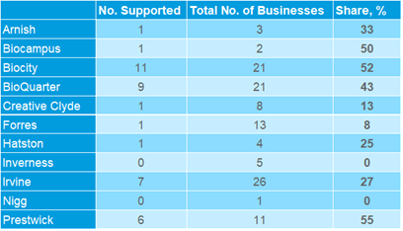
Source: Scottish Enterprise/Highlands and Islands Enterprise Account Management Database
Figure 2 below shows the total number of support products awarded by SE and/or HIE to businesses within EAs between 2011/12 and 2017/18. The graph illustrates that BioCity and BioQuarter benefited from the highest level of support products although without robust monitoring data, there is no evidence to determine why this is the case or whether location in the EA was a factor. Support products include the following interventions: business improvement; business innovation; investment grants; market development; high growth ventures; strategy support; skills and development; workplace innovation; research & development. Of these, market development, high growth ventures and workplace innovation were most frequently accessed.
Figure 2: No. of Support Products Provided
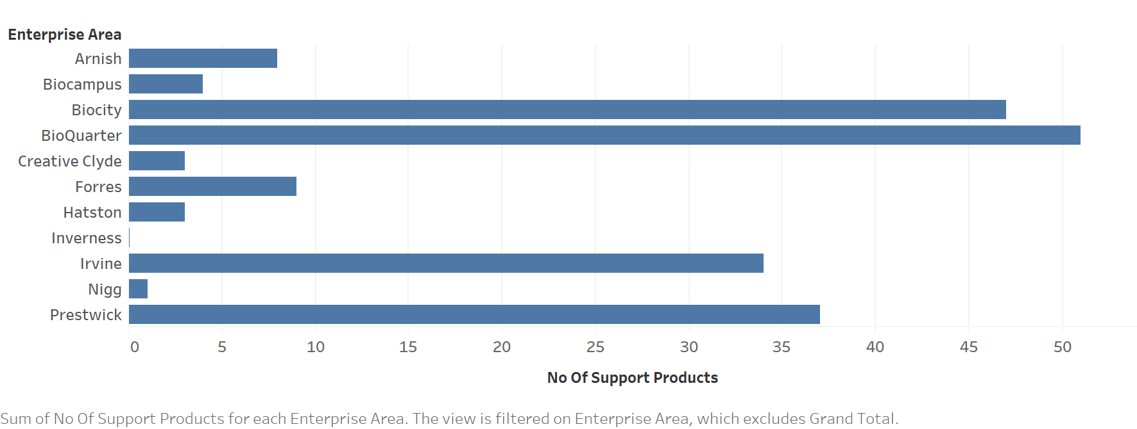
Source: Scottish Enterprise Account Management Database

SDS Support Provision

Engagement with SDS Sector Managers
SDS’ team of Sector Managers perform a strategic role, supporting skills planning across the following sectors in Scotland: construction; creative industries; engineering; energy; financial & business services; ICT and Digital; food & drink; health & social care; life & chemical sciences; and tourism.
Typically, the Sector Managers work in their respective sectors focussing on the implementation of Skills Investment Plans (SIPs) in collaboration with industry. The SIPs are evidence-based documents which highlight the priorities that need to be addressed to support the sector’s future growth ambitions and put in place actions to address these. The Sector Managers work extensively with employers, either through the Industry Leadership Groups (ILGs) or on a more direct basis in relation to a wide range of industry projects.
Although there is not a causal link between location in an EA and engagement with SDS Sector Managers, feedback from SDS Sector Managers has revealed that engagement with EA businesses has been most significant within the Life & Chemical Sciences and Energy sectors. For example:
- Life & Chemical Sciences:
  - Companies from the Irvine and BioCity EAs have participated in the Scottish Life Sciences Internship programme, which is an initiative managed by Lanarkshire Enterprise in collaboration with SDS and the Association of Graduate Careers Advisory Service (AGCAS) and ScotGrad. The scheme allows undergraduates studying a Life Science degree at Scottish Universities to undertake a 10-12-week placement to improve employability skills.
  - Companies from the BioQuarter and Irvine EAs have either supported the delivery of, or attended the Regulatory & Quality course, which was developed and run by SDS in partnership with Scottish Enterprise. This course aims to upskill existing staff in a priority area identified by the Life and Chemical Sciences Skills Investment Plan.
  - Some companies in the EAs have also taken up opportunities to work with SDS to support wider skills development in the industry by: sitting on the industry skills group; contributing to the development of National Occupational Standards; promoting apprenticeships at industry events; and, leading on the delivery of the Digital Masterclass.
- Energy:
  - The SDS energy sector manager has engaged with companies in the Forres and Nigg Enterprise Areas. The nature of this engagement has included Circular Economy and representation on the Energy Jobs Taskforce which was set up by SG.

Uptake of Modern Apprenticeships (MAs)
A review of information relating to the uptake of MAs by the companies in the EAs reveals that:
- There has been a total of 303 MA starts between 2012/13 and 2018/19 (see Table 3 below);
- The number of MAs in the EAs increased marginally, from 22 in 2012/13 to 34 in 2018/19;
- The number of MAs peaked at 76 starts in 2014/15; and,
- The greatest volume of MA starts has been in Irvine, with 95 MA starts in total between 2012/13 and 2018/19.
Table 3: Uptake of MAs amongst EA Businesses 2012/13 to 2018/19
 | MA Starts 2012/13 – 2018/19
 | 2012/13 | 2013/14 | 2014/15 | 2015/16 | 2016/17 | 2017/18 | 2018/19 | Total
BioCampus |  |  |  | 15 | 11 |  | 5 | 31
BioQuarter |  |  |  |  |  |  | * | *
Creative Clyde |  |  |  |  | * | * | * | *
Forres |  | * | 33 | 15 | * | 11 | 7 | 70
Irvine | 8 | * | 37 | * | 7 | 18 | 9 | 95
Nigg | * | 46 | * |  |  |  |  | 55
Prestwick International | * | 12 | * | * | * | * | 8 | 43
Total | 22 | 63 | 76 | 44 | 24 | 40 | 34 | 303
Source: SDS (* Disclosure control is applied to values less than five or where numbers can be identified by differencing). EAs not included have not had any MA starts

Engagement with SDS employer engagement interventions
SDS offer a number of employer engagement products and colleague interactions with businesses, including:
- Partnership Action for Continuing Employment (PACE) – the national strategic partnership framework for responding to redundancy situations;
- Work-Based Learning (WBL) – typically engagements with companies to prepare them for engagement with SDS’ Apprenticeship Family;
- Skills for Growth (SfG) – a free diagnostic service for businesses of between five and 250 employees, helping them plan and achieve their business growth ambitions through staff consultation, dedicated adviser support, and development of a tailored action plan for each business;
- Flexible Training Opportunities (FTO) – no longer operating, but FTO was open to businesses with 100 employees or less and offered funding of up to £5,000 towards employee training costs; and,
- Low Carbon Skills Fund (LCSF) – to enable employers to access sector specific training to help the adoption of processes around carbon reduction and energy efficiency.
A review of data relating to EA company involvement with SDS employer engagement products shows that:
- Of the list of 114 companies located on EAs (provided by SE), 35 (31%) have accessed at least one intervention from SDS’ employer engagement services, with 12 of these companies having accessed two services;
- There were 47 interventions of all types between 2011 and 2016;
- The majority of these interventions (80%, 38) were either in SDS’ PACE service, or to find out more about WBL opportunities (each accounting for 19 / 40% of interventions; and
- Companies in nine EAs received some form of intervention from SDS’ employer engagement services, with the highest levels of interventions coming in Prestwick (10 interventions), BioQuarter and Forres (nine each), and Irvine (eight – see Figures 4 and 5 below).
Figure 4: Intervention from SDS employer engagement services, by service, 2011 – 2016

Source: SDS Employer Engagement data. N= 35, multiple responses possible

Figure 5: Location of SDS intervention, by EA, 2011 – 2016

Source: SDS Employer Engagement data. N = 47 (where EAs not identified, SDS has not been working with businesses identified by SE at these locations)

Appendix 4: EA Case Studies

International Experience
In the USA and France there has also been a focus on area-based Enterprise Zones as a regeneration and economic development tool. Between 1994 and 2011 the USA Federal Government established 2,145 unique zones with a further 2,260 State Zones also in operation. In France, spatial inequalities between municipalities led to three waves of Enterprise Zone development. Like in the UK, France and the USA offer tax incentives and other support to secure investment. In the USA there are tax credits for capital investment, research and development, new jobs and jobs for local people. In France, firms locating in a designated zone are exempt for at least five years from business tax, tax on corporate profits, property tax on built lands, and from employers' social contributions. Interestingly however, in order to increase additionality, the level of financial support available to businesses is varied depending on actual financial burden for small businesses and on the structure of their revenues and costs (e.g. payroll tax benefits are impacted by wage costs). As in the UK however, the efficiency of Enterprise Zones is an issue of debate.
Research has suggested that Enterprise Zones promote only a short-term boost to local economic growth but with limited long-term impact. Some zones in the USA are now seeing the impact of zone status decline as the trade-offs of investment in zone areas, such as distance from markets, devalue the financial advantages. This suggests therefore that other supporting factors (alongside financial incentives to businesses) are also important in the long term success of EAs, and this is supported by the findings from Scotland.
In France, analysis of the first wave of Enterprise Zones indicates that the survival rate of businesses are above non-treated areas in the first two years, but this is no longer the case after tax exemptions end. Furthermore, after five- and ten-years, survival rates were not substantially improved amongst businesses benefitting from EZ status.
Enterprise Zones have also been found to be expensive job creation tools, with research suggesting the cost could be as high as £50,000 per job, with little impact on employment recorded in some states such as California. Furthermore, they have been found to benefit landowners through property price increases which can be at the expense of surrounding areas. The impact on land values was identified as an issue in the USA and also in France where Enterprise Zones were identified as having ‘significant negative spill overs of the programme on neighbouring areas”.

Experience from England: A Review of the Literature

Enterprise Zones in the 1980’s and 1990’s
The rationale and incentives of English Enterprise Zones is broadly comparable with EAs in Scotland with both focused on the provision of financial and streamlined planning incentives to encourage private sector investment in key employment sites which would deliver direct and ‘trickle-down’ economic benefits.
Research into the impact of Enterprise Zones across England paints a mixed picture of their effectiveness as area-based regeneration interventions. Between 1981 and 1993, twenty-two Enterprise Zones were established in England, levering some £3 billion of investment, an average of £163 million per zone at 2019 prices. This investment secured public/private sector leverage of £1:2.3 and by 1990, Enterprise Zones had bought back into development 2,700 hectares of land and provided 6,000,000 square metres of floorspace. Her Majesty’s Stationary Office figures suggested that by 1995 over 5,000 companies had located onto Enterprise Zones, employing 126,000 people.
Importantly much of this regeneration investment was directed at areas where market failure and years of urban economic decline provided the rationale for an intervention which could use property-based subsidies to regenerate deprived areas. The Enterprise Zones in these areas had a significant impact:
“Some former Enterprise Zones, such as Canary Wharf and Salford, look quite different now than they did in the 1980s, and Enterprise Zones can claim some credit for this”.

Net Impact and Cost
Behind headline figures of inward investment and job creation, the performance of Enterprise Zones and its functionality as a regeneration tool has been heavily criticised. Critics suggest the concept of Enterprise Zones in the UK has failed to grasp the true concept of a laissez faire economic opportunity area that has worked well in areas such as the Far East, a model for the 1980 approach to Enterprise Zones and still largely followed today. Negative impacts included:
- The cost to the public sector for the impacts above was estimated at £1.2 billion, with only 58,000 out of the 126,000 jobs created being additional. Job creation figures for the current English Enterprise Zones are reported as gross and therefore net additionality is difficult to determine.
- Research suggested most of the jobs created are displaced from other areas, ‘pushing industry’ around the UK rather than attracting new investment. This movement can even be at a regional level, transferring employment from the city centre to out of town facilities, damaging town centre vitality. Evidence suggests ‘up to 80% of jobs they (Enterprise Zones) create are taken from other areas. As noted above however, findings from Scotland suggests that this ‘displacement’ has to be reviewed on a case by case basis and may also be part of the natural churn of the business base, with EAs facilitating business expansion and retention in an area.
‘The conclusion can therefore be reached that the true objective of the new EZs is to act as a catalyst for change, to stimulate development in economically marginalised areas, even if it is at the expense of employment in surrounding areas’.
- Enterprise Zones promote a short-term boost to local economic growth but then result in a longer-term reversal back to depression. Many of the original zones in the UK were in areas struggling with long term economic decline and in locations where long-term benefits were difficult to achieve. As with international examples outlined above therefore, this points towards other supporting factors being important in achieving sustainable economic growth in an area;
- As was found in the USA, Enterprise Zones are expensive job creation tools, with research from 1980’s zones suggesting a net cost per job of over £23,000; and,
- Enterprise Zones impact on property prices, which can mean landowners are the true beneficiaries of investment and adjacent areas suffer from land price deflation and negative economic impact.

Enterprise Zones from 2010
Despite the shortcomings of Enterprise Zones of the 1980s and 1990’s, in 2010, the Government issued a new White Paper, Local growth – ‘Realising every place’s potential’ - in which it set out plans for a new approach to local economic growth in England. The paper included confirmation of the closure of Regional Development Agencies to support a move toward greater localism, confirmation of the role of Local Enterprise Partnerships and new funds to promote regional economic development, the Growth Fund. In successive budgets provision was made for the establishment of new Enterprise Zones:
- 24 Enterprise Zones were established in the 2011 Budget;
- 20 Enterprise Zones in 2015; and,
- 4 Enterprise Zones in 2016.
Enterprise Zones have therefore been a key component of Government regeneration policy and they continue the UK’s approach to local urban regeneration and investment in area-based initiatives which can be traced back to the 1980’s. Enterprise Zones offer incentives to business primarily through tax incentives including:
- Non-domestic rate discount of up to 100% over a five-year period, potentially worth up to £275,000 per business;
- Enhanced capital allowances for capital purchases; and,
- Simplified planning processes.
Progress reports from the 48 Enterprise Zones are submitted quarterly, with the latest published data available to the end of December 2016. In that time the Enterprise Zones have delivered impacts on jobs, business location and private sector investment set out below.
Impact | April 2012 - Dec. 2016
Jobs including construction | 38,393
Companies | 877
Private sector investment | £3,504m

National figures do however present several issues. Reporting provides information on gross jobs created as there are no evaluations of current net impacts and at this stage of development the majority are in construction. Enterprise Zones are at different stages of development, with some Zones facing greater site infrastructure challenges than others and beginning later. The location of Zones also plays a role in determining early success – those located in stronger regions, such as the South East, have been better placed to take advantage of inward investment and relocation, suggesting that wider economic trends are also a factor in the success of Zones.
Early progress was deemed slow by the National Audit Office (NAO) and there have been some misgivings about the impact of the Enterprise Zone policy at a national level. Key issues relate to the slow implementation of many Zones, overambitious targets and the additionality of jobs and business investment. These are criticisms which echo evaluation findings of earlier rounds of Enterprise Zones designated in the 1980’s and indeed from research outside of the UK where similar industrial regeneration policies have been developed. In 2011, the Centre for Cities recognised Enterprise Zones’ capacity and success in regenerating areas of dereliction particularly in areas affected by the decline in traditional manufacturing. The report however highlighted serious misgivings about net job creation, the high cost of Enterprise Zones and the displacement effects on business activity, shifting investment around the country rather than attracting new and focused inward investment.
In December 2013, the National Audit Office’s report, ‘Funding and structures for local economic growth’, examined the effectiveness of Department for Communities and Local Government (DCLG) and Business Innovation and Skills (BIS) programmes to support regional growth. In a critical report, the NAO questioned the original Government impact projections and identified barriers to success through the focus on “short term financial incentives” which “create uncertainty for businesses.”
By the end of December 2013, just 4,649 net jobs had been created in Enterprise Zones across England, a figure the Public Accounts Committee (PAC) deemed ‘particularly underwhelming’. The PAC questioned the likelihood and reality of projected job and investment figures, noting that the target of 54,000 by 2015 had been based on LEP projections which had not been subject to adequate scrutiny. However, the slow progress should be considered in the context of a sharp economic downturn since 2012. Progress has now accelerated to the current level of 38,393 gross jobs. Nonetheless, while leading Zones such as Sheffield remained buoyant, others are less optimistic. The Leeds City Region, one of the largest Local Enterprise Partnerships, blamed insufficient incentives for the zones and a lack of general business confidence as it downgraded its jobs forecast for its Aire Valley zone from about 700 by 2015 to 200.
“We have got the zone in the right place, but we do not have the demand. We want to encourage advanced manufacturing, healthcare and the digital and creative sector. I still think there is more that the government has to do to persuade businesses to invest.”
There is currently no plan by Government to measure outcomes or evaluate performance across the range of different local growth programmes and therefore, it is not possible to compare value for money between Enterprise Zones. As noted, the national performance of Enterprise Zones masks significant variations of performance and does not allow for impact assessment of Zones by location, sector focus or enhanced support to generate investment.
A review of individual Enterprise Zones provides an opportunity to dig deeper into impact and some of the barriers and challenges to success, and a report by the Work Foundation recommended that:
- new Enterprise Zones should be larger;
- they need to be in areas with a clear focus and chance of success;
- they should be compatible with the concept of localism;
- they should include a strong focus on skills and productivity; and,
- There be a tailored approach to Enterprise Zones to meet local requirements rather than a generic template.

Case Study: Greater Birmingham and Solihull LEP (GBSLEP) - A City Centre Model
GBSLEP were the first city centre model in England which was based on the USA model of tax increment financing (TIF) that allows borrowing against future business rates income. This TIF has enabled massive infrastructure expenditure (£100m+) for capital investment in site preparation and early intervention on infrastructure unlocking city centre sites.
The TIF approach has proved to be a powerful instrument which has accelerated site development in the city centre with immediate gains and impacts as a result of the investment in public realm, land reclamation and non-private sector investment items (e.g. early moves and readiness to take advantage of HS2 in 2026 with the main station in the growing Creative Quarter).
TIF programme for the EZ runs to 2046 (end repayment date). Flexibility in the approach means that if non-domestic rates fluctuate the programme slows rather than stops as businesses can only borrow against future non-domestic rates income.
The local authority also brokers Joint Ventures which has led to two major city centre development sites: Paradise and Smithfield coming forwards.
Promotion and marketing is undertaken through the West Midlands Growth Company which handles FDI and targets relocations. The team and their activities are part funded by the EZ which provides an effective and important hand holding service to inward investors. This service has helped to unlock additional investment such as doubling KPMG’s investment in the area and securing the HSBC HQ for UK retail banking which created 6,000 jobs. The support service breeds confidence for investors and occupiers as well as strengthening stakeholder commitment and cooperation.
A streamlined planning service is provided by the local authority including use of compulsory purchase orders, and collectively this (alongside other incentives) works as an effective package in the EZ. Other support is however also important. Skills gaps and shortages can be a major drag on growth and productivity, and it is vital therefore to ensure there is a strong, skilled pipeline of talent as well as access to people who can meet current demand. Local colleges and universities are consulted regularly to build their role and activities into a partnership embedded eco-system. Qualitative feedback suggests companies value this and it is important in their deliberations about coming to the city centre.
Although the EZ targets sectors (financial services, related professional services, digital and creative media, Fintech and related data analytics services and city centre leisure/support facilities), the inclusion of several priority sectors provides flexibility to respond to opportunities.
Although formal evaluation has not been undertaken, time additionality has been the main advantage delivered. Overall, it is perceived that “things get done faster” and the City is ready to take advantage of new opportunities.
Moving forward the city is considering a scaled-down version of the EZ for smaller settlements in the area (towns of 50-100k population). This is being undertaken as part of the LEPs engagement with local authorities to think about the future of their towns and town centres as their roles and functions change e.g. some are becoming dormitory towns and not all will have the same mix of investment and services, and also to reflect the changing nature of the high street.

Case Study: Humber Enterprise Zone
The Humber Enterprise Zone is the UK’s largest Enterprise Zone and is set to more than double in size, expanding to include additional employment land in all four areas of the region (Hull, East Riding, North Lincolnshire and North East Lincolnshire). The Humber LEP worked with its local authority partners, and in consultation with neighbouring LEPs, to identify packages of land that met the requirements of a new bid for sites, with the aim of accelerating the development of new employment land to meet the continuing needs of the rapidly growing renewables sector.

Policy and Planning Context
The Enterprise Zone plays a central role in the regeneration of the Humber estuary and remains critical to planning and development. The key market failure in the Humber remains the low value of land which limits speculative development. Much of the derelict land earmarked for development is contaminated or derelict following the demise of the Fishing Industry and manufacturing on the Humber.
The Humber LEP reports strong demand for modern employment premises based on the number of enquiries it receives. Demand has accelerated since the confirmation of Siemens’ decision to invest in a new wind turbine facility in the region. The Enterprise Zone therefore remains relevant as there is a pressing need to provide modern premises, particularly prime, serviced development plots to support supply chain development.
Unforeseen changes have led to some consideration of re-designating sites within the Enterprise Zone. The LEP has identified some sites as being unlikely to deliver development within a reasonable timescale due to:
- New flood risks along some sites on the Humber; and,
- Delays in bringing forward investment plans by key landowners.
There are also significant constraints on some sites including poor accessibility. Plans to de-designate sites will have implications for Local Plans and Assisted Area designations and Enterprise Zone status cannot be transferred to other sites without Secretary of State approval. This does raise issues relating to the extent localism plays in the development of Enterprise Zones.

Marketing and Engagement
The Humber Enterprise Zone has centred on the profile of the Humber’s burgeoning reputation as a home for the Renewable’s industry and port logistics. The clear focus and brand is important to the successful marketing of the Enterprise Zone and its ability to engage business in target sectors. The LEP has enhanced its marketing as a centre for renewables by linking the Enterprise Zone to its plans to secure a net zero-carbon economy by 2040. Marketing also emphasises the role Hull and the Humber will play in the development of a Northern Powerhouse. A clear message and sector focus are key lessons for future marketing activity, as well as building on existing successful sectors – in the Humber these have been identified as caravans, trains and food processing.

Performance
As of December 2016, there were 29 companies located successfully on sites within the original Enterprise Zone allocation, creating 845 new jobs locally and 118 construction jobs. Key success stories included:
- a £310 million investment by Siemens and Associated British Ports to enable the development of a wind turbine blade manufacturing plant at Green Port Hull. This investment is projected to create 1,000 jobs;
- 15 companies attracted to the former BAE Systems site on the Humber Estuary Park;
- completion of Able Marine Energy Park; and,
- Able UK is investing £450m in its ports facility to further develop the offshore wind and renewable energy cluster. This investment will create c1,300m of new deep-water riverside berths suitable for offshore wind installation vessels. Able UK is progressing well with plans to build a marine energy park on the largest enterprise zone in the UK for the supply and manufacture of wind turbines to huge offshore wind farms. Able Logistics Park in North Lincolnshire, a 497.5-hectare Greenfield site, will be sequentially developed to support the renewables growth sector.
Central to success has been the clear focus on target sectors i.e. green technologies, ports/ logistics and food, which has also delivered some success in Scottish EAs. The LEP’s Growth Hub programme has also played a role in attracting new investment through marketing of sites and the promotion of key sectors, notably renewables, through supply chain activity and business support grants.

Design
The selection of sites across the Humber was largely based on the development of existing brownfield sites along the Humber estuary and to focus on key strategic investment areas. The LEP recognised the importance of tying development to economic opportunity and has focused on developing sites in Goole, Grimsby, Hull and Immingham close to road access. To support this the LEP has invested in infrastructure such as the ERDF funded link road for Goole and improved access to the Port of Immingham to overcome a long-standing bottleneck. The access to the ports of Hull, Immingham and Grimsby and Goole are pivotal to the aims of the LEP and early signs are encouraging. However, some sites have taken longer to come to development (with some requiring major investment in infrastructure), and the low value of land is behind the consideration of de-designating some sites. After regeneration some sites are still only 80% of market value making landowner investment unlikely without significant additional investment. The focus of the LEP is on developing sites for regeneration that are closer to the market.
The LEP’s offer includes significant business support and investment in skills and training to complement the standard enterprise zone support. The Humber LEP and local authority economic development teams are also brokering relationships between potential investors and local skills providers such as Grimsby Institute for Further and Higher Education, where new training courses in green technologies have been introduced.

Governance and Delivery
The Humber Enterprise Zone is overseen by the Humber LEP Board, which includes representatives of each relevant local authority and meets quarterly. To support delivery there is a clear Memorandum of Understanding establishing roles and responsibilities as well as the expectations of partners. The MoU is subject to quarterly scrutiny, and is seen as an essential element of the successful management of the enterprise zone drawing on:
- Strong leadership.
- Early engagement of the private sector.
- Coordination with other LEP activity to support business growth.

Case Study: North East Enterprise Zone
The North East Enterprise Zone covers the Local Authority areas of the North East LEP (County Durham; Gateshead; Newcastle; North Tyneside; Northumberland; South Tyneside; and, Sunderland.)
The North East Local Enterprise Partnership has invested in 115 hectares of new site since 2012 across three locations with a focus on supporting businesses to start, grow and expand in three key areas of economic strength:
- A19 corridor (ultra-low carbon manufacturing including vehicles);
- North Bank of the River Tyne (offshore and marine engineering and industries); and,
- Port of Blyth (next-generation renewables).

Policy and Planning Context
In 2018, the seven Local Authority areas in the North East introduced a North East Planning Development Framework. The framework established the need for Local Authorities to ensure a continuous supply of land to provide a variety of choice in size, quality and location. The role of the Enterprise Zones is seen as pivotal to delivery of the spatial plan ambitions and wider LEP aims to create 100,000 jobs. The plan does note the need to ensure consideration of the robustness of town centres and the potential damage of edge of town office provision, a concern of previous Enterprise Zone evaluations elsewhere. Simplified planning procedures have been put forward by the LEP as central to the success of its plans.

Marketing and Engagement
Marketing of the sites to date has been through the offices of the LEP. With the focus on core development sites, marketing activity has been limited. This is in part due to the strategic investment of key industries on to the sites to provide an anchor for regeneration such as Toyota in Sunderland. Collectively, the North East Enterprise Zone consists of 21 sites which will be brought on line over the next four years. Marketing for these sites and wider North East investment sites is coordinated by North East England Works, to provide a seamless fit with other activity and try to manage the potential for displacement.

Performance
By 2018, the Zones had created 1,318 jobs and secured 46 businesses. In total, the 12 Enterprise sites have secured £36 million of investment to the North East. An example of success has been the regeneration of Neptune Yard in Newcastle. This was the centre of shipbuilding on the Tyne, but regeneration has focused on renewables and offshore industry. The site has created 485 jobs supported by heavy investment in infrastructure and land remediation. Importantly for the success of the zone, Newcastle University has established a facility on site, Tyne Subsea, to support development in offshore and underwater exploration.

Design
Sites within the North East were based on strategic locations easily accessible by road, focusing on the A19 Corridor, North Bank of the Tyne and the Port of Blyth. An issue the LEP faces is that there is a lack of relevant datasets to provide detailed planning for new sectors. The LEP has therefore commissioned research to identify key innovation sectors, assets and competencies in the region. Their aim is to put in place a new model of partnership to bring forward new inward investment based around commercialisation of ideas and provision of appropriate accommodation and access to knowledge on enterprise zone sites.

Governance and Delivery
The North East Enterprise Zone is governed by the LEP, its Board consisting of business and education leaders, economic experts and Local Authority representatives. They are supported by an Investment Board and three advisory boards supporting: Business growth; Employment and Skills; and, Innovation.
Key to success here is the ability to draw on sector specific knowledge to guide the development of sites. This allows a degree of direction to ensure new employment opportunities through inward investment are additional and drive regional growth ambitions.

Case Study: Sheffield Enterprise Zone
The Sheffield Enterprise Zone sector focus is on Advanced Manufacturing and Engineering, Creative Industries, Low Carbon Industry, Pharmaceuticals and Healthcare.

Policy and Planning Context
The Sheffield City Region Enterprise Zone runs along the M1 corridor providing strategic links to the M62 and M18 corridors. This provides excellent links to the Midlands, North West and Yorkshire. These links were strengthened by £120 million investment in the M1 and link roads to support the Enterprise Zone. The Zones are located in Sheffield, Barnsley, Rotherham, Markham Vale and Doncaster.
The Enterprise Zone enforces a commitment to link investment with companies committed to turn ideas into products and services and so retain a strong focus on key sectors. This means the focus is on companies which can demonstrate one or more characteristics:
- Manufacturing that entails rapid transfer of science and technology into manufacturing products and processes;
- The use of recently developed techniques and equipment to produce commodities generally considered to be high tech, complex or difficult to make; and,
- Companies which seek to differentiate their business and move up the value chain through R&D, advanced technology, contributions to advances in materials, product design, or customer service.

Marketing and Engagement
Marketing of the Zone is delivered through the LEP. Business engagement is facilitated by a sharp focus on the nature and scale of businesses the LEP wishes to see investing in the Zone. By focusing on a relatively tight criteria, marketing can be segmented, and skillsets developed to work with businesses in specific sectors. The role of the Sheffield Advance Manufacturing and Research Centre AMRC, based on site, is also crucial for marketing.

Performance
The Sheffield Enterprise Zone has been lauded as an excellent example of Enterprise Zones’ potential, particularly where they build on local assets, strengths and existing critical mass. The Zone benefits greatly from its location close to world class businesses including Boeing, Siemens and Rolls Royce, which has been a feature of marketing activity by the Sheffield LEP. The success of the Zone is partly attributable to the close links with the University sector on the Zone as Sheffield University located its Advanced Manufacturing Research Centre (AMRC), a world-class centre for research into advanced manufacturing technologies used in the aerospace, automotive, medical and other high-value manufacturing sectors. The same site is also home to the separate Nuclear AMRC. The AMRC and Nuclear AMRC are both members of the High Value Manufacturing Catapult, a consortium of seven leading manufacturing and process research centres, backed by the UK’s innovation agency, Innovate UK. Critical mass and the clustering of complementary activities and institutions is therefore a key feature of the Zone’s success.
Inward investors include Nikken Kosakuso Europe, who opened their Nikken Innovation Centre Europe in December 2015. The Innovation Centre provides equipment to help companies become more competitive by increasing production rates and quality while reducing costs. In the same month, the AMRC with Boeing also took possession of a new Factory 2050 building which is at the heart of the University of Sheffield’s new advanced manufacturing campus on Sheffield Business Park.

Design
The location of the AMRC has been instrumental to the success of the Enterprise Zone but there are other factors too. The LEP has been committed to securing genuine additionality from the Enterprise Zones and so has implemented stringent controls on potential businesses. Potential businesses must demonstrate they are:
- seeking to occupy larger business premises, or considerably increasing their permanent workforce;
- anticipating a substantial increase in the turnover of the business; or,
- co-locating to support another organisation also located within the Enterprise Zone, for example reducing transport and logistical problems.
Adjacent to the Zone there is an AMRC Training Centre, providing training in practical and academic skills for advanced manufacturing companies, ranging from apprenticeships through to doctorate and MBA level. Working in partnership with Sheffield University the Zone provides 250 apprenticeships every year for local young people and won the Times Higher Education Outreach Award for creating a blueprint for bridging the manufacturing skills gap and promoting social mobility at the same time. The proposed development of a Translational Energy Research Centre by the University of Sheffield will further develop the site as a location where businesses can benefit from proximity to the knowledge base.

Governance and Delivery
The Zone is overseen by the Sheffield City Region LEP, supported by the Growth Hub which manages related funding opportunities and support. The impetus for strong management is the active role of the University through the AMRC, which acts as a hub for enquiries for advanced technology and a gateway to the Zone using the criteria agreed by the LEP.

Wales
Wales provides an interesting comparison in that work has been delivered to evaluate impact as some of the Enterprise Zones have closed or are winding down. There were eight Enterprise Zones in Wales:
- Cardiff – focusing on the Financial and Professional Services sector;
- Anglesey – focusing on the Energy sector;
- Deeside – focusing on the Advanced Manufacturing sector;
- Cardiff Airport and St Athan – focusing on the Aerospace sector;
- Ebbw Vale – focusing on the Advanced Manufacturing sector;
- Snowdonia – focusing on the Energy and Environment, and ICT sectors;
- Haven Waterway – focusing on the Energy and Environment sector; and,
- Port Talbot Waterfront – focusing on the Advanced Manufacturing, Energy and Environment and Construction sectors.

Designation
Evidence from evaluation has painted a very mixed picture of delivery and, as with the Zones in England, those Zones with a focus on sectors with strong track records fared best. Cardiff and Deeside were chosen to exploit obvious economic strengths, while others, such as Anglesey and Ebbw Vale, were intended to address significant local challenges. Selection of areas however did not follow any particular criteria and as a result there has been criticism that some areas received support which was perhaps unnecessary, notably Cardiff, and others, such as Snowdonia, were never likely to achieve projected delivery outputs. The extent to which a ‘one size fits all’ initiative is appropriate could therefore be questioned.

Management
The Welsh Assembly was concerned that access to performance data was poor and at times unreliable. A lack of a framework for delivery meant that comparison between areas was difficult. The lack of data meant that a special Assembly enquiry felt that there had been a drip-feed approach to the sharing of information.

Establishing Realistic Ambitions
Echoing the concerns from evaluations of previous Enterprise Zones in England, the Welsh Assembly noted that whilst economic development for disadvantaged areas was inherently a good thing, goals and outcomes should be shaped by the needs of specific areas rather than a pan-Wales approach. These goals should be clear, transparent and realistic.

Impact
There have been concerns in Wales as to the impact of Enterprise Zones. Critics point to a high cost per job and lack of robust data to provide assurance of delivery. Ebbw Vale Enterprise Zone in 2018 had delivered 175 new jobs and safeguarded 70.5 with a further 144 jobs assisted. This was set against total Welsh Government expenditure of £94.6 million, a cost per job created or safeguarded of £242,493.

The N-RIP is a key action identified in the Scottish Government’s Renewables Action Plan published in June 2009. It also takes forward the action agreed by the First Minister’s Energy Advisory Board. The Government’s aim is to maximise the sustainable economic growth potential of a Scottish based offshore renewables industry that delivers offshore wind, wave and tidal energy with devices that are “made in Scotland”. The objective of the N-RIP is to make sure that appropriate sites are available in the right locations to provide the platform for the growth of this industry.
Additional details of City and Growth deals are provided in Appendix 2
https://www.scottish-enterprise.com/media/3109/scottish-enterprise-building-scotlands-future-today.pdf
A summary of the changing economic context at the local EA level is provided in Appendix 1 and demonstrates broadly comparable trends with national data.
Defined by NOMIS as the percentage of people aged 16 to 64 who ‘did some paid work in the reference week (whether as an employee or self-employed); those who had a job that they were temporarily away from (e.g., on holiday); those on government-supported training and employment programmes; and those doing unpaid family work.’
https://www.skillsdevelopmentscotland.co.uk/media/43852/jobs-and-skills-in-scotland-2017-main-report.pdf
SE analysis using OECD data and Scottish Government BERD data and cited in Scottish Enterprise Business Plan 2018-2019
As defined by the IACEW Business Confidence Index. This is calculated by 1,000 telephone interviews each quarter with IACEW members working in industry and commerce and calculated based on the responses to the question ‘Overall, how would you describe your confidence in the economic prospects facing your business over the next 12 months, compared to the previous 12 months?’.
NB Numbers reflect grants accepted
Do State-Designated Enterprise Zones Promote Economic Growth? Beck 2001
Papke (1992) “What do we know about Enterprise Zones?” Michigan State University
The location effects of Enterprise Zones, Mayer, Mayneris, Py 2012
Do Enterprise Zones have a role to play in delivering a place based industrial strategy? Hooton 2012
Austin et. al. (2018) “Jobs for the Heartland: Place-Based Policies in 21st-Century America”
BBS news, Aberdeen Evening Express April 2019
MACE (2018) “Supercharged Free Ports”
BBC Wales 25th October 2017
The attraction of Enterprise Zones: Tax Benefits and Incentives for Business, Crawford 2019 Area Development
Do Enterprise Zones Work? The Work Foundation 2011
Ibid. p.3
Governing for Success: Reviewing the Evidence on Enterprise Zones, Policy Institute for Wales 2015
Do Enterprise Zones have a role to play in delivering a place based industrial strategy? Hooton 2012
Do Enterprise Zones Work? The Work Foundation 2011
Do State-Designated Enterprise Zones Promote Economic Growth? Beck 2001
The location effects of Enterprise Zones, Mayer, Mayneris, Py 2012
The attraction of Enterprise Zones: Tax Benefits and Incentives for Business, Crawford 2019 Area Development
The attraction of Enterprise Zones: Tax Benefits and Incentives for Business, Crawford 2019 Area Development
Saving the Heartland: Place-based policies in 21st Century America, Austin et al 2018
What do we know about Enterprise Zones, Papke 1993
Place-based tax exemptions and displacement effects: An evaluation of the Zones Franches Programme Givord et al 2012
Making Enterprise Zones Work, Professor Peter Tyler 2012
HMSO (1995). A Further Assessment of the Enterprise Zone Policy updated using Bank of England inflation calculator
The nature of investment into EZ’s (i.e. expansions/relocations of existing England-based companies or foreign inward investment) is not always specified in individual research reports. Therefore, it is difficult to determine whether job impacts are gross or net.
What would Maggie Do? Why the Government’s Enterprise Zones need to be radically different to the failed policy of the 1980s, Larkin and Wilcox, 2011
Do Enterprise Zones Work? The Work Foundation 2011
Ibid. p.3
Enterprise Zones: Do they create or transfer value, Wainwright 2011
Kieran Larkin & Zach Wilcox, Why the Government’s policy on Enterprise Zones needs to be radically different to the failed policy of the 1980s, Centre for Cities, February 2011
NAO, ‘Funding and structures for local economic growth’, 2013
Keith Wakefield, Leader of Leeds City Council, Financial Times April 14th, 2013
Do Enterprise Zones Work, The Work Foundation 2011
https://enterprisezones.communities.gov.uk/enterprise-zone-finder/humber-enterprise-zone/
https://www.nelep.co.uk/news/new-enterprise-zones
Governing for Success: Reviewing the Evidence on Enterprise Zones, Public Policy Institute for Wales 2015

